Mineral Titles Act
NOTICE OF LAND CEASING TO BE A MINERAL TITLE
Title Type and Number: | Extractive Mineral Permit 30593
Area ceased on: | 29 October 2018
Area: | 90.00 Hectare
Locality: | KOOLPINYAH
Name of Applicants(s)Holder(s): | 100% BORAL RESOURCES (QLD) PTY LIMITED [ACN. 009 671 809]
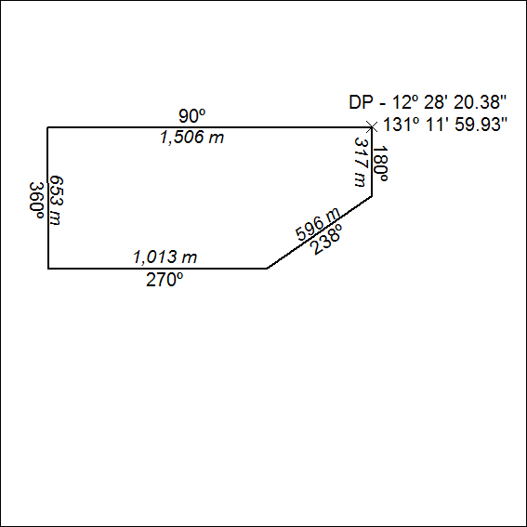

489/18

Mineral Titles Act
NOTICE OF LAND CEASING TO BE A MINERAL TITLE
Title Type and Number: | Extractive Mineral Permit 30593
Area ceased on: | 29 October 2018
Area: | 90.00 Hectare
Locality: | KOOLPINYAH
Name of Applicants(s)Holder(s): | 100% BORAL RESOURCES (QLD) PTY LIMITED [ACN. 009 671 809]
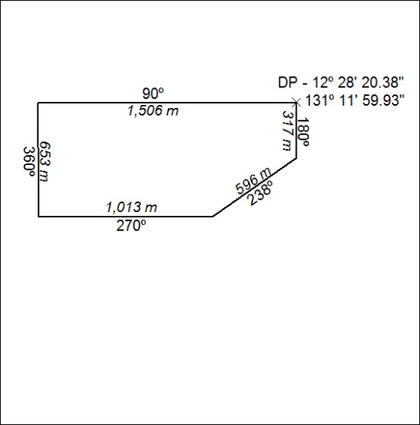

490/18

Mineral Titles Act
NOTICE OF LAND CEASING TO BE A MINERAL TITLE
Title Type and Number: | Extractive Mineral Permit 30594
Area ceased on: | 29 October 2018
Area: | 35.00 Hectare
Locality: | KOOLPINYAH
Name of Applicants(s)Holder(s): | 100% BORAL RESOURCES (QLD) PTY LIMITED [ACN. 009 671 809]
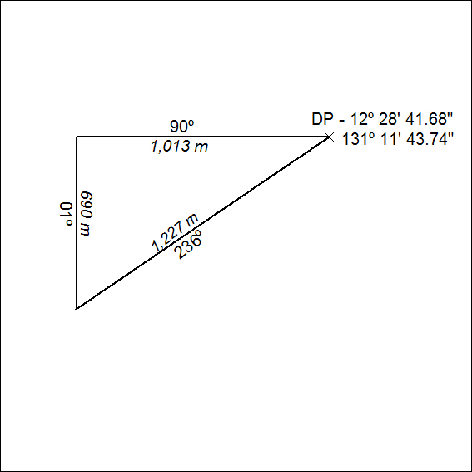

491/18

Mineral Titles Act
NOTICE OF LAND CEASING TO BE A MINERAL TITLE
Title Type and Number: | Extractive Mineral Permit 30596
Area ceased on: | 29 October 2018
Area: | 94.00 Hectare
Locality: | KOOLPINYAH
Name of Applicants(s)Holder(s): | 100% BORAL RESOURCES (QLD) PTY LIMITED [ACN. 009 671 809]
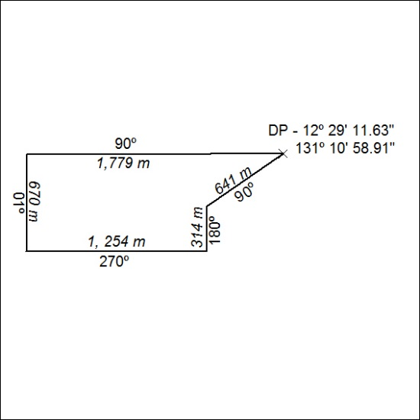

492/18

Mineral Titles Act
NOTICE OF LAND CEASING TO BE A MINERAL TITLE
Title Type and Number: | Extractive Mineral Permit 30597
Area ceased on: | 29 October 2018
Area: | 98.00 Hectare
Locality: | KOOLPINYAH
Name of Applicants(s)Holder(s): | 100% BORAL RESOURCES (QLD) PTY LIMITED [ACN. 009 671 809]
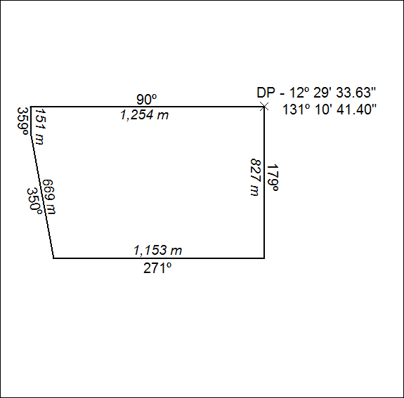

493/18

Mineral Titles Act
NOTICE OF LAND CEASING TO BE A MINERAL TITLE AREA
Title Type and Number: | Exploration Licence 24248
Area Ceased on: | 30 October 2018
Area: | 98 Blocks, 209.51 km²
Locality: | MARCHIN BAR
Name of Applicant(s)/Holder(s): | 100% GULF ALUMINA PTY LTD * [ACN. 108 086 371]
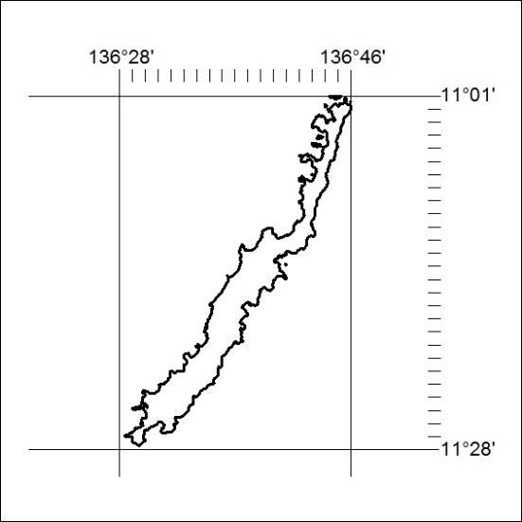

494/18

Mineral Titles Act
NOTICE OF GRANT OF A MINERAL TITLE
Title Type and Number: | Exploration Licence 31787
Granted: | 29 October 2018, for a period of 6 Years
Area: | 250 Blocks, 811.40 km²
Locality: | WOLLOGORANG
Name of Holder/s: | 100% TSC EXPLORATION PTY LTD* [ACN. 622 780 027]
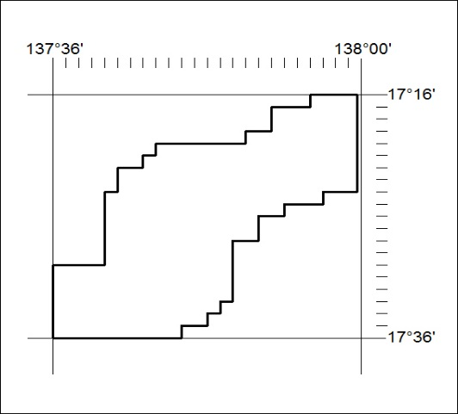
Area granted is indicated above. The titleholder is not permitted to exercise occupational rights on any land that is subject to a development title, or an application for a development title. Any land the subject of a Reserved Land gazettal under the Mineral Titles Act and all land vested in the Commonwealth of Australia is also excluded by description but not excised from the grant area.

495/18

Mineral Titles Act
NOTICE OF GRANT OF A MINERAL TITLE
Title Type and Number: | Exploration Licence 31788
Granted: | 29 October 2018, for a period of 6 Years
Area: | 250 Blocks, 820.54 km²
Locality: | WOLLOGORANG
Name of Holder/s: | 100% TSC EXPLORATION PTY LTD* [ACN. 622 780 027]
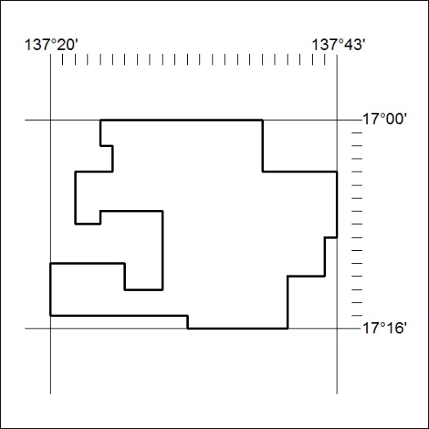
Area granted is indicated above. The titleholder is not permitted to exercise occupational rights on any land that is subject to a development title, or an application for a development title. Any land the subject of a Reserved Land gazettal under the Mineral Titles Act and all land vested in the Commonwealth of Australia is also excluded by description but not excised from the grant area.

496/18

