Mineral Titles Act
NOTICE OF LAND CEASING TO BE A MINERAL TITLE AREA
Title Type and Number: | Exploration Licence 28658
Area Ceased on: | 08 November 2018
Area: | 51 Blocks, 154.43 km²
Locality: | BATTEN
Name of Applicant(s)/Holder(s): | 100% SANDFIRE RESOURCES NL [ACN. 105 154 185]
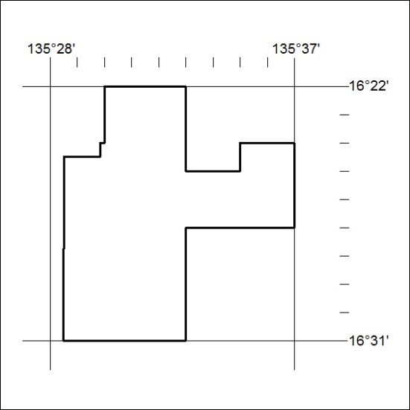

508/18

