Mineral Titles Act
NOTICE OF LAND CEASING TO BE A MINERAL TITLE AREA
Title Type and Number: | Exploration Licence 31564
Area Ceased on: | 20 December 2018
Area: | 238 Blocks, 742.81 km²
Locality: | GILES
Name of Applicant(s)/Holder(s): | 100% ELM RESOURCES PTY LTD [ACN. 612 700 606]
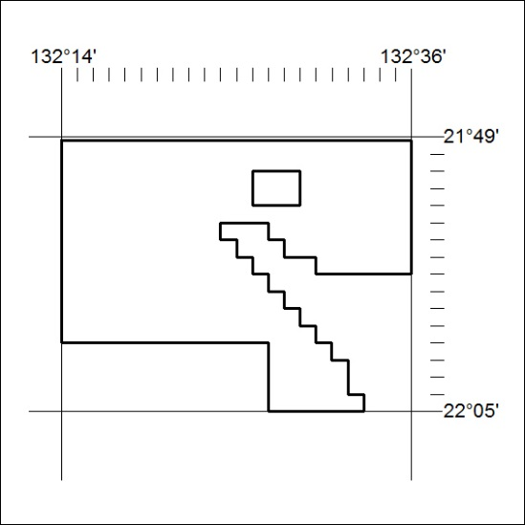

591/18

Mineral Titles Act
NOTICE OF LAND CEASING TO BE A MINERAL TITLE AREA
Title Type and Number: | Exploration Licence 31565
Area Ceased on: | 20 December 2018
Area: | 240 Blocks, 757.01 km²
Locality: | GILES
Name of Applicant(s)/Holder(s): | 100% ELM RESOURCES PTY LTD [ACN. 612 700 606]
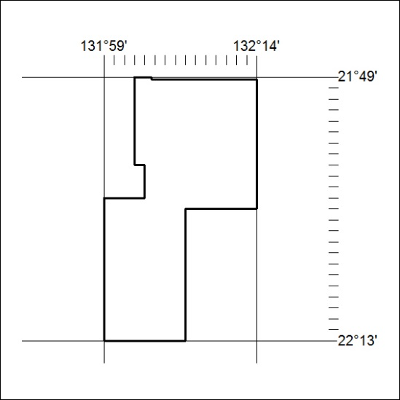

592/18

Mineral Titles Act
NOTICE OF LAND CEASING TO BE A MINERAL TITLE AREA
Title Type and Number: | Exploration Licence 31566
Area Ceased on: | 20 December 2018
Area: | 209 Blocks, 659.41 km²
Locality: | REYNOLDS RANGE
Name of Applicant(s)/Holder(s): | 100% ELM RESOURCES PTY LTD [ACN. 612 700 606]
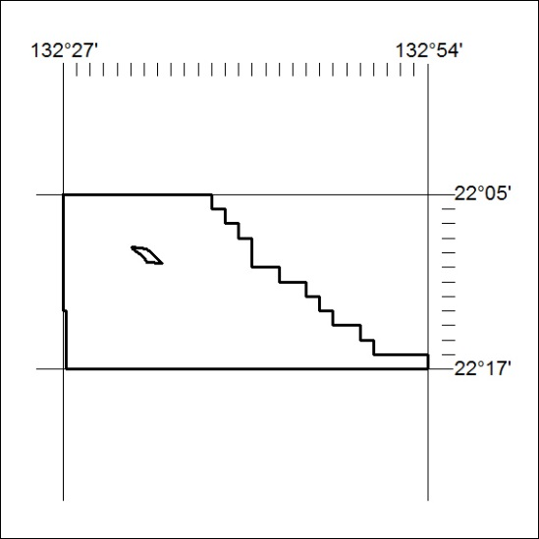

593/18

Mineral Titles Act
NOTICE OF LAND CEASING TO BE A MINERAL TITLE AREA
Title Type and Number: | Exploration Licence 31567
Area Ceased on: | 20 December 2018
Area: | 242 Blocks, 762.41 km²
Locality: | REYNOLDS RANGE
Name of Applicant(s)/Holder(s): | 100% ELM RESOURCES PTY LTD [ACN. 612 700 606]
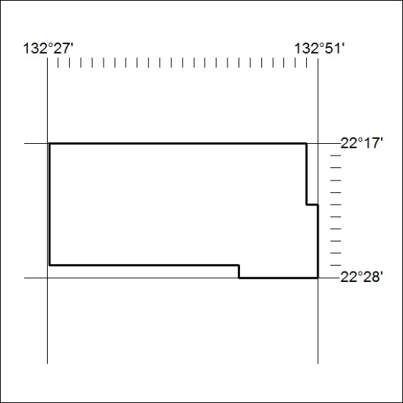

594/18

Mineral Titles Act
NOTICE OF LAND CEASING TO BE A MINERAL TITLE AREA
Title Type and Number: | Exploration Licence 31598
Area Ceased on: | 20 December 2018
Area: | 250 Blocks, 795.66 km²
Locality: | VAUGHAN
Name of Applicant(s)/Holder(s): | 100% ELM RESOURCES PTY LTD [ACN. 612 700 606]
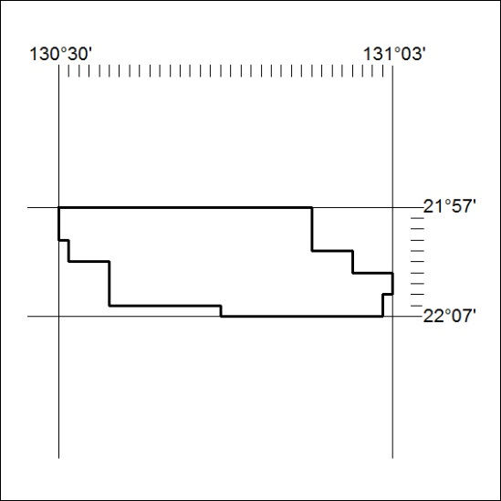

595/18

Mineral Titles Act
NOTICE OF LAND CEASING TO BE A MINERAL TITLE AREA
Title Type and Number: | Exploration Licence 31599
Area Ceased on: | 20 December 2018
Area: | 250 Blocks, 794.99 km²
Locality: | VAUGHAN
Name of Applicant(s)/Holder(s): | 100% ELM RESOURCES PTY LTD [ACN. 612 700 606]
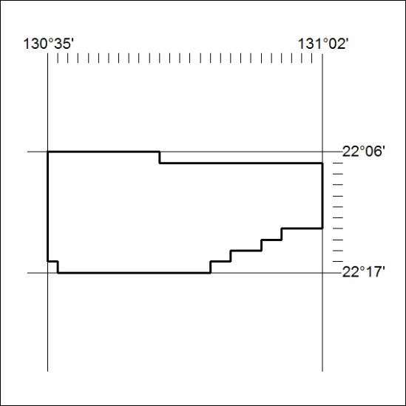

596/18

Mineral Titles Act
NOTICE OF LAND CEASING TO BE A MINERAL TITLE AREA
Title Type and Number: | Exploration Licence 31728
Area Ceased on: | 20 December 2018
Area: | 240 Blocks, 761.04 km²
Locality: | DENISON
Name of Applicant(s)/Holder(s): | 100% ELM RESOURCES PTY LTD [ACN. 612 700 606]
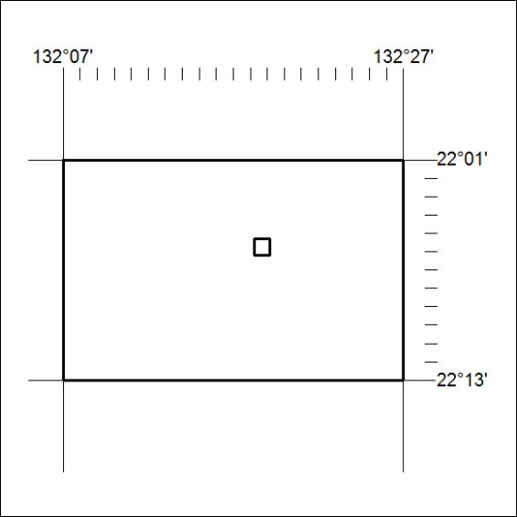

597/18

