Mineral Titles Act
NOTICE OF LAND CEASING TO BE A MINERAL TITLE
Title Type and Number: | Extractive Mineral Lease (Northern) 54
Area ceased on: | 05 February 2019
Area: | 3.00 Hectare
Locality: | MARY RIVER
Name of Applicants(s)Holder(s): | 100% S.G. KENNON & CO PROPRIETARY LIMITED [ACN. 009 592 803]
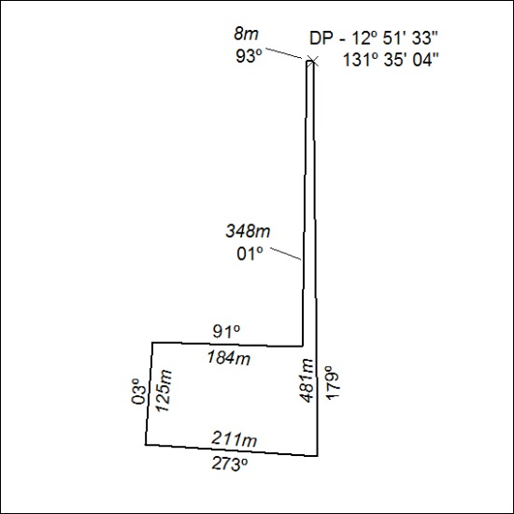

39/19

