Mineral Titles Act
NOTICE OF LAND CEASING TO BE A MINERAL TITLE AREA
Title Type and Number: | Exploration Licence 23824
Area Ceased on: | 07 February 2019
Area: | 17 Blocks, 56.79 km²
Locality: | McKINLAY RIVER
Name of Applicant(s)/Holder(s): | 100% OUTBACK METALS PROPRIETARY LIMITED* [ACN. 126 797 573]
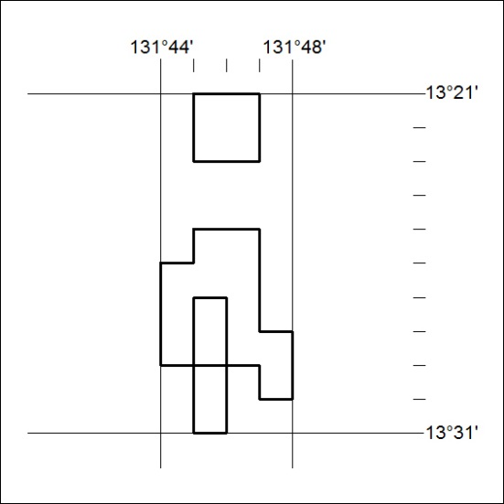

40/19

Mineral Titles Act
NOTICE OF LAND CEASING TO BE A MINERAL TITLE AREA
Title Type and Number: | Exploration Licence 31303
Area Ceased on: | 07 February 2019
Area: | 118 Blocks, 368.46 km²
Locality: | REYNOLDS RANGE
Name of Applicant(s)/Holder(s): | 100% LITCHFIELD MINERALS PTY LTD [ACN. 612 660 429]
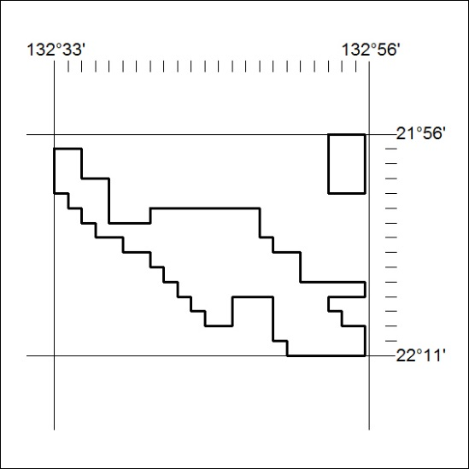

41/19

