Mineral Titles Act
NOTICE OF LAND CEASING TO BE A MINERAL TITLE AREA
Title Type and Number: | Exploration Licence 31012
Area Ceased on: | 07 March 2019
Area: | 13 Blocks, 42.64 km²
Locality: | LANCEWOOD
Name of Applicant(s)/Holder(s): | 100% RIPPLE RESOURCES PTY LTD [ACN. 127 220 768]
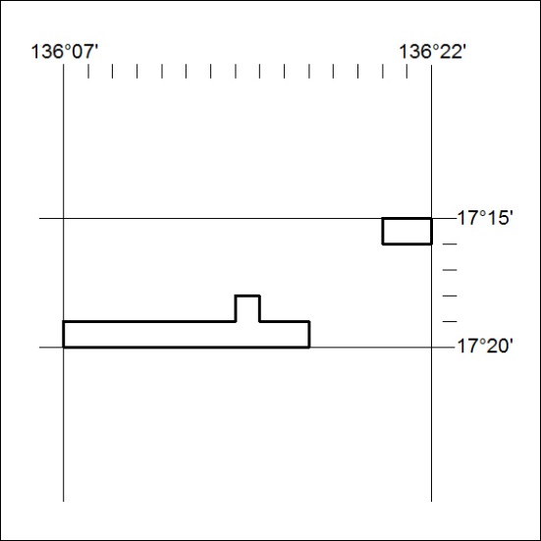

70/19

Mineral Titles Act
NOTICE OF GRANT OF A MINERAL TITLE
Title Type and Number: | Exploration Licence 31896
Granted: | 07 March 2019, for a period of 6 Years
Area: | 61 Blocks, 185.96 km²
Locality: | BARROW
Name of Holder/s: | 100% BENGER John William
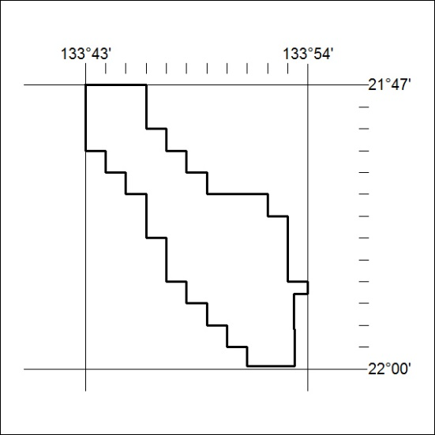
Area granted is indicated above. The titleholder is not permitted to exercise occupational rights on any land that is subject to a development title, or an application for a development title. Any land the subject of a Reserved Land gazettal under the Mineral Titles Act and all land vested in the Commonwealth of Australia is also excluded by description but not excised from the grant area.

71/19

