Mineral Titles Act
NOTICE OF GRANT OF A MINERAL TITLE
Title Type and Number: | Exploration Licence 31701
Granted: | 08 March 2019, for a period of 4 Years
Area: | 250 Blocks, 823.67 km²
Locality: | KILDURK
Name of Holder/s: | 100% GEVINA AND YAYIN PTY LTD [ACN. 099 438 203]
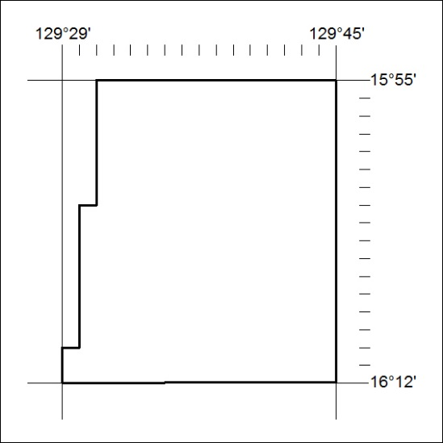
Area granted is indicated above. The titleholder is not permitted to exercise occupational rights on any land that is subject to a development title, or an application for a development title. Any land the subject of a Reserved Land gazettal under the Mineral Titles Act and all land vested in the Commonwealth of Australia is also excluded by description but not excised from the grant area.
72/19

Mineral Titles Act
NOTICE OF GRANT OF A MINERAL TITLE
Title Type and Number: | Exploration Licence 31892
Granted: | 07 March 2019, for a period of 6 Years
Area: | 8 Blocks, 26.75 km²
Locality: | BATCHELOR
Name of Holder/s: | 100% BACCHUS RESOURCES PTY LTD [ACN. 606 340 872]
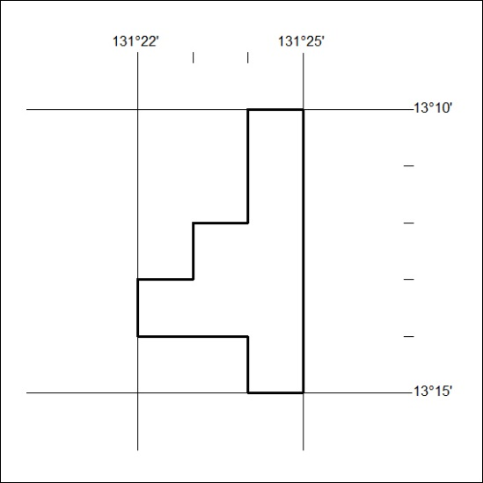
Area granted is indicated above. The titleholder is not permitted to exercise occupational rights on any land that is subject to a development title, or an application for a development title. Any land the subject of a Reserved Land gazettal under the Mineral Titles Act and all land vested in the Commonwealth of Australia is also excluded by description but not excised from the grant area.
73/19

Mineral Titles Act
NOTICE OF GRANT OF A MINERAL TITLE
Title Type and Number: | Exploration Licence 31974
Granted: | 07 March 2019, for a period of 6 Years
Area: | 171 Blocks, 552.40 km²
Locality: | FAVENC
Name of Holder/s: | 50% MRG RESOURCES PTY LTD [ACN. 614 946 164], 50% WEST Jonathan
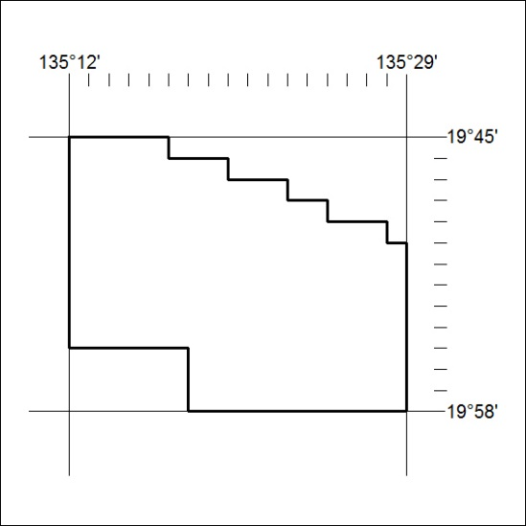
Area granted is indicated above. The titleholder is not permitted to exercise occupational rights on any land that is subject to a development title, or an application for a development title. Any land the subject of a Reserved Land gazettal under the Mineral Titles Act and all land vested in the Commonwealth of Australia is also excluded by description but not excised from the grant area.
74/19

