Mineral Titles Act
NOTICE OF GRANT OF A MINERAL TITLE
Title Type and Number: | Exploration Licence 31967
Granted: | 11 April 2019, for a period of 6 Years
Area: | 250 Blocks, 822.47 km²
Locality: | FLAT TOP HILL
Name of Holder/s: | 100% SANTONIAN RESOURCES PTY LTD [ACN. 627 611 563]
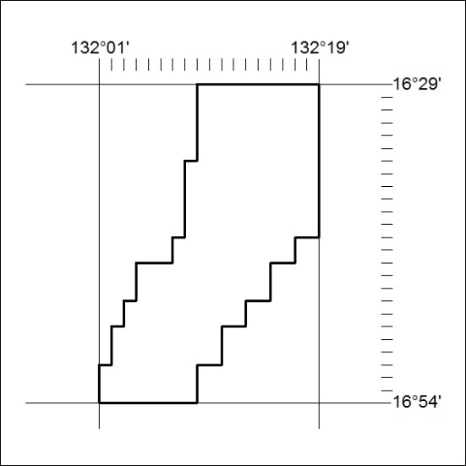
Area granted is indicated above. The titleholder is not permitted to exercise occupational rights on any land that is subject to a development title, or an application for a development title. Any land the subject of a Reserved Land gazettal under the Mineral Titles Act and all land vested in the Commonwealth of Australia is also excluded by description but not excised from the grant area.
128/19

Mineral Titles Act
NOTICE OF GRANT OF A MINERAL TITLE
Title Type and Number: | Exploration Licence 31971
Granted: | 11 April 2019, for a period of 6 Years
Area: | 220 Blocks, 723.73 km²
Locality: | FLAT TOP HILL
Name of Holder/s: | 100% SANTONIAN RESOURCES PTY LTD [ACN. 627 611 563]
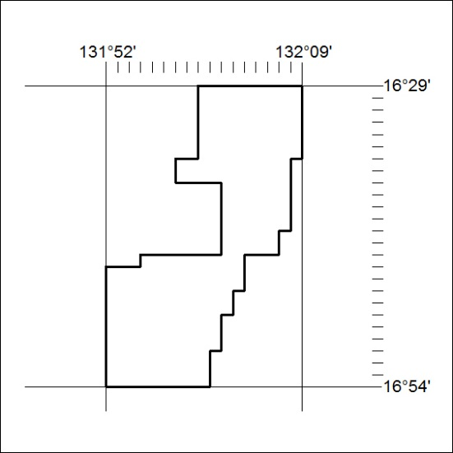
Area granted is indicated above. The titleholder is not permitted to exercise occupational rights on any land that is subject to a development title, or an application for a development title. Any land the subject of a Reserved Land gazettal under the Mineral Titles Act and all land vested in the Commonwealth of Australia is also excluded by description but not excised from the grant area.
129/19

