Mineral Titles Act
NOTICE OF GRANT OF A MINERAL TITLE
Title Type and Number: | Extractive Mineral Exploration Licence 31969
Granted: | 23 April 2019, for a period of 2 Years
Area: | 3 Blocks, 2.30 km²
Locality: | KOOLPINYAH
Name of Holder/s: | 100% MOUSELLIS & SONS PTY. LTD. [ACN. 009 654 791]
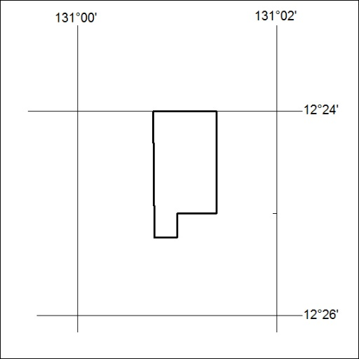
Area granted is indicated above. The titleholder is not permitted to exercise occupational rights on any land that is subject to a development title, or an application for a development title. Any land the subject of a Reserved Land gazettal under the Mineral Titles Act and all land vested in the Commonwealth of Australia is also excluded by description but not excised from the grant area.

130/19

Mineral Titles Act
NOTICE OF GRANT OF A MINERAL TITLE
Title Type and Number: | Extractive Mineral Exploration Licence 31970
Granted: | 23 April 2019, for a period of 2 Years
Area: | 2 Blocks, 0.66 km²
Locality: | KOOLPINYAH
Name of Holder/s: | 100% MOUSELLIS & SONS PTY. LTD. [ACN. 009 654 791]
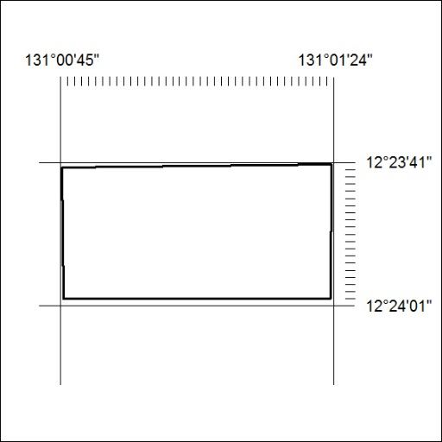
Area granted is indicated above. The titleholder is not permitted to exercise occupational rights on any land that is subject to a development title, or an application for a development title. Any land the subject of a Reserved Land gazettal under the Mineral Titles Act and all land vested in the Commonwealth of Australia is also excluded by description but not excised from the grant area.

131/19
Corrigendum
Notice Number 116/19 appearing in MN39/19 on 3 April 2019 is hereby cancelled and replaced by the following:

Mineral Titles Act 2010
NOTICE OF LAND CEASING TO BE A MINERAL TITLE AREA
Title Type and Number: | Exploration Licence 30090
Area Ceased on: | 02 April 2019
Area: | 15 Blocks, 45.92 km²
Locality: | LAUGHLEN
Name of Applicant(s)/Holder(s): | 100% DAVENPORT RESOURCES LIMITED* [ACN. 153 414 852]
