Mineral Titles Act 2010
NOTICE OF LAND CEASING TO BE A MINERAL TITLE AREA
Title Type and Number: | Extractive Mineral Exploration Licence 31318
Area Ceased on: | 04 July 2019
Area: | 4 Blocks, 3.44 km²
Locality: | NOONAMAH
Name of Applicant(s)/Holder(s): | 100% AKRON GROUP NT PTY LTD [ACN. 158 046 425]
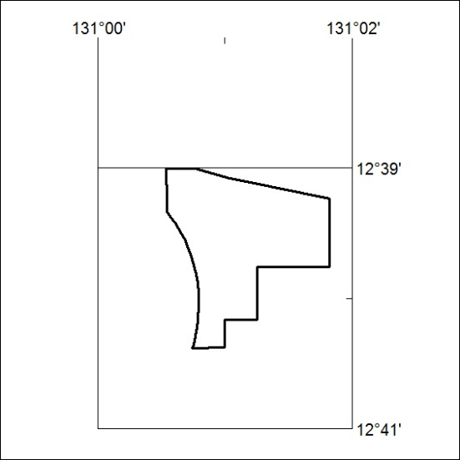

274/19

Mineral Titles Act
NOTICE OF GRANT OF A MINERAL TITLE
Title Type and Number: | Exploration Licence 32055
Granted: | 04 July 2019, for a period of 6 Years
Area: | 6 Blocks, 18.88 km²
Locality: | WILSON CREEK
Name of Holder/s: | 100% PRODIGY GOLD NL* [ACN. 009 127 020]
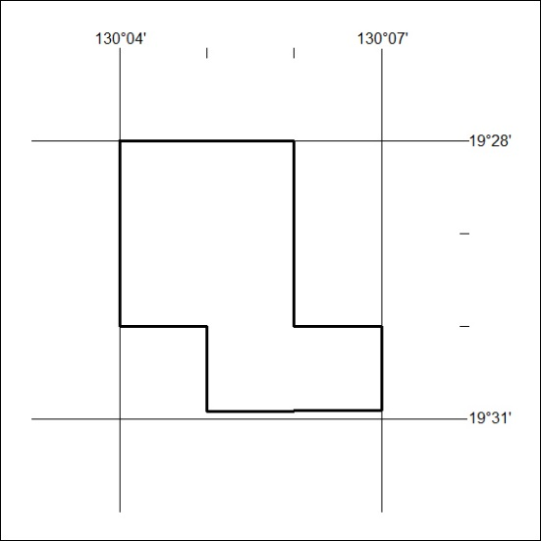
Area granted is indicated above. The titleholder is not permitted to exercise occupational rights on any land that is subject to a development title, or an application for a development title. Any land the subject of a Reserved Land gazettal under the Mineral Titles Act and all land vested in the Commonwealth of Australia is also excluded by description but not excised from the grant area.

275/19

