Mineral Titles Act
NOTICE OF GRANT OF A MINERAL TITLE
Title Type and Number: | Exploration Licence 32073
Granted: | 09 August 2019, for a period of 6 Years
Area: | 4 Blocks, 13.35 km²
Locality: | PINE CREEK
Name of Holder/s: | 100% WILD BULL RESOURCES LIMITED [ACN. 109 681 478]
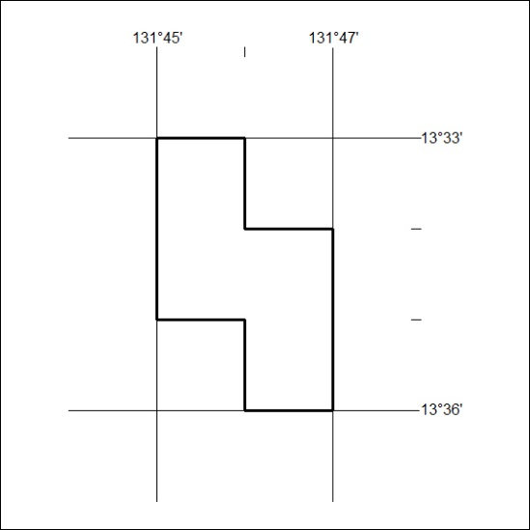
Area granted is indicated above. The titleholder is not permitted to exercise occupational rights on any land that is subject to a development title, or an application for a development title. Any land the subject of a Reserved Land gazettal under the Mineral Titles Act and all land vested in the Commonwealth of Australia is also excluded by description but not excised from the grant area.
339/19

Mineral Titles Act
NOTICE OF GRANT OF A MINERAL TITLE
Title Type and Number: | Exploration Licence 32090
Granted: | 09 August 2019, for a period of 6 Years
Area: | 9 Blocks, 28.50 km²
Locality: | NAPPERBY
Name of Holder/s: | 100% MIOXIDE AUSTRALIA PTY LTD [ACN. 052 522 111]
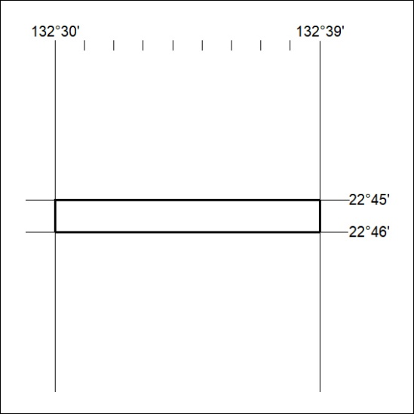
Area granted is indicated above. The titleholder is not permitted to exercise occupational rights on any land that is subject to a development title, or an application for a development title. Any land the subject of a Reserved Land gazettal under the Mineral Titles Act and all land vested in the Commonwealth of Australia is also excluded by description but not excised from the grant area.
340/19

