Mineral Titles Act 2010
NOTICE OF LAND CEASING TO BE A MINERAL TITLE APPLICATION AREA
Title Type and Number: | Exploration Licence 23796
Area Ceased on: | 12 August 2019
Area: | 34 Blocks, 107.21 km²
Locality: | EHRENBERG
Name of Applicant(s)/Holder(s): | 100% KAJEENA MINING COMPANY PTY. LTD. [ACN. 080 270 471]
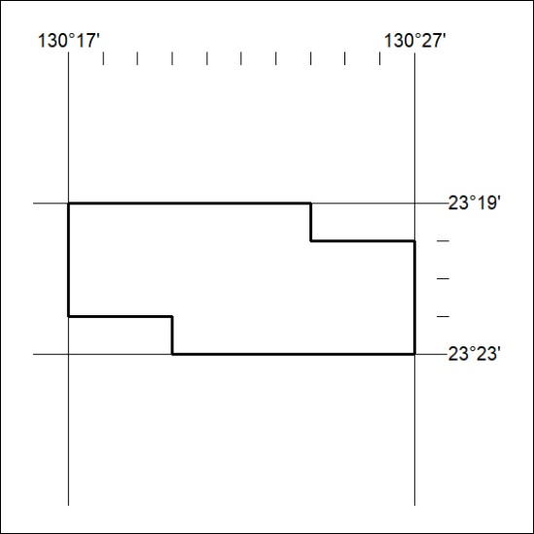

341/19

Mineral Titles Act 2010
NOTICE OF LAND CEASING TO BE A MINERAL TITLE APPLICATION AREA
Title Type and Number: | Exploration Licence 32145
Area Ceased on: | 08 August 2019
Area: | 5 Blocks, 16.67 km²
Locality: | PINE CREEK
Name of Applicant(s)/Holder(s): | 100% ARMSTRONG Robert Leslie
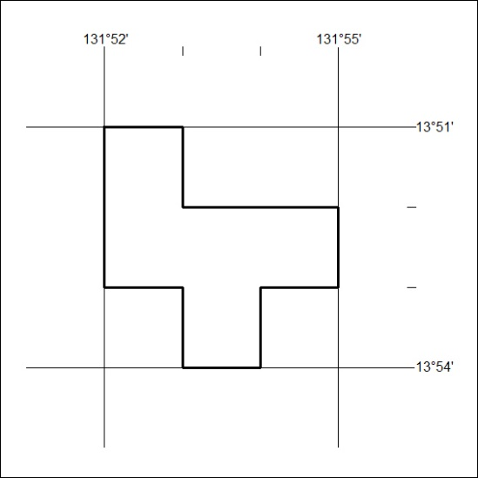

342/19
Mineral Titles Act 2010
NOTICE OF LAND CEASING TO BE A MINERAL TITLE APPLICATION AREA
Title Type and Number: | Exploration Licence 32146
Area Ceased on: | 07 August 2019
Area: | 13 Blocks, 43.16 km²
Locality: | PINE CREEK
Name of Applicant(s)/Holder(s): | 100% WILD BULL RESOURCES LIMITED [ACN. 109 681 478]
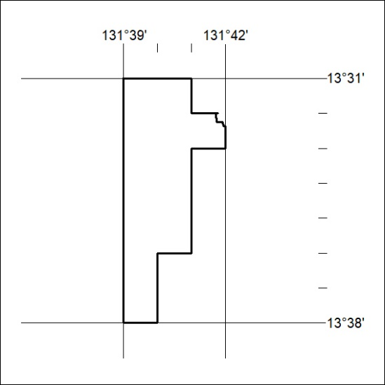

343/19

Mineral Titles Act 2010
NOTICE OF LAND CEASING TO BE A MINERAL TITLE APPLICATION AREA
Title Type and Number: | Mineral Lease 29531
Area ceased on: | 13 August 2019
Area: | 157.00 Hectares
Locality: | SHORT RANGE
Name of Applicants(s)Holder(s): | 100% SANTEXCO PTY LTD [ACN. 002 910 296]
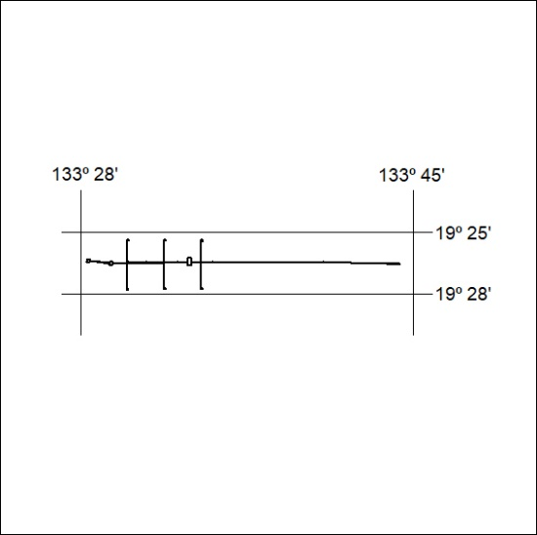

344/19

