Mineral Titles Act 2010
NOTICE OF LAND CEASING TO BE A MINERAL TITLE AREA
Title Type and Number: | Exploration Licence 31517
Area Ceased on: | 11 December 2019
Area: | 11 Blocks, 36.70 km²
Locality: | PINE CREEK
Name of Applicant(s)/Holder(s): | 100% ROCKWASH PTY LTD [ACN. 611 356 837]
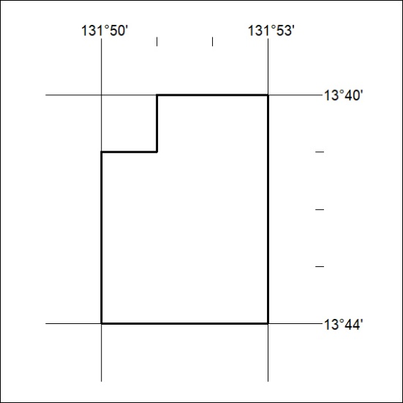

531/19

