Mineral Titles Act 2010
NOTICE OF LAND CEASING TO BE A MINERAL TITLE AREA
Title Type and Number: | Exploration Licence 30837
Area Ceased on: | 17 April 2020
Area: | 21 Blocks, 66.28 km²
Locality: | QUARTZ
Name of Applicant(s)/Holder(s): | 100% PINNACLE EXPLORATION PTY LTD [ACN. 605 748 196]
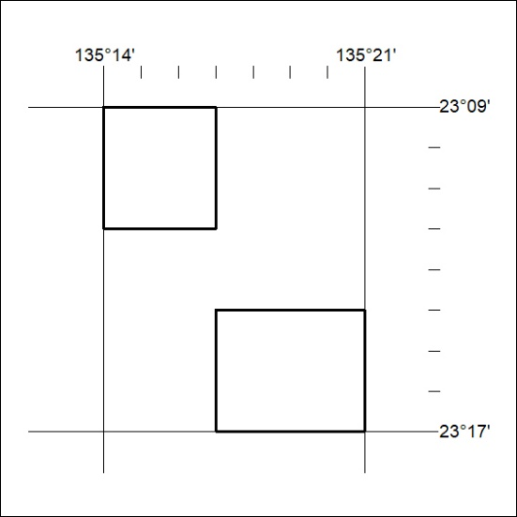
169/20

