Mineral Titles Act 2010
NOTICE OF LAND CEASING TO BE A MINERAL TITLE AREA
Title Type and Number: | Exploration Licence 31623
Area Ceased on: | 19 August 2020
Area: | 21 Blocks, 67.54 km²
Locality: | OORADIDGEE
Name of Applicant(s)/Holder(s): | 100% TREASURE CREEK PTY LTD [ACN. 619 057 644]
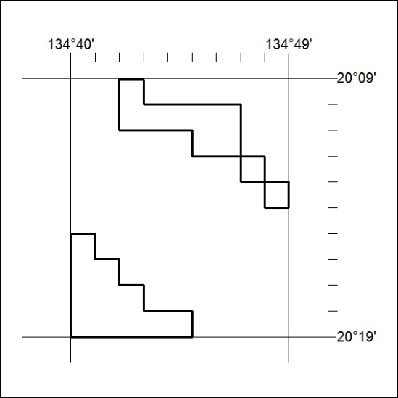

280/20

Mineral Titles Act 2010
NOTICE OF LAND CEASING TO BE A MINERAL TITLE AREA
Title Type and Number: | Exploration Licence 31625
Area Ceased on: | 19 August 2020
Area: | 22 Blocks, 70.88 km²
Locality: | EPENARRA
Name of Applicant(s)/Holder(s): | 100% TREASURE CREEK PTY LTD [ACN. 619 057 644]
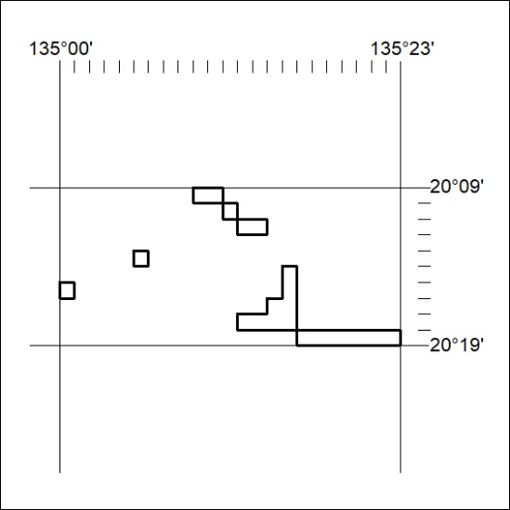

281/20
Mineral Titles Act 2010
NOTICE OF LAND CEASING TO BE A MINERAL TITLE AREA
Title Type and Number: | Exploration Licence 31627
Area Ceased on: | 19 August 2020
Area: | 36 Blocks, 115.85 km²
Locality: | EPENARRA
Name of Applicant(s)/Holder(s): | 100% TREASURE CREEK PTY LTD [ACN. 619 057 644]
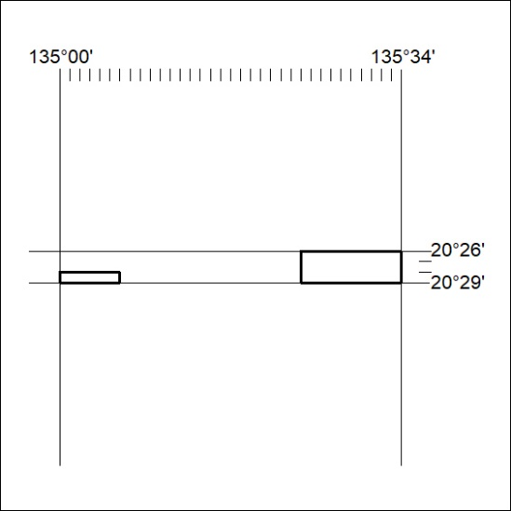

282/20

Mineral Titles Act 2010
NOTICE OF LAND CEASING TO BE A MINERAL TITLE AREA
Title Type and Number: | Exploration Licence 31628
Area Ceased on: | 19 August 2020
Area: | 40 Blocks, 127.32 km²
Locality: | HATCHES
Name of Applicant(s)/Holder(s): | 100% TREASURE CREEK PTY LTD [ACN. 619 057 644]
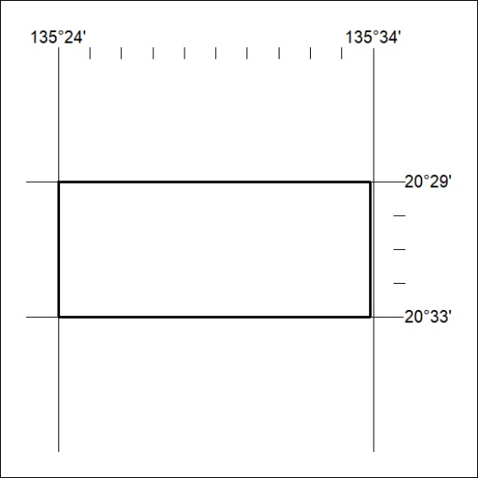

283/20

Mineral Titles Act
NOTICE OF GRANT OF A MINERAL TITLE
Title Type and Number: | Extractive Mineral Permit 32401
Granted: | 18 August 2020, for a period of 5 Years
Area: | 22.80 Hectares
Locality: | TENNANT CREEK
Name of Holder/s: | 100% PHILLIPS Edward James
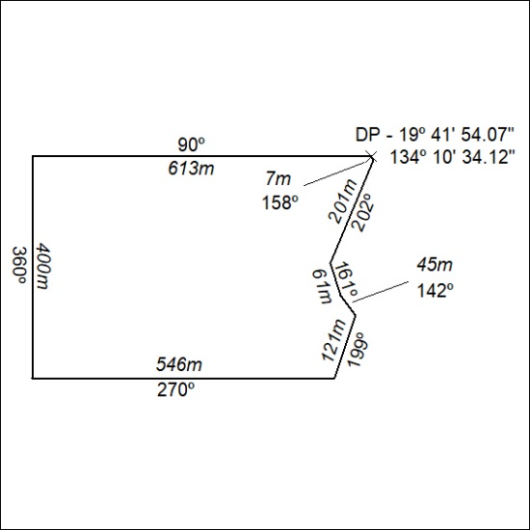

284/20

