Mineral Titles Act 2010
NOTICE OF LAND CEASING TO BE A MINERAL TITLE AREA
Title Type and Number: | Exploration Licence 26555
Area Ceased on: | 10 September 2020
Area: | 15 Blocks, 49.73 km²
Locality: | ROPER
Name of Applicant(s)/Holder(s): | 100% SANDFIRE RESOURCES LIMITED* [ACN. 105 154 185]
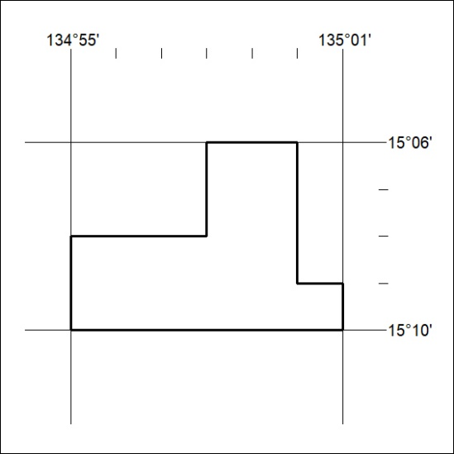

308/20

Mineral Titles Act 2010
NOTICE OF LAND CEASING TO BE A MINERAL TITLE AREA
Title Type and Number: | Extractive Mineral Exploration Licence 31837
Area Ceased on: | 09 September 2020
Area: | 6 Blocks, 12.55 km²
Locality: | KOOLPINYAH
Name of Applicant(s)/Holder(s): | 100% OSTOJIC GROUP PTY LTD* [ACN. 009 629 805]
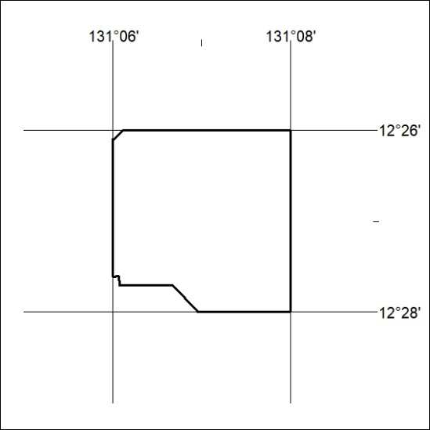

309/20
Mineral Titles Act 2010
NOTICE OF LAND CEASING TO BE A MINERAL TITLE AREA
Title Type and Number: | Extractive Mineral Exploration Licence 31844
Area Ceased on: | 09 September 2020
Area: | 3 Blocks, 4.24 km²
Locality: | KOOLPINYAH
Name of Applicant(s)/Holder(s): | 100% OSTOJIC GROUP PTY LTD* [ACN. 009 629 805]
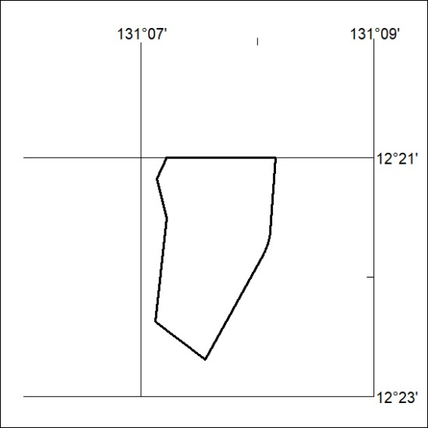

310/20

Mineral Titles Act 2010
NOTICE OF LAND CEASING TO BE A MINERAL TITLE AREA
Title Type and Number: | Extractive Mineral Exploration Licence 31845
Area Ceased on: | 09 September 2020
Area: | 4 Blocks, 2.75 km²
Locality: | KOOLPINYAH
Name of Applicant(s)/Holder(s): | 100% OSTOJIC GROUP PTY LTD* [ACN. 009 629 805]
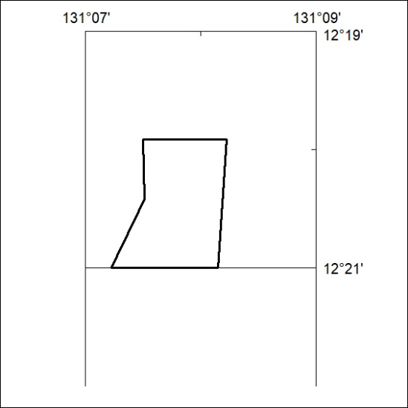

311/20

Mineral Titles Act
NOTICE OF GRANT OF A MINERAL TITLE
Title Type and Number: | Exploration Licence 32323
Granted: | 10 September 2020, for a period of 6 Years
Area: | 250 Blocks, 820.51 km²
Locality: | WOLLOGORANG
Name of Holder/s: | 100% REDBANK OPERATIONS PTY LTD* [ACN. 109 362 165]
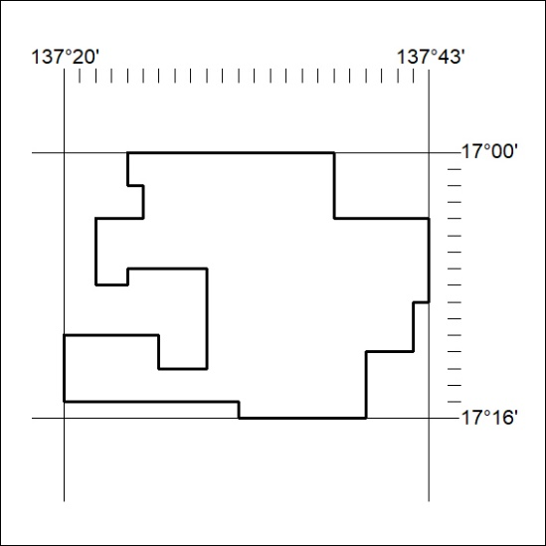
Area granted is indicated above. The titleholder is not permitted to exercise occupational rights on any land that is subject to a development title, or an application for a development title. Any land the subject of a Reserved Land gazettal under the Mineral Titles Act and all land vested in the Commonwealth of Australia is also excluded by description but not excised from the grant area.
312/20

Mineral Titles Act
NOTICE OF GRANT OF A MINERAL TITLE
Title Type and Number: | Exploration Licence 32324
Granted: | 10 September 2020, for a period of 6 Years
Area: | 250 Blocks, 811.41 km²
Locality: | WOLLOGORANG
Name of Holder/s: | 100% REDBANK OPERATIONS PTY LTD* [ACN. 109 362 165]
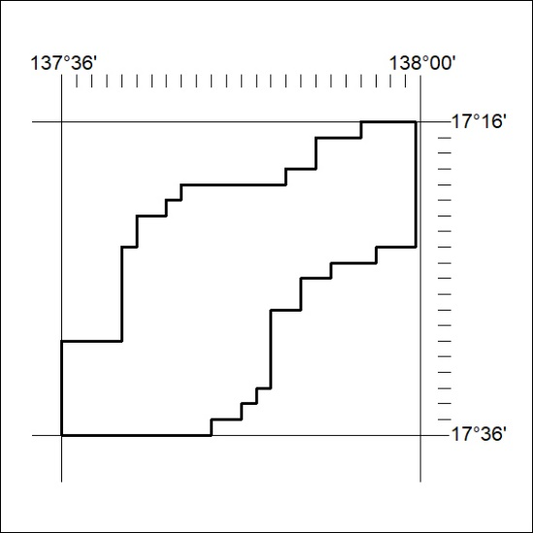
Area granted is indicated above. The titleholder is not permitted to exercise occupational rights on any land that is subject to a development title, or an application for a development title. Any land the subject of a Reserved Land gazettal under the Mineral Titles Act and all land vested in the Commonwealth of Australia is also excluded by description but not excised from the grant area.
313/20

Mineral Titles Act
NOTICE OF GRANT OF A MINERAL TITLE
Title Type and Number: | Exploration Licence 32325
Granted: | 10 September 2020, for a period of 6 Years
Area: | 215 Blocks, 704.85 km²
Locality: | WOLLOGORANG
Name of Holder/s: | 100% REDBANK OPERATIONS PTY LTD* [ACN. 109 362 165]
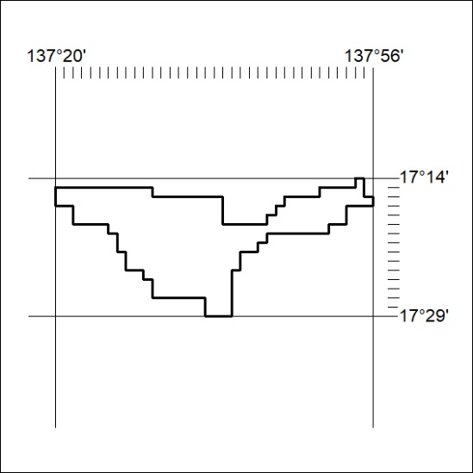
Area granted is indicated above. The titleholder is not permitted to exercise occupational rights on any land that is subject to a development title, or an application for a development title. Any land the subject of a Reserved Land gazettal under the Mineral Titles Act and all land vested in the Commonwealth of Australia is also excluded by description but not excised from the grant area.
314/20

