Mineral Titles Act 2010
NOTICE OF LAND CEASING TO BE A MINERAL TITLE AREA
Title Type and Number: | Extractive Mineral Exploration Licence 31826
Area Ceased on: | 12 September 2020
Area: | 4 Blocks, 9.47 km²
Locality: | NOONAMAH
Name of Applicant(s)/Holder(s): | 100% RUSCA ENVIRONMENTAL SOLUTIONS PTY LTD [ACN. 612 642 458]
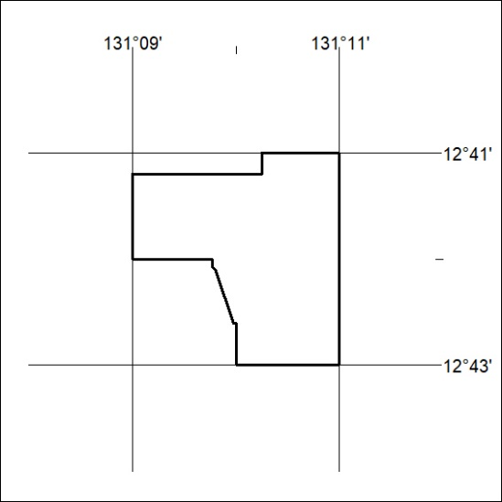

315/20

