Mineral Titles Act 2010
NOTICE OF LAND CEASING TO BE A MINERAL TITLE AREA
Title Type and Number: | Extractive Mineral Permit 23036
Area ceased on: | 05 October 2020
Area: | 47.00 Hectare
Locality: | NOONAMAH
Name of Applicants(s)Holder(s): | 100% BERNO BROS. PTY. LIMITED [ACN. 009 592 741]
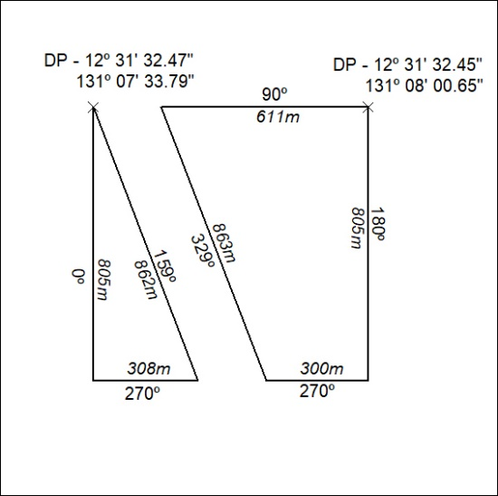

333/20

Mineral Titles Act 2010
NOTICE OF LAND CEASING TO BE A MINERAL TITLE AREA
Title Type and Number: | Extractive Mineral Permit 23037
Area ceased on: | 05 October 2020
Area: | 47.00 Hectare
Locality: | NOONAMAH
Name of Applicants(s)Holder(s): | 100% BERNO BROS. PTY. LIMITED [ACN. 009 592 741]
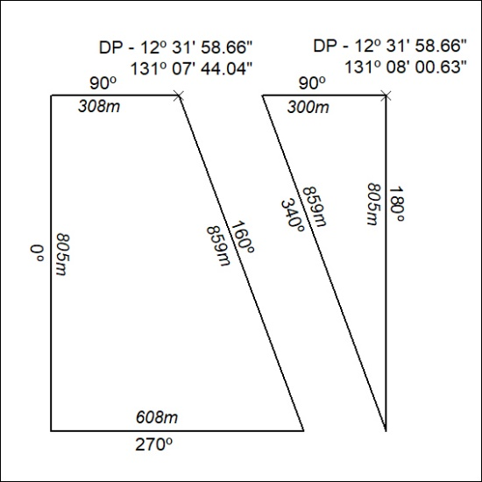

334/20

Mineral Titles Act 2010
NOTICE OF LAND CEASING TO BE A MINERAL TITLE AREA
Title Type and Number: | Extractive Mineral Permit 23038
Area ceased on: | 05 October 2020
Area: | 57.00 Hectare
Locality: | NOONAMAH
Name of Applicants(s)Holder(s): | 100% BERNO BROS. PTY. LIMITED [ACN. 009 592 741]
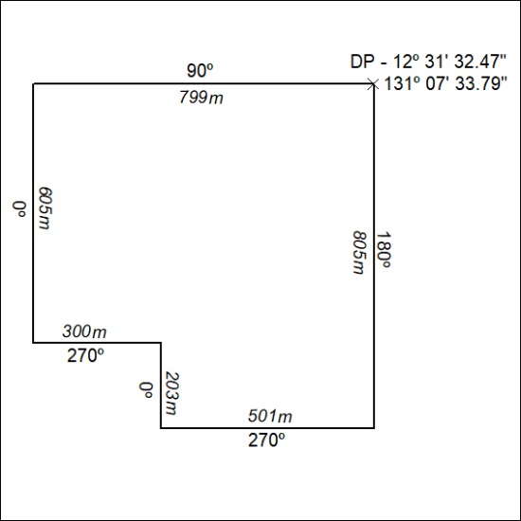

335/20

Mineral Titles Act 2010
NOTICE OF LAND CEASING TO BE A MINERAL TITLE AREA
Title Type and Number: | Extractive Mineral Permit 23039
Area ceased on: | 05 October 2020
Area: | 57.00 Hectare
Locality: | NOONAMAH
Name of Applicants(s)Holder(s): | 100% BERNO BROS. PTY. LIMITED [ACN. 009 592 741]
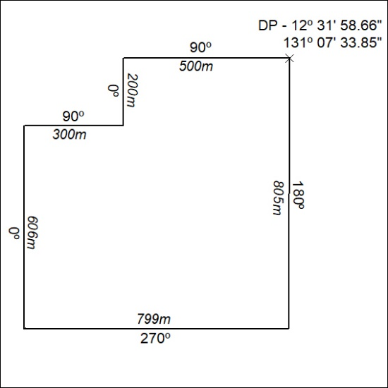

336/20

Mineral Titles Act 2010
NOTICE OF LAND CEASING TO BE A MINERAL TITLE AREA
Title Type and Number: | Extractive Mineral Permit (Northern) 1313
Area ceased on: | 05 October 2020
Area: | 16.26 Hectare
Locality: | NOONAMAH
Name of Applicants(s)Holder(s): | 100% BERNO BROS. PTY. LIMITED [ACN. 009 592 741]
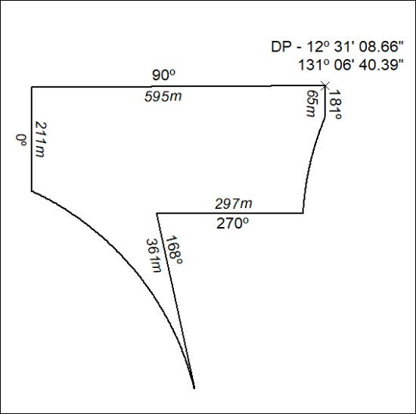

337/20

Mineral Titles Act 2010
NOTICE OF LAND CEASING TO BE A MINERAL TITLE AREA
Title Type and Number: | Extractive Mineral Permit (Northern) 1321
Area ceased on: | 05 October 2020
Area: | 14.70 Hectare
Locality: | NOONAMAH
Name of Applicants(s)Holder(s): | 100% BERNO BROS. PTY. LIMITED [ACN. 009 592 741]
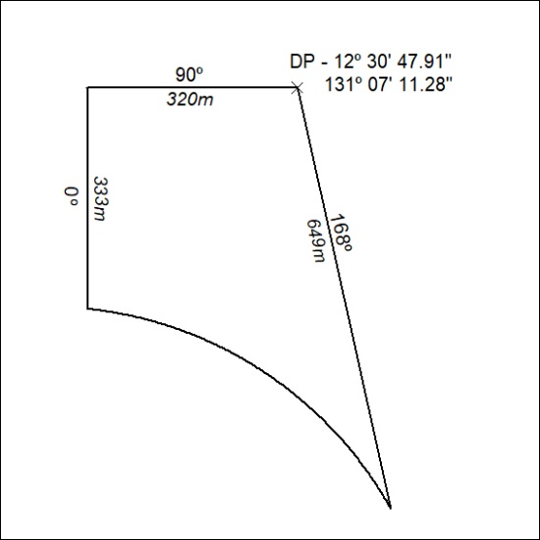

338/20

