Mineral Titles Act 2010
NOTICE OF LAND CEASING TO BE A MINERAL TITLE APPLICATION AREA
Title Type and Number: | Exploration Licence 23898
Area Ceased on: | 21 October 2020
Area: | 125 Blocks, 398.34 km²
Locality: | NARDUDI
Name of Applicant(s)/Holder(s): | 100% PRODIGY GOLD NL* [ACN. 009 127 020]
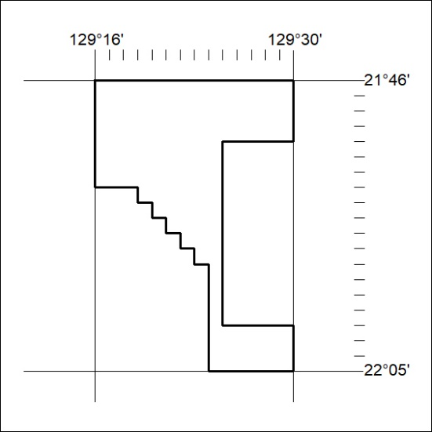

342/20

Mineral Titles Act 2010
NOTICE OF LAND CEASING TO BE A MINERAL TITLE APPLICATION AREA
Title Type and Number: | Exploration Licence 24473
Area Ceased on: | 21 October 2020
Area: | 60 Blocks, 191.16 km²
Locality: | NARDUDI
Name of Applicant(s)/Holder(s): | 100% PRODIGY GOLD NL* [ACN. 009 127 020]
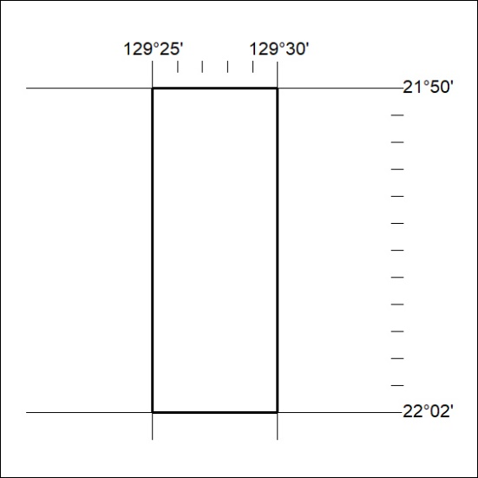

343/20
Mineral Titles Act 2010
NOTICE OF LAND CEASING TO BE A MINERAL TITLE APPLICATION AREA
Title Type and Number: | Exploration Licence 27894
Area Ceased on: | 21 October 2020
Area: | 455 Blocks, 1426.29 km²
Locality: | McEWIN
Name of Applicant(s)/Holder(s): | 100% PRODIGY GOLD NL* [ACN. 009 127 020]
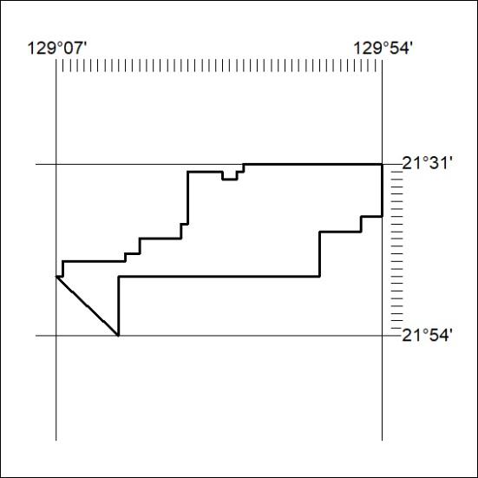

344/20

Mineral Titles Act 2010
NOTICE OF LAND CEASING TO BE A MINERAL TITLE APPLICATION AREA
Title Type and Number: | Exploration Licence 30552
Area Ceased on: | 21 October 2020
Area: | 186 Blocks, 593.22 km²
Locality: | McEWIN
Name of Applicant(s)/Holder(s): | 100% PRODIGY GOLD NL* [ACN. 009 127 020]
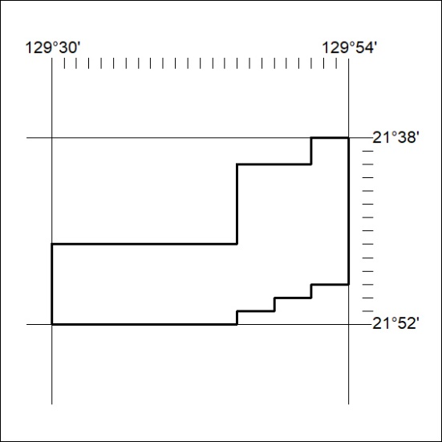

345/20
Mineral Titles Act 2010
NOTICE OF LAND CEASING TO BE A MINERAL TITLE APPLICATION AREA
Title Type and Number: | Exploration Licence 30553
Area Ceased on: | 21 October 2020
Area: | 189 Blocks, 602.21 km²
Locality: | McEWIN
Name of Applicant(s)/Holder(s): | 100% PRODIGY GOLD NL* [ACN. 009 127 020]
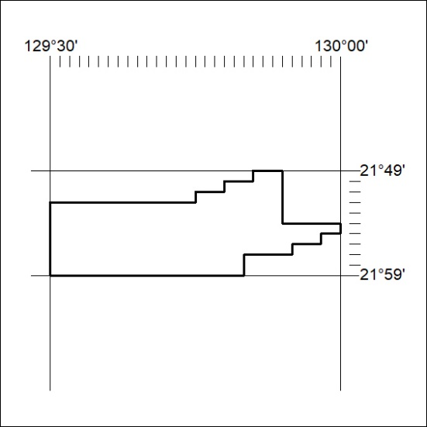

346/20

Mineral Titles Act 2010
NOTICE OF LAND CEASING TO BE A MINERAL TITLE APPLICATION AREA
Title Type and Number: | Exploration Licence 30554
Area Ceased on: | 21 October 2020
Area: | 99 Blocks, 315.79 km²
Locality: | MOUNT FAREWELL
Name of Applicant(s)/Holder(s): | 100% PRODIGY GOLD NL* [ACN. 009 127 020]
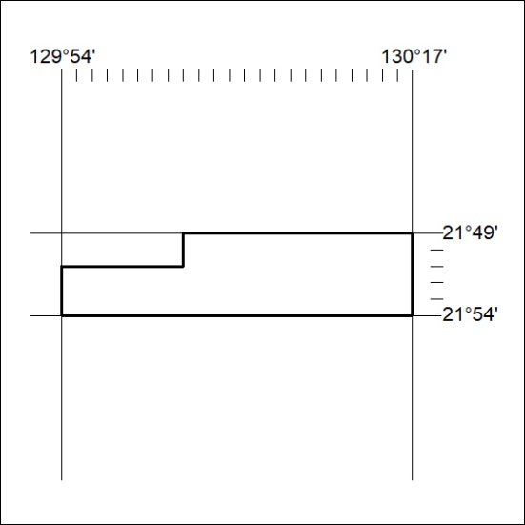

347/20
Mineral Titles Act 2010
NOTICE OF LAND CEASING TO BE A MINERAL TITLE APPLICATION AREA
Title Type and Number: | Exploration Licence 30555
Area Ceased on: | 21 October 2020
Area: | 250 Blocks, 795.90 km²
Locality: | MOUNT FAREWELL
Name of Applicant(s)/Holder(s): | 100% PRODIGY GOLD NL* [ACN. 009 127 020]
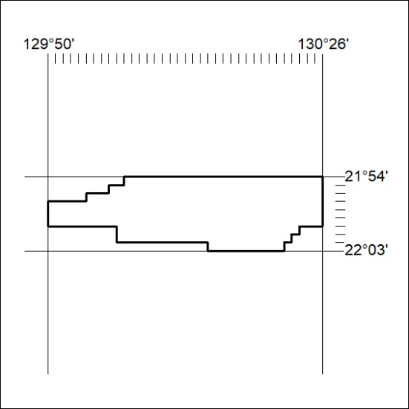

348/20

Mineral Titles Act 2010
NOTICE OF LAND CEASING TO BE A MINERAL TITLE APPLICATION AREA
Title Type and Number: | Exploration Licence 30556
Area Ceased on: | 21 October 2020
Area: | 194 Blocks, 617.80 km²
Locality: | WARBURTON
Name of Applicant(s)/Holder(s): | 100% PRODIGY GOLD NL* [ACN. 009 127 020]
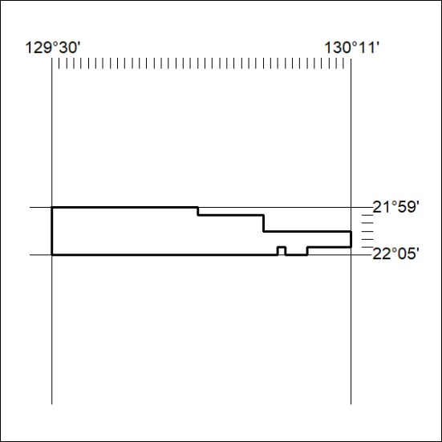

349/20

