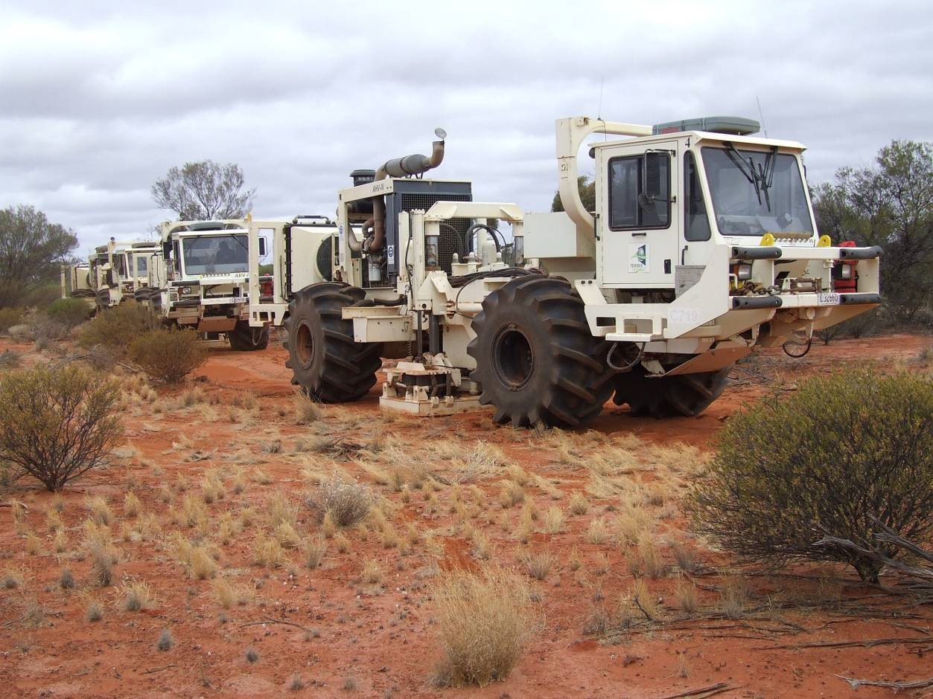

**Exploration Permit-161, 2D Seismic Exploration Survey, 2013**

**Environmental Plan Summary**

**ENV-EP161-STO-0002**

**Rev**

**Date**

**Reason for issue**

**Author**

**Checked**

**Approved**

0

22/07/2013

Issued to N.T. Dept. of Mines and Energy

ST

ST

MG



EP - 161 Environmental Plan Summary

**Table of Contents**

**Introduction ........................................................................................ 1**

**1**

1.1

1.2

Proponent ......................................................................................... 1

Scope................................................................................................. 1

**2**

**Project Activity Description.................................................................. 2**

2.1

2.2

Project Location ................................................................................ 2

Seismic Methodology........................................................................ 6

2.2.1

2.2.2

2.2.3

2.2.4

Planning ............................................................................. 7

Seismic line and access track preparation......................... 7

Line surveying .................................................................... 8

Recording........................................................................... 8

2.3

2.4

2.5

2.6

2.7

Camp sites and associated supplies.................................................. 9

Up hole drilling and logging activities ............................................. 11

Seismic line / access track and camp site restoration .................... 12

Post survey monitoring and GAS auditing ...................................... 12

Timeframes ..................................................................................... 13

**3**

**Environment Description ................................................................... 13**

3.1

Physical Environment...................................................................... 13

3.1.1

3.1.2

3.1.3

3.1.4

3.1.5

Climate............................................................................. 13

Geology............................................................................ 13

Soils.................................................................................. 13

Land systems ................................................................... 14

Hydrology ........................................................................ 14

3.2

Biological Environment ................................................................... 14

3.2.1

3.2.2

3.2.3

3.2.4

Bioregions ........................................................................ 14

Flora................................................................................. 15

Fauna ............................................................................... 15

Socio-economic environment ......................................... 15

3.3

Environmental and Cultural Sensitivities ........................................ 16

3.3.1

3.3.2

3.3.3

3.3.4

3.3.5

3.3.6

Sacred and cultural heritage site protection................... 16

Protected or conservation areas ..................................... 16

Threatened flora and fauna............................................. 16

Significant habitat............................................................ 16

Fire regime....................................................................... 17

Pest plant and animal control ......................................... 17

ENV- EP161- STO- 0002 Rev0

Uncontrolled when printed

ii



EP - 161 Environmental Plan

**4**

**Environmental Risk Identification ...................................................... 17**

4.1

4.2

Management of Hazard Identification and Risk Assessment ......... 17

ALARP demonstration ..................................................................... 18

**5**

**6**

**7**

**Environmental Hazards, Consequences and Risk Assessment .............. 18**

**Environmental Performance Objectives ............................................. 22**

**Implementation Strategy ................................................................... 22**

7.1

7.2

Project Management Systems ........................................................ 22

Current operating procedures used to minimise impacts .............. 23

7.2.1

7.2.2

7.2.3

7.2.4

7.2.5

7.2.6

7.2.7

7.2.8

Terrain ............................................................................. 23

Native vegetation ............................................................ 24

Native fauna / habitat ..................................................... 24

Pollution .......................................................................... 25

Landholder infrastructure ............................................... 25

Petroleum infrastructure................................................. 25

Third party access............................................................ 25

Sacred and cultural heritage sites ................................... 25

7.3

7.4

7.5

7.6

7.7

7.8

Chain of Command ......................................................................... 26

Induction and Training .................................................................... 26

Monitoring ...................................................................................... 26

Audits .............................................................................................. 27

Management of Non-conformance ................................................ 27

Emergency Response Plan .............................................................. 27

**8**

**9**

**10**

**Reporting .......................................................................................... 28**

**Consultation...................................................................................... 28**

**Further Details .................................................................................. 29**

**List of Tables**

Table 1: Bounding polygon coordinates for seismic lines .....................................6

Table 2: Santos risk matrix...................................................................................18

Table 3: Summary of residual risk levels for seismic operations ........................19

Table 4: Table of stakeholder consultation ........................................................28

ENV- EP161- STO- 0002 Rev0

Uncontrolled when printed

iii



EP - 161 Environmental Plan

**List of Figures**

Figure 1: Location of Exploration Permit (EP) 161, McArthur Basin......................3

Figure 2: Indicative location of seismic lines within EP-161. ................................4

Figure 3: Coordinates of EP-161 proposed seismic survey (bounding polygon). ..5

Figure 4: Schematic of 2D seismic acquisition process.........................................7

Figure 5: Typical main camp ...............................................................................10

Figure 6: Up hole drilling rig and LVL recording truck ........................................11

Figure 7: Risk assessment process ......................................................................18

ENV- EP161- STO- 0002 Rev0

Uncontrolled when printed

iv



EP - 161 Environmental Plan Summary

**DOCUMENT CONTROL**

This Environmental Plan (EP) Summary is a controlled document. Should the recipient (user)

become aware of any changes or corrections that are required please photocopy this page and the relevant page(s) to be changed, note the corrections and deliver them to:

Steve Tunstill

Group Principal Adviser - Environment

Santos Ltd

Level 12, 60 Flinders Street, Adelaide

Ph (08) 8116 7896

[steve.tunstill@santos.com](mailto:steve.tunstill@santos.com)

ENV- EP161- STO- 0002 Rev0

Uncontrolled when printed

v



EP - 161 Environmental Plan

**1**

**Introduction**

Santos (QNT) Pty Ltd (Santos), as the Operator of Northern Territory Exploration Permit (EP) 161, is

proposing to undertake a 2D seismic survey within the permit during the second half of 2013.

This Environmental Plan (EP) Summary provides information on:

•

•

•

•

•

•

•

the coordinates and locality of the proposed seismic survey

a description of the physical environment

a description of the seismic survey in relation to the environment

major environmental hazards and risks and the risk assessment process the approach adopted to mitigate environmental impacts

consultation that has been undertaken and is proposed

contact details of the operator’s nominated liaison person

Full details are provided in the Exploration Permit - 161, 2D Seismic Exploration Survey, 2013

Environmental Plan (Document Number ENV-EP161-STO-001, Rev 0, 31/5/2013).

**1.1**

**Proponent**

Santos (QNT) Pty Ltd is a wholly owned subsidiary of Santos Ltd. Santos Ltd is an Australian Securities

Exchange listed company with its Head Office at 60 Flinders Street, Adelaide, South Australia. It has operations and interests in every major Australian petroleum province and in Indonesia, Vietnam, Papua New Guinea, Bangladesh, India and Central Asia.

Santos holds 50% interest and Operator of Exploration Permits (EP), 161, 162, 189 and 299(A) in the

McArthur Basin. Tamboran Resources Pty Ltd holds the remaining 50% interest in these exploration permits.

**1.2**

**Scope**

This EP applies only to activities associated with the 2D seismic exploration survey which is proposed

to be undertaken by Santos within Exploration Permit 161 (refer **Figure 2**) below. Activities associated with the geophysical operations to be undertaken in the second half of 2013 are as follows:

•

line and access track preparation (after sacred site and cultural heritage approvals have

been obtained)

line surveying (starts just after line preparation)

recording operations

establishment and operation of camp sites and provision of associated supplies

up hole drilling and logging (during or after recording phase, as and when required) monitoring and auditing of selected locations (pre and post line preparation and post restoration); and

monitoring of seismic line, access track and camp site restoration where required (after completion of recording and up hole drilling / logging).

•

•

•

•

•

•

ENV- EP161- STO- 0002 Rev0

Uncontrolled when printed

1



EP - 161 Environmental Plan

**2**

**Project Activity Description**

**2.1**

**Project Location**

Exploration Permit (EP) 161 is located in the McArthur Basin in the far north-east of the Northern

Territory. The exploration permit is approximately 350 km south-east of Katherine (refer Figure 1).

ENV- EP161- STO- 0002 Rev0

Uncontrolled when printed

2

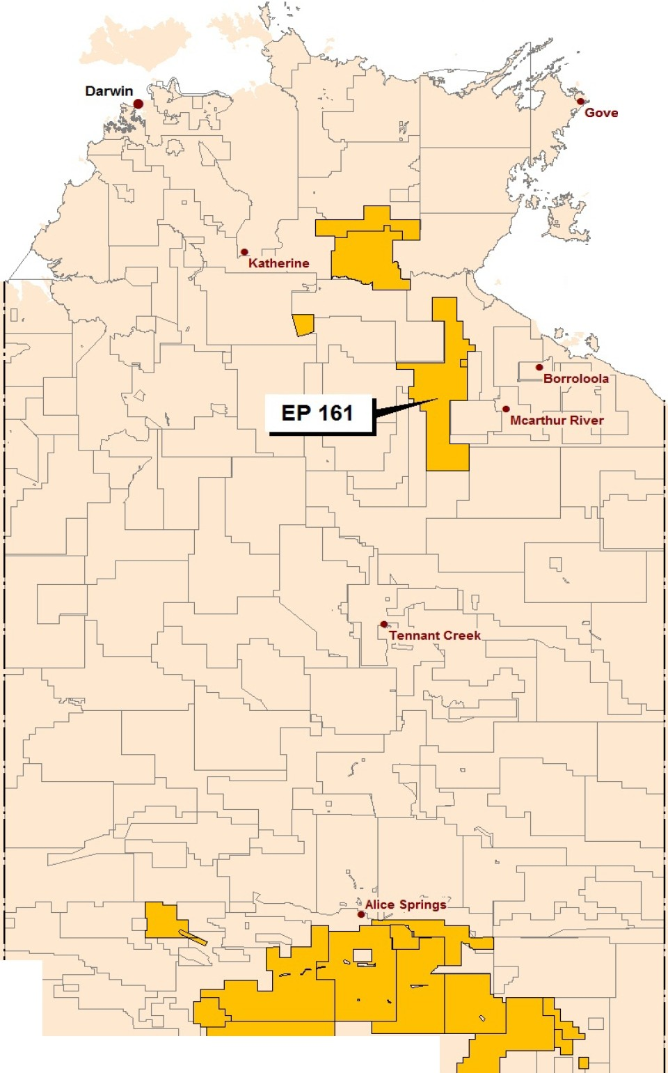

**Santos**

We have the energy.

EP - 161Environmental Plan

**L-** --------- _'-_-_-_-_-_J.:.:.==-

-- c_'_D_::....J: .L........._---1---L-..l.....I....--L --·'----

**Figure 1: Location of Exploration Permit (EP) 161, McArthur Basin**

ENV- EP161- STO- 0002 RevO

U ncontrolled when pri nted

3

Santos Acreage **Santos**

Northern Territory Onshore Acreage **Santos Onshore Acreage in the Northern Territory**

**2013**

Kilometres

0 50 100 150 200 250

**15 May 2013, File No. NTGEN 076**

I

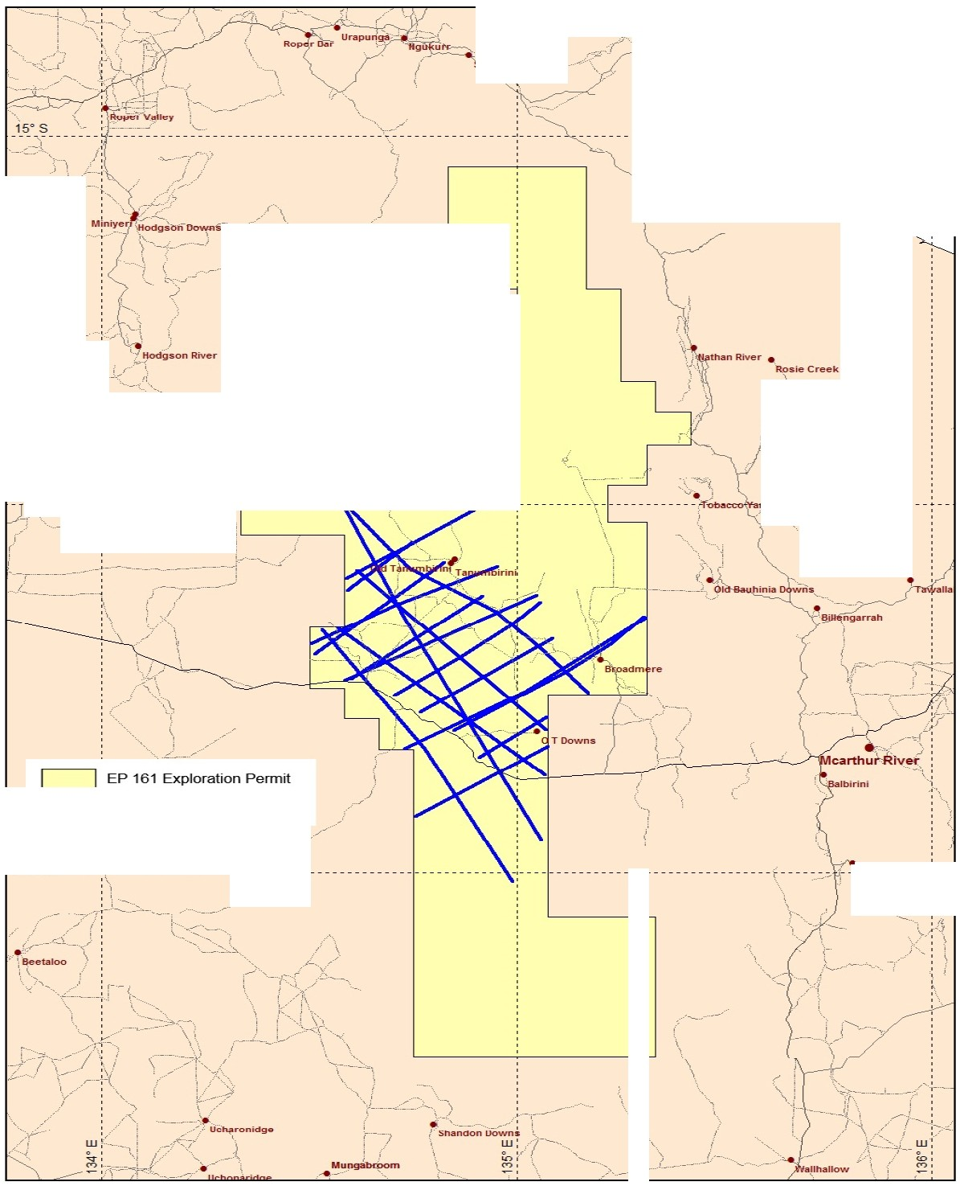

**Santos**

We have the energy.

EP - 161Environmental Plan

To avoid or minimise any environmental impacts arising from the seismic survey, Santos has

proposed 500 m corridors (250m either side of the indicative seismic line) within which a 5 m

seismic line will be prepared 1 This approach allows final line placement to reflect on-ground

_

conditions,avoid sensitive features,weave lines to reduce aesthetic impacts,avoid sites of cultural

or sacred site significance and isolated trees or stands of vegetation_

*::[:*"-y/

'"

**Santos**

-- .....--

**EP 161**

,

I

.i

**Pete,-za,-d**• _

**Buffalo Hole Yard**

*)*

*'I- ----*

<:-

**10-. --- - - --** f--- t;<= _-:-_ -- ---*:*-.·*.* ------ ...,..------ ---

-(. :

_t_

**d**

,**- - -- - -- - -- - --** -- -- --

:-.

---Proposed Seismic

_1_7_ _?_ _ _ ; . _ _ _ _ _ _ '--- - -- -- -- - -- - -- - -- - --- - --- - - -

-- -- - --- - -- - -- - -- - -- -- -- -- - r - -- - - >::,: **-pv unyah - :--**

' -

:

*/*

**Figure 2: Indicative location of seismic lines within EP-161.**

1

Only approximately 50% of the i ndicative lines will be prepared and data acquired. Final li nes selection wi ll depend on c l earances, on

gr ound conditions and approvals.

ENV- EP161- STO- 0002 RevO

U ncontrolled when pri nted

4

*I*

*_ _* Northern Territory

**Pr-oposed Seismic**

Kilometres

0 10 20 30 40 50

**1S l.tay 201l. Fie No. NTGEN *on***

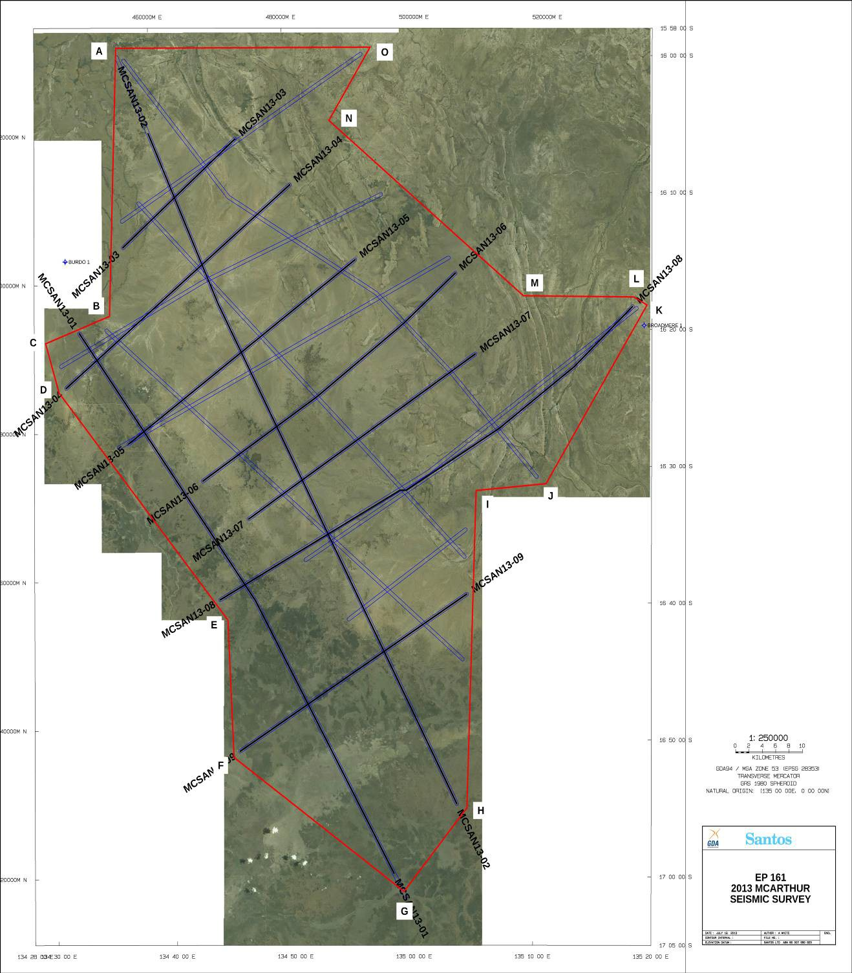

EP - 161 Environmental Plan

**Figure 3: Coordinates of EP-161 proposed seismic survey (bounding polygon).**

Detailed coordinates of the bounding polygon (refer Figure 3 above) within which the final seismic

lines will be prepared and recorded are provided in **Table 1** below.

ENV- EP161- STO- 0002 Rev0

Uncontrolled when printed

5



EP - 161 Environmental Plan

Datum: GDA 94. Format: Decimal Degrees

**Table 1: Bounding polygon coordinates for seismic lines**

**2.2**

**Seismic Methodology**

Seismic acquisition allows the exploration company to ‘image’ below the surface and identify areas

where oil and gas deposits may have accumulated. The seismic method uses energy sources such as vibrator trucks or buried explosive charges. The energy source creates sound (acoustic) waves, which travel through the earth and are then reflected from subsurface geological structures (refer Figure 4).

ENV- EP161- STO- 0002 Rev0

Uncontrolled when printed

6

**Point**

**Longitude**

**Latitude**

A

134.5817

15.9910

B

134.5724

16.3174

C

134.4827

16.3506

D

134.5013

16.4107

E

134.7381

16.6873

F

134.7465

16.8546

G

134.9856

17.0180

H

135.0740

16.9162

I

135.0869

16.5298

J

135.1852

16.5214

K

135.3266

16.3036

L

135.3078

16.2938

M

135.1532

16.2926

N

134.8803

16.0792

O

134.9381

15.9900

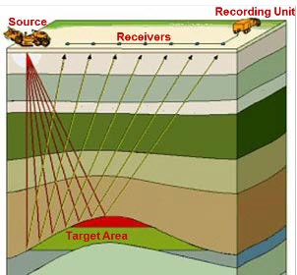

EP - 161 Environmental Plan

**Figure 4: Schematic of 2D seismic acquisition process**

The returning reflections are recorded in a digital format and relayed to a seismic data processing

centre to produce a ‘cross-section’ of the layers of the earth’s crust. This data is then interpreted to identify potential future drilling locations. The following sections explain the field procedures for recording seismic data.

**2.2.1**

**Planning**

The seismic survey proposed to be undertaken in EP-161 during the second half of 2013 will be a 2D

survey.

Seismic lines are carefully planned to avoid sensitive environmental sites as well as cultural features

such as buildings, dams, water wells and known cultural heritage or sacred sites. Santos will obtain the required approvals to operate within 500 m wide corridors (250 m either side of the indicative seismic line) which allow greater flexibility to avoid such features on the ground and further reducing the environmental impact of the survey.

The camp sites required to accommodate the line preparation / survey crew, main recording crew

and up-hole crew (if required) will all be situated within these approved corridors. All seismic lines will be approximately 4- 5 m in width and will, along with any access that may be required, be located within these approved corridors. Once the exploration team have proposed a seismic survey (refer **Figure 2**), the seismic program is plotted onto detailed topographic and / or satellite images.

**2.2.2**

**Seismic line and access track preparation**

Line preparation will only commence once all approvals (including sacred and cultural heritage site,

landholder and regulatory) have been obtained for the 500 m wide (250 m either side of the indicative seismic line position) corridors within which the final seismic lines and camp sites for the survey will be positioned.

ENV- EP161- STO- 0002 Rev0

Uncontrolled when printed

7



EP - 161 Environmental Plan

While approximately 1,000 linear km of seismic lines are indicated on Figure 2 and Figure 3, Santos

will only prepare and record approximately 500 km of these lines. Final line selection is dependent on technical requirements, on-ground access considerations and approval conditions.

The line preparation team or teams operate from small dedicated camps independent of the main

recording crew and camp. The seismic line preparation crew and camp, typically comprises a cook, mechanic, machine operators and surveyors. The camp, on average, accommodates 6-10 personnel (including surveyors) with camp units usually trailer mounted for easy mobility. Wherever possible, camp sites are set up on sites previously used or in areas naturally devoid of vegetation and always adjacent to any existing tracks to minimise impact on the terrain between the camp and tracks.

The line preparation crew usually operate simultaneously on different lines, characteristically using

two D6 or D7 bulldozers and / or graders for 2D surveys. Daily production of prepared line is approximately 30 km (i.e. 15 km per dozer) although though this varies with terrain and can be reduced substantially when operating in densely vegetated areas or steep terrain. The dozers will simply ‘walk’ with the blade up in easily traversable terrain, with the marks of the tracks being sufficient for the surveyors to follow. The line position, plus tolerances for weaving the line around vegetation etc. are pre-programmed into the GPS units housed in the dozers. These GPS units are kinematic dual frequency units that allow the dozer operators to get real time position fixes. These are plotted on a pilot display that also indicates the weaving tolerances for the dozer operators. The dozers weave around isolated vegetation stands and on open ground the machines weave every 75-

100 m to reduce visual impacts.

All machine operators are given environmental inductions at regular intervals and receive cultural

heritage training prior to commencing work. Dozer operators are required to keep a very close watch for cultural heritage sites that may have been inadvertently missed during the clearance survey. Any additional sites discovered are flagged and detoured as above.

**2.2.3**

**Line surveying**

Surveying commences shortly after line preparation. The field surveyors use real time kinematic GPS

receivers to position receiver points for 2D surveys. Surveyors insert metal pins (pin flags) with numbered plastic tags to indicate the points. Selected points are marked by a wooden stake. Markers protrude about 30 cm above ground level. All of these markers are removed on completion of the recording phase. Line detours are often marked with biodegradable flagging which is also removed. Each survey team (one surveyor in a light 4WD vehicle) generally makes only one pass

over any given section of seismic line. Back tracking possibly occurs in areas where vehicle access routes have deviated from the true line position and markers need to be inserted on foot.

**2.2.4**

**Recording**

Recording operations normally commence one to three weeks after the start of line preparation

activities. This operation is the largest part of the seismic operation in terms of personnel and vehicles. A 2D recording crew would normally number approximately 40 personnel however these figures vary with recording technique, terrain and season.

ENV- EP161- STO- 0002 Rev0

Uncontrolled when printed

8



EP - 161 Environmental Plan

Work commences with the laying of cable and deployment of geophone bundles from light 4WD

vehicles. Geophone strings normally consist of 12 interconnected geophones and are dropped off at each receiver station. These strings are looped onto metal hangers for ease of handling. The geophones are then pulled off the hanger and planted in the ground by personnel (‘Juggies’) on foot. Once planted, the string (typically between 15 m and 37.5 m in length to match the distance

between receiver points) is connected to a ‘take out’ on the recording cable. The recording cable is

spooled out from the side of the vehicle and offset to one side of the line to prevent damage from following vehicles.

Recording in 2D mode would normally commence when about 8 km of cable and geophones have

been laid out. This layout is termed ‘the spread’ and a preselected ‘live’ section of it picks up the acoustic energy reflected from subsurface layers, converts it to electrical energy and transmits it to the instrument recording truck. The instrument recording truck that collects, decodes and amplifies these signals, sets up at a suitable location approximately 100 m from the spread and connects to it. Once the instruments and spread have been satisfactorily tested, recording is ready to commence.

The acoustic energy source is normally an array of three or four truck mounted vibrator units

electronically synchronised to vibrate in phase with each other. They line up along a seismic line, a few metres apart, centred on a source point. Each unit, on command from the instrument truck, inputs one or more frequency sweeps into the ground at each source point. Each sweep lasts for only a few seconds. Generally four seconds of reflected data is recorded. The source points are typically the same distance apart as the receiver points, generally between 37.5 or 50 m apart. On completion of one source point the set of vibrators quickly move to the next source point.

The ‘live’ section of spread is determined by depth of target being imaged, and generally in the

range of 5 km to 8km in length. This is the only part of the spread where a signal is recorded for any given source position. The live spread is moved (controlled by the recording truck operator) as the vibrators move up. As the spread becomes redundant behind the vibrators (back end of a seismic line) it is picked up and transported to the front end of the line. This cycle continues until recording of the line is completed.

The recording truck may move once or twice during the day to keep pace with the spread. All

operational vehicles stay on the prepared line. Non-operational vehicles are required to park off line to avoid causing ‘noise’ on the spread and interference with line traffic.

**2.3**

**Camp sites and associated supplies**

There are generally only two camp sites in operation – the line preparation / survey camp and main

camp. The former is briefly explained in the line preparation section. The main camp houses the recording crew, crew management team and the recording and mechanical back-up teams (refer Figure 5). Camp sites are sited on ground conducive to camping and located as near as practical to existing tracks or roads to avoid the need for clearance of native vegetation and subsequent disturbance to animal habitats. The camp site is located on a previously disturbed area wherever possible. All camps will be sited within the 500 m corridors which have been cleared to ensure sites of sacred or cultural heritage significance are avoided.

ENV- EP161- STO- 0002 Rev0

Uncontrolled when printed

9

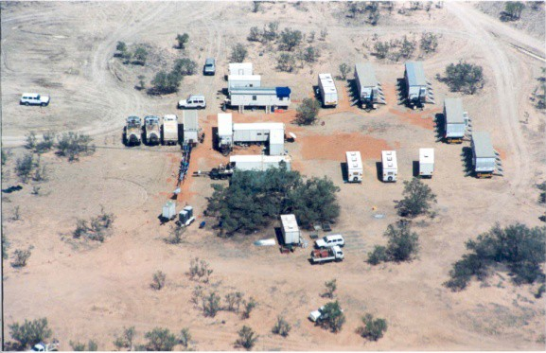

EP - 161 Environmental Plan

**Figure 5: Typical main camp**

A 2D project can require frequent camp moves but with tenure lasting only a few days. The main

camp can accommodate about 40 personnel and contain more than 20 trailers and approximately 36 vehicles. As the majority of these vehicles transit from camp to adjacent road and back at least once per day, and some several times, the routes from camp are clearly defined to restrict wheel track impact and impacts to adjacent areas.

Some camp sites may require multiple access routes to minimise the potential for bull dust to be

created. Vehicles are restricted to the perimeter of the camp and parking areas are also defined.

Wastewater from laundry, showers and kitchen is piped to an evaporation sump about 50 m outside

the camp. Wastepaper, cardboard and food scraps are disposed of to skips set up adjacent to the camp area. The skips are transported regularly for disposal of waste to a licensed landfill.

Recyclable materials are segregated on camp and regularly transported to an approved waste depot facility in Katherine or Darwin. Punctured or ruined tyres will be returned to Katherine or Darwin for repair, recycling or disposal.

Sewage management practices at all camp sites consist of the use of port-a-loos and grey water

capture and disposal to grade with the aim of minimising any risks to human health or the environment.

Potential spill containment practices as approved under the Santos EHSMS are to contain fuel drums

within portable bunding. The storage of fuel at camp sites is contained within tankers utilising safety features such as double-skins, safety cut-off valves, top accessing or transportable bunding etc. to minimise or eliminate the potential for spills. Drip trays are provided to contain minor drips and

spills which may occur during re-fuelling operations. Any uncontained spillage is chemically treated

and the ground ripped.

Once the camp site has been vacated, rehabilitation is undertaken, including ensuring no rubbish or

any man made items are left in situ and, when necessary and terrain permitting, the area is tyne ripped to relieve compaction and wheel tracks and ruts. Shoulders of adjacent formed tracks are reinstated and the area left to rehabilitate.

ENV- EP161- STO- 0002 Rev0

Uncontrolled when printed

10

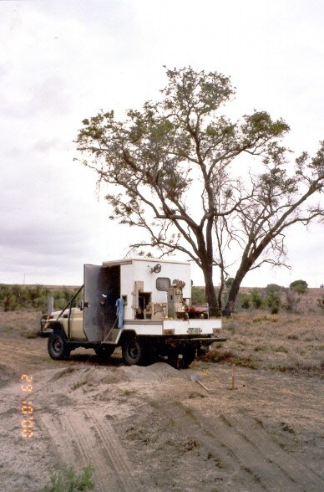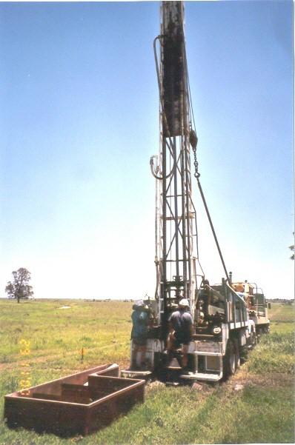

EP - 161 Environmental Plan

**2.4**

**Up hole drilling and logging activities**

This component of seismic surveys consists of truck mounted up hole drilling rig(s) and logging

vehicle(s), plus support water tanker trucks when mud drilling (refer Figure 6). The support camp may house six trailers or more. The rig normally drills 4¾“ diameter holes that vary in depth from project to project. Most holes are in the 30 m to 90 m range. Holes are drilled using mud, air or water injection as required.

Distance between up holes can vary considerably depending on Santos’ requirements, but are

normally at 1 km to 5 km spacings along lines.

Immediately a hole is drilled the drill rig moves off and a logging vehicle moves in to record seismic

measurements in the hole. This involves the lowering of a probe (downhole geophone) to the bottom of the hole and triggering a heavy weight that drops from the back of the truck to produce an acoustic impulse. The time it takes this impulse to reach the probe is recorded on a set of electronic instruments housed in the logging vehicle (usually a 4WD light vehicle). This process is repeated as the probe is gradually moved up the hole. A picture is thus built up of successive travel times through the near surface layers that provide information on the thickness and velocity – vital information for correcting the vibroseis seismic data.

**Figure 6: Up hole drilling rig and LVL recording truck**

On completion of logging activities, the drill cuttings are returned to the hole and the hole is capped.

Surplus cuttings are then either spread to minimise visual impact or removed. In some areas, the colour of the cuttings is markedly different from the ground surface and spreading of cuttings exacerbates visual impact rather than minimising it. Removal of cuttings under these circumstances reduces this impact.

ENV- EP161- STO- 0002 Rev0

Uncontrolled when printed

11



EP - 161 Environmental Plan

**2.5**

**Seismic line / access track and camp site restoration**

The majority of seismic lines and access tracks and camp sites do not require restoration work as one

of the main objectives is to prepare and utilise them in a way that will facilitate rapid natural recovery. However, operational impacts that can require restoration include:

•

•

•

•

•

•

•

•

wheel ruts caused after wet periods

windrows not fully removed by grader rill kill

windrows that have been created at intersection of lines and public tracks compaction of top soil at camp sites

compaction of shoulders on public access tracks

heavily trafficked routes between camp sites and the nearest public access access tracks that have turned to bulldust due to extensive seismic traffic; and

watercourse channel infill and or natural flow restriction.

Normally a single dozer or grader is sufficient to carry out the restoration work. Methods used for

restoration include:

•

•

•

•

•

ripping of compacted areas with the bulldozer’s rear tynes

windrow material pushed onto line and levelled public road shoulders / verges reinstated

wheel rut material used to infill affected areas; and / or

affected water course channels and creek banks reinstated.

**2.6**

**Post survey monitoring and GAS auditing**

Assessments are undertaken prior, during and subsequent to geophysical operations to ensure that

activities have been conducted in accordance with those detailed in the EP and this Summary and all regulatory requirements. These assessments can be implemented in a number of ways. The following briefly describes the method utilised successfully by Santos during its operating history.

Prior to the commencement of any survey a number of environmental monitoring points (EMPs) are

selected to give a balanced representation of the various landforms and vegetation types encountered. The locations of the EMPs are positioned near roads or tracks or seismic lines to minimise any future access impacts upon the environment. They are also subject to ground conditions that cannot be easily accessed.

These points are coordinated and marked with star droppers prior to the start of line preparation.

Photographs are taken at these locations along the proposed line direction to give a view of the terrain prior to line-preparation. All photographs are optimally taken with a 50 mm lens or equivalent digital setting, for consistent comparison. The process is repeated after line preparation and again after recording. These EMPs are then photo monitored over the ensuing four-year period (minimum) to give a visual representation of the recovery process. The revisit intervals are generally one year, two years and four years although the return period is determined by weather / road conditions and current activity in the region.

ENV- EP161- STO- 0002 Rev0

Uncontrolled when printed

12



EP - 161 Environmental Plan

**2.7**

**Timeframes**

Subject to obtaining all necessary approvals and consents, Santos is anticipating commencing line

preparation activities from mid July 2013 onwards and expects to start recording operations approximately 2-3 weeks after line preparation activities have begun. Recording operations are planned to take approximately 8 to 10 weeks with all operations, including any rehabilitation works completed by the end of October 2013.

On-ground conditions, wet weather, seismic crew availability and delays in obtaining all required

approvals and consents may delay the commencement date and / or extend the duration of the survey.

**3**

**Environment Description**

**3.1**

**Physical Environment**

**3.1.1**

**Climate**

The region of EP-161 experiences a ‘Grassland’ climate (based on the Köppen classification system)

which consists of two distinct seasons: the wet season which lasts from December to March; and the generally dry conditions which last for the remainder of the year (winter drought).

Mean maximum temperature ranges from 29.7°C in June to 38.6°C in November and historically the

highest temperatures recorded have been in November. The mean minimum temperature ranges from 12.2°C in July to 24.9°C in December-January. Coolest temperatures occur in June-July.

The majority of rainfall occurs in the summer wet season months between December and March

with a mean annual rainfall of 796 mm. Significantly lower rainfall and drought like conditions occur between May and September. Cyclones, thunderstorms and monsoonal rainfall are typical and lead to highly variable stream flows in catchments located within the region.

Average annual Class A pan evaporation is about 2400 mm for the region, with evaporation

exceeding rainfall even in the wettest months of the year.

**3.1.2**

**Geology**

The survey area overlays the McArthur Basin which covers an area of approximately 180,000 km2

and comprises a mixed carbonate-silicilastic succession with minor volcanic units near the base. Rock types include quartzose sandstone, mudstone, dolostone and minor mafic and felsic volcanic rocks. Depositional environments range from fluvial and lacustrine to shallow marginal marine in an overall intracratonic setting. Overall the region to the west is flat to gently undulating with little

local relief while the region to the east towards the gulf coast includes dissected sandstone plateaux.

**3.1.3**

**Soils**

Soils in the region of the survey are dominated by tenosols, kandosols and vertosols with rudosols

associated with rugged rock terrain.

ENV- EP161- STO- 0002 Rev0

Uncontrolled when printed

13



EP - 161 Environmental Plan

Tenosols are weakly developed or sandy soils, commonly shallow (slightly more developed than

Rudosols), although they can include the deep sand dunes of beach ridges, granitic soils and sand dunes of deserts. Tenosol soils show some degree of soil profile organisation (minor colour or soil texture changes in subsoil). Rudosols are very shallow soils or those with minimal soil development and includes very shallow rocky and gravely soils across rugged terrain. Kandosols are massive and earthy soils (formerly red, yellow and brown earths) that are widespread across the Sturt plateau regions. Vertosols are cracking clay soils which may or may not be poorly drained.

**3.1.4**

**Land systems**

The southern part of the survey area is dominated by the lateritic plains and rises of the Beetaloo

and Cresswell land systems. The northern and central parts of the survey area contain a range of land systems including large areas of lateritic plains and rises (Horse Creek, Inacumba, Jumpup land systems) and alluvial floodplains (Frog, Coolibah, McArthur land systems), with minor areas of steep and rugged sandstone plateaux and hills (Bukalara, Lancewood land systems).

**3.1.5**

**Hydrology**

The majority of the catchments within the survey area drain north-easterly towards the Gulf of

Carpentaria. Major rivers within the survey area include the Limmen Bight River, October Creek and Cox River (which lie to the north of the proposed seismic survey area). The highest flows for these rivers occur during the wet season, predominantly due to cyclones and monsoonal rainfall. In contrast to these larger rivers, smaller streams and drainage lines such as the Lansen, Inacumba, Tanumbirini and Lagoon Creeks are largely ephemeral and usually run dry during the dry season. There is also a range of small wetlands associated with sinkholes and minor depressions in the generally flat landscape.

**3.2**

**Biological Environment**

**3.2.1**

**Bioregions**

EP-161 overlies the Sturt Plateau and the Gulf Falls and Uplands bioregions.

The Sturt Plateau bioregion dominates most of the southern part of EP-161, south of the Carpentaria

Highway. It mostly comprises a gently undulating plain on lateritised Cretaceous sandstones. Soils are predominantly neutral sandy red and yellow earths. The most extensive vegetation is eucalypt woodland (dominated by Variable-barked Bloodwood *Corymbia dichromophloia*) with spinifex understorey, but there are also large areas of Lancewood (*Acacia shirleyi*) thickets, Bullwaddy (*Macropteranthes keckwickii*) woodlands, Acacia shrublands on deep sands, and eucalypt open forests (dominated by a range of species including Darwin Stringybark *Eucalyptus tetrodonta*) over tussock grass understorey. The Sturt Plateau bioregion includes the most extensive areas of the distinctive lancewood-bullwaddy vegetation associations, with associated fauna including the Spectacled Hare-wallaby.

The Gulf Falls and Uplands bioregion occurs in the northern half of EP-161, north of the Carpentaria

Highway, and on the southern boundary of the EP. It comprises undulating terrain with scattered low, steep hills on Proterozoic and Palaeozoic sedimentary rocks, often overlain by lateritised Tertiary material. Soils are mostly skeletal or shallow sands.

ENV- EP161- STO- 0002 Rev0

Uncontrolled when printed

14



EP - 161 Environmental Plan

The most extensive vegetation is woodland dominated by Darwin Stringybark *Eucalyptus tetrodonta*

and Variable-barked Bloodwood *C. dichromophloia* with spinifex understorey, and woodland dominated by Northern Box *Eucalyptus tectifica* with tussock grass understorey.

**3.2.2**

**Flora**

Vegetation types within EP-161 include woodland, open woodland, open forest, tussock grassland

and hummock grasslands.

The dominant species within the vegetation communities present include Darwin Stringybark

*Eucalyptus tetrodonta* and Variable-barked Bloodwood *C. dichromophloia* with spinifex understorey, and woodland dominated by Kullingal *Eucalyptus pruinosa* or *Melaleuca* spp. with tussock grass understorey. There are also large areas of Lancewood (*Acacia shirleyi*) thickets, Bullwaddy (*Macropteranthes keckwickii*) woodlands and Acacia shrublands on deep sands.

**3.2.3**

**Fauna**

The region supports a diverse range of fauna. Over 435 vertebrate species have been recorded from

the Gulf Falls and Uplands bioregion, including 24 species that are rare or threatened. Ten species in this bioregion are listed as threatened at a Territory or national level. The Sturt Plateau bioregion is known to support over 350 vertebrate species, including six species listed as threatened at a Territory or national level.

The sandstone ranges and stony hills of the region support a number of endemic species, while the

major river systems are important environments for many species because of the much lower annual rainfall than the more northern savannas, and the very high summer temperatures.

The region’s eucalypt woodlands support a relatively diverse range of birds, with nectarivorous

species such as honeyeaters, friarbirds and lorikeets extremely abundant when the dominant trees flower. The diversity and abundance of small mammal species in the region’s woodlands are low compared with higher rainfall woodland to the north, possibly because of limited availability of daytime refuges among small trees.

**3.2.4**

**Socio-economic environment**

The survey area overlays two Local Government Areas - Barkly Shire to the south and Roper Gulf to

the north. The two shire areas cover an area of more than 500, 000 km2 with a population of approximately 13,650. The shires include numerous Aboriginal land trusts, pastoral properties and outstations, and towns and communities of varying sizes.

The closest towns to the survey area include Borroloola (approximately 100 km to the east) and Daly

Waters (approximately 120 km to the west). The closest significant population centre is Katherine located approximately 350 km to the north-west.

The local area remains generally undeveloped in terms of infrastructure and roads. Major

infrastructure within EP-161 includes the Carpentaria Highway and the Daly Waters to McArthur River gas pipeline, both of which run approximately parallel with one another east-west through the southern half of the tenement. The McArthur River Mine is located approximately 85 km east of the seismic survey area.

ENV- EP161- STO- 0002 Rev0

Uncontrolled when printed

15



EP - 161 Environmental Plan

**3.3**

**Environmental and Cultural Sensitivities**

**3.3.1**

**Sacred and cultural heritage site protection**

Agreements and processes are in place to ensure that all sites of sacred or cultural heritage

significance are identified, recorded and avoided during the course of the EP-161 2D seismic survey. The Northern Land Council (NLC) has been engaged and in turn has commissioned an independent anthropological assessment and report on any cultural and sacred sites and values of the area that will be subjected to the seismic survey. Following consultation with the Traditional Owners and completion of ground and aerial reconnaissance, the anthropologists report will be provided to the NLC for consideration and to determine the extent and nature of any conditions which may be imposed on the survey. No on ground activity will commence until all required approvals, consents and any associated conditions have been obtained from the NLC and the seismic crew has been fully inducted and is aware of all operational requirements and their specific responsibilities. Santos has also submitted an application to the Aboriginal Areas Protection Authority for Clearance Certificates for the survey area. This application has been submitted in accordance with the requirements of the *Aboriginal Sacred Sites Act 2004* (NT) and to ensure that all sites of sacred significance are identified and avoided.

There are no areas or sites within EP-161 on the National Heritage List or the NT Heritage Register.

**3.3.2**

**Protected or conservation areas**

The Limmen National Park overlaps the northern section of EP-161 while a separate section of the

park lies to the east of and outside the EP-161 boundary. No seismic activities are proposed within either section of the National Park. The Bullwaddy Conservation Area is west of and outside the EP-

161 permit area. No sites identified as of conservation significance for biodiversity values in the

Northern Territory occur within EP-161.

**3.3.3**

**Threatened flora and fauna**

A search of online databases for flora and fauna species listed under the *Environment Protection and*

*Biodiversity Conservation Act 1999* (EPBC Act) and a review of Northern Territory flora and fauna databases were undertaken to identify nationally listed threatened flora or fauna that may occur or are likely to occur within EP-161. The search identified 13 Nationally Threatened species, 13 listed Migratory species, and 13 listed Marine species. The search did not identify any Threatened Ecological Communities in the area. No records of plant species with high Territory or national conservation significance occur within the proposed survey area.

Due to the small nature and scale of the disturbance footprint associated with the proposed seismic

activities, no threatened species or species habitat are considered likely to be significantly impacted by the proposed activities.

**3.3.4**

**Significant habitat**

No sites of conservation significance for biodiversity values have been formally identified within the

project area. Habitats of particular significance in the region include riparian and wetland systems, particularly deep gorges with deep permanent water (which provide important refuges), and sandstone ridges, stony hills and rocky ranges, which have also been identified as a significant

ENV- EP161- STO- 0002 Rev0

Uncontrolled when printed

16



EP - 161 Environmental Plan

biological refuge. Large trees with hollows provide important habitat for a range of species, including

a number of threatened species.

**3.3.5**

**Fire regime**

Fire management or controlled burns within the region are a common occurrence. Controlled burns

are undertaken to reduce the possibility of uncontrolled fires and to assist in land management (e.g. local Indigenous people in traditional hunting activities). The peak fire season for the region is during the dry season when lower rainfall increases the amount of dry vegetation available to fuel potential bushfires. Periods of increased temperature and reduced rainfall and humidity due to climatic cycles such as El Niño can exacerbate these conditions.

**3.3.6**

**Pest plant and animal control**

Pest plant and animal control is considered to be a significant land management issue in the

Northern Territory. Seventeen Weeds of National Significance (WoNS) have been identified within the Northern Territory and 38 Territory declared weeds may occur within the survey area.

Weed distribution is more often related to environmental disturbances caused by the construction

of roads and tracks, cattle grazing and feral animals. Weeds are most prevalent on land under pastoral lease with infestations generally concentrated around infrastructure such as water points, fence lines and tracks, and also along the banks of watercourses where cattle and feral animals tend to congregate.

Pest animals include rabbits, feral cats, brumbies, pigs, donkey and camels.

**4**

**Environmental Risk Identification**

Environmental risk assessment refers to a process where hazards associated with an activity are

assessed for their impact on the environment (physical, biological, and socio-economic) at a defined location and specified period of time. The *Petroleum Act 2011 (NT), Schedule of Onshore Petroleum Exploration and Production Requirements, 2012 and Environmental Plan (EP) Requirements Guideline* require that the environmental impacts and risks must be included in an EP and evaluated. This section describes the process by which Santos conducts such an assessment and its application in

this Environmental Plan.

**4.1**

**Management of Hazard Identification and Risk Assessment**

Santos EHS Management Standard 09 Hazard Identification, Risk Assessment and Control describes

the Santos standard and process with respect to risk assessment for all Santos activities. The methodology described in EHSMS09 is based upon the risk management process described in AS/NZ ISO 31000, and is depicted in Figure 7. This approach aligns with the EP process as required by the *Environmental Plan (EP) Requirements Guideline.*

ENV- EP161- STO- 0002 Rev0

Uncontrolled when printed

17

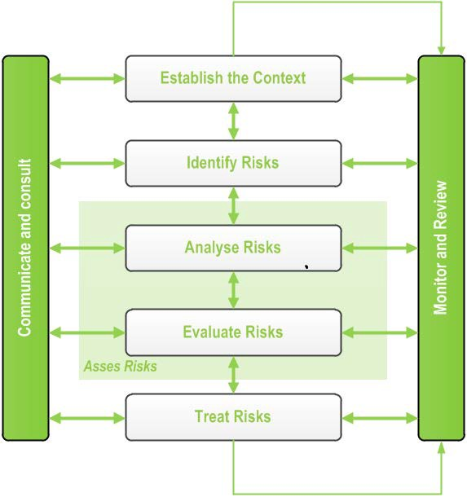

EP - 161 Environmental Plan

**Figure 7: Risk assessment process**

**ALARP demonstration**

**4.2**

The iterative process is continued until such time that any further reduction in the residual risk

ranking is not reasonably practicable to implement. At this point the risk is said to have been reduced to as low as reasonably practicable (ALARP). The ALARP principle states that it must be possible to demonstrate that the cost involved in reducing the risk further would be grossly disproportionate to the benefit gained. The ALARP principle arises from the fact that infinite time, effort and money could be spent attempting to reduce a risk to zero. The risk treatments that were considered to be reasonably practicable have or will be implemented during the course of the seismic survey.

**5**

**Environmental Hazards, Consequences and Risk Assessment**

Table 2 details the Santos environmental risk assessment matrix for likelihood and consequences of

environmental risks that may occur during the seismic survey, while the severity of consequence is dependent on the receiving environment.

**Table 2: Santos risk matrix**

ENV- EP161- STO- 0002 Rev0

Uncontrolled when printed

18

**Consequence**

**Negligible**

**Minor**

**Moderate**

**Major**

**Critical**

**I**

**II**

**III**

**IV**

**V**

**Likelihood**

**Almost Certain**

**A**

2

3

4

5

5

**Likely**

**B**

1

3

3

4

5

**Possible**

**C**

1

2

3

3

4

**Unlikely**

**D**

1

1

2

2

3

**Remote**

**E**

1

1

1

1

2



EP - 161 Environmental Plan

Table 3 summarises the environmental risk assessment for the 2D seismic survey proposed to be

undertaken in EP-161. The consequence and likelihood of a specific hazard are combined to produce a level of risk for any given hazard.

**Table 3: Summary of residual risk levels for seismic operations**

ENV- EP161- STO- 0002 Rev0

Uncontrolled when printed

19

**Activity**

**Hazard**

**Potential Consequence**

**Severity**

**Likelihood**

**Residual**

**Risk**

Line and access track preparation

*Earthworks*

Loss of native vegetation and habitat

Negligible

Possible

1

Soil erosion and disturbance to natural drainage patterns

Minor

Unlikely

1

Noise generation, airborne dust

Negligible

Possible

1

Disturbance to native fauna

Minor

Unlikely

1

Disturbance to stock

Minor

Unlikely

1

Introduction and spread of weeds

Moderate

Unlikely

2

Visual impact

Minor

Possible

2

Damage to landholder infrastructure

Minor

Unlikely

1

Damage to petroleum infrastructure

Minor

Remote

1

Impact and / or damage to significant

Aboriginal sites

Major

Possible

3

Third party access resulting in third parties getting lost

Minor

Unlikely

1

Fire destruction of vegetation and habitat

Minor

Possible

2

*Vehicle movements*

Introduction and spread of weeds

Moderate

Unlikely

2

Damage to landholder infrastructure

Minor

Unlikely

1

Disturbance to stock

Minor

Unlikely

1

Damage to petroleum infrastructure

Minor

Remote

1

Airborne dust

Negligible

Likely

1

Fire destruction of vegetation and habitat

Minor

Possible

2

*Spills and leaks*

Contamination of soil, groundwater, water courses

Minor

Unlikely

1

Line surveying

*Vehicle movements*

Introduction and spread of weeds etc.

Moderate

Unlikely

2

Damage to landholder infrastructure

Minor

Unlikely

1

Damage to petroleum infrastructure

Minor

Unlikely

1

Impact and / or damage to significant

Aboriginal sites

Major

Possible

3

Airborne dust

Negligible

Likely

1

Recording

*Vehicle movements*

Introduction and spread of weeds

Moderate

Unlikely

2

Damage to landholder infrastructure

Minor

Unlikely

1

Damage to petroleum infrastructure

Minor

Remote

1



EP - 161 Environmental Plan

ENV- EP161- STO- 0002 Rev0

Uncontrolled when printed

20

**Activity**

**Hazard**

**Potential Consequence**

**Severity**

**Likelihood**

**Residual**

**Risk**

Wheel tracks and ruts, bulldust generation, airborne dust

Minor

Likely

1

Visual impact

Minor

Possible

2

Impact and / or damage to significant

Aboriginal sites

Major

Unlikely

2

Fire destruction of vegetation and habitat

Minor

Possible

2

*Vibrator operations*

Soil compaction, wheel tracks and ruts, noise generation, airborne dust

Minor

Likely

3

Disturbance to native fauna

Minor

Likely

3

Disturbance to stock

Negligible

Unlikely

1

Introduction and spread of weeds etc.

Moderate

Unlikely

2

Damage to landholder infrastructure

Minor

Unlikely

1

Damage to petroleum infrastructure

Minor

Remote

1

Impact and / or damage to significant

Aboriginal sites

Major

Unlikely

2

*Spills and leaks*

Contamination of soil, groundwater, water courses

Minor

Unlikely

1

Loss of organic beef certification

Major

Remote

1

Camp sites and associated supply logistics

*Vehicle movements*

Wheel tracks and ruts, bulldust generation, soil compaction, noise generation, airborne dust, visual impact

Minor

Likely

1

*Impact upon vegetation and habitat*

Loss of vegetation, damage to tree root structures

Minor

Unlikely

1

Fire destruction of vegetation and habitat

Minor

Possible

2

*Spills and leaks*

Contamination of soil, groundwater, water courses

Minor

Unlikely

1

Loss of organic beef certification

Major

Remote

1

*Disposal of domestic and chemical waste*

Contamination of soil, groundwater, water courses

Minor

Unlikely

1

Loss of organic beef certification

Major

Remote

1

Impact and / or damage to significant

Aboriginal sites

Major

Unlikely

2

Up hole drilling and logging

*Disposal of chemical waste*

Contamination of soil, groundwater, water courses

Minor

Unlikely

1

Loss of organic beef certification

Major

Remote

1

*Spills and leaks*

Contamination of soil, groundwater, water courses

Minor

Unlikely

1

Loss of organic beef certification

Major

Unlikely

2



EP - 161 Environmental Plan

ENV- EP161- STO- 0002 Rev0

Uncontrolled when printed

21

**Activity**

**Hazard**

**Potential Consequence**

**Severity**

**Likelihood**

**Residual**

**Risk**

*Up hole drilling activity*

Contamination of soil, groundwater, water courses

Minor

Unlikely

1

Uncontrolled discharge of artesian aquifer

Moderate

Unlikely

2

Injury to / loss of native fauna

Minor

Unlikely

1

Injury to / loss of stock

Negligible

Unlikely

1

Visual impact, noise generation, airborne dust

Negligible

Likely

1

Impact and / or damage to significant

Aboriginal sites

Major

Unlikely

2

*Vehicle movements*

Introduction and spread of weeds

Moderate

Unlikely

2

Damage to landholder infrastructure

Minor

Unlikely

1

Damage to petroleum infrastructure

Minor

Unlikely

1

Wheel tracks and ruts, bulldust generation, airborne dust

Minor

Likely

3

Impact and / or damage to significant

Aboriginal sites

Major

Unlikely

2

Line and access track restoration

*Earthworks*

Noise generation

Negligible

Possible

1

Disturbance to native fauna

Minor

Unlikely

1

Disturbance to stock

Negligible

Unlikely

1

Introduction and spread of weeds

Moderate

Unlikely

2

Damage to landholder infrastructure

Minor

Unlikely

1

Damage to petroleum infrastructure

Minor

Remote

1

Impact and / or damage to significant

Aboriginal sites

Major

Possible

3

*Vehicle movements*

Introduction and spread of weeds

Moderate

Possible

3

Damage to landholder infrastructure

Minor

Unlikely

1

Damage to petroleum infrastructure

Minor

Remote

1

Impact and / or damage to significant

Aboriginal sites

Major

Possible

3

Airborne dust

Negligible

Likely

1

*Spills and leaks*

Contamination of soil, groundwater, water courses

Minor

Unlikely

1

Loss of organic beef certification

Major

Unlikely

2

Monitoring / Auditing

*Vehicle movements*

Damage to landholder infrastructure

Minor

Unlikely

1

Damage to petroleum infrastructure

Minor

Unlikely

1

Impact and / or damage to significant

Aboriginal sites

Major

Unlikely

2



EP - 161 Environmental Plan

**6**

**Environmental Performance Objectives**

Santos’ environmental objectives for the 2D seismic survey proposed to be undertaken in EP-161 are

to:

•

•

•

•

•

•

minimise the visual impact of operations.

minimise disturbance to soil resources.

minimise disturbance to native vegetation and native fauna. avoid disturbance to sites of cultural and heritage significance.

minimise disturbance to livestock, pastoral infrastructure and landholders.

avoid the introduction or spread of exotic species and implement control measures as necessary.

not generate any fires.

minimise disturbance to drainage patterns and avoid contamination of surface waters and shallow groundwater resources.

optimise (in order of most to least preferable) waste avoidance, reduction, reuse, recycling, treatment and disposal.

rehabilitate operational areas as necessary.

•

•

•

•

Each objective identified above will be assessed to enable Santos, regulatory agencies and

stakeholders to determine the level of achievement of the objectives. The criteria for measuring the achievement of the environmental objectives will include one of more of the following methodologies:

•

ensuring defined conditions are met or acted upon. These could include prohibitions on the

undertaking of specific actions, or requirements to carry out certain actions in accordance with approved procedures or industry standards.

Goal Attainment Scaling (GAS) to measure the degree to which objectives are achieved;

longer-term data and information gathering and scientific studies;

photo monitoring.

•

•

•

Santos will establish and enhance relationships with the Northern Territory community and

stakeholders as well as adhere to the principles of ecologically sustainable development (ESD). Adherence to the principles of ESD will ensure the avoidance of long term significant adverse impact(s) on biological diversity, cultural components of the environment, groundwater and other land uses.

**7**

**Implementation Strategy**

**7.1**

**Project Management Systems**

Management systems will be a key tool in the management of Santos’ environmental

responsibilities, issues and risks associated with the proposed 2D seismic survey in EP-161. Management systems provide a framework for the coordinated and consistent management of environmental issues by ensuring the:

•

establishment of the Company’s Environmental Policy;

ENV- EP161- STO- 0002 Rev0

Uncontrolled when printed

22



EP - 161 Environmental Plan

•

identification of environmental risks and legal and other requirements relevant to seismic

and other exploration, development and production operations;

setting of appropriate environmental objectives and targets;

establishment of a structure and program to implement the Environmental Policy and achieve objectives and targets including the development of procedures and guidelines for specific activities and education and induction programs; and

facilitation of planning, control monitoring, corrective action, auditing and review of

activities to ensure that the requirements and aspirations of the Santos Environmental Policy are achieved.

•

•

•

The Santos Environmental Health and Safety Management System (EHSMS) applies to all Santos

operations within Australia. The framework has been developed to ensure compliance with Australian Standard 4801:2001 *Occupational Health and Safety Management Systems - Specification with guidance for use*, and AS/NZS ISO 14001:2004 *Environmental Management Systems - Specification with guidance for use*.

Santos’ seismic survey should achieve or establish accepted best practice and industry-accepted

standards. Ongoing audits of systems should be regularly conducted using a risk-based approach to ensure that systems are maintained and operations are undertaken in accordance with industry- accepted practices and regulatory requirements.

**7.2**

**Current operating procedures used to minimise impacts**

In order to mitigate the risks and potential impacts of activities undertaken during the conduct of

this seismic survey and to achieve the objectives of the EP, the following recommended procedures will be implemented.

**7.2.1 Terrain**

**7.2.1.1 Wheel tracks**

•

•

Where possible, existing tracks, roads or seismic lines will be used for access.

Off line driving for the main crew is prohibited – no bush bashing or short cuts are permitted.

Camp sites are positioned close to existing roads where possible.

•

**7.2.1.2 Wheel ruts**

•

Operations are shut down during wet weather or flooding and only restarted once potential

for extensive damage has passed. Unavoidable damage is reported and reinstated on completion of work.

**7.2.1.3 Compaction**

•

•

Following in off-line wheel tracks is banned.

Unavoidable compaction is reported and, in areas other than those susceptible to erosion, will be ripped on completion of work.

The number of camp sites will be minimised with the aim being to share existing sites wherever reasonably practicable.

•

ENV- EP161- STO- 0002 Rev0

Uncontrolled when printed

23



EP - 161 Environmental Plan

•

Camp site areas are ripped, if necessary, on completion of work.

**7.2.1.4 Erosion**

•

•

•

•

Blade work is banned on naturally smooth surfaces or flat easy terrain.

Minimal blade work is permitted elsewhere.

All windrows are removed either during or on completion of work.

Creek bank vegetation is left intact and detours sought if too dense to pass through.

**7.2.1.5 Bulldust**

•

Susceptible tracks are avoided. If not possible then tracks will be watered and is reinstated

after use.

**7.2.1.6 Visual amenity**

•

•

Lines are prepared to a single blade width only (approximately 4m to 5m).

Lines are weaved at least every 75m to 100m about the general line of traverse and stands of vegetation.

Lines are doglegged at road and track crossings preferably around vegetation.

Dozers are walked with blade up wherever possible.

•

•

**7.2.1.7 Natural drainage**

•

•

•

Creek bank vegetation is left intact and detours sought if too dense to pass through.

Creek crossings are boxed and filled to original bed level when hard fill required.

Any windrows or other disturbance to drainage patterns are removed from creek bed crossings.

Camps should not be established near major watercourses, creeks or surface water bodies. No camp site shall be located within one km of any stock watering place.

All windrows are removed either during or on completion of work.

•

•

•

**7.2.2**

**Native vegetation**

•

•

Off line driving is banned – no bush bashing or short cuts are permitted.

Vegetation is removed only when absolutely necessary - avoided by weaving lines through vegetated areas.

Root stock, topsoil and seeds are left on line during line preparation. Creek bank vegetation is left intact and detours located if dense.

All vehicles are thoroughly cleaned to prevent the introduction of weeds into the survey area.

•

•

•

**7.2.3**

**Native fauna / habitat**

•

•

•

•

Up holes are capped and backfilled to prevent injury or death to wildlife.

No heavy line preparation machinery is used in wetlands areas. Natural drainage channels are left clear at line crossings.

Creek bank vegetation is left intact and detours located if dense.

ENV- EP161- STO- 0002 Rev0

Uncontrolled when printed

24



EP - 161 Environmental Plan

•

All vehicles are thoroughly cleaned to prevent the introduction of weeds into the survey

area.

**7.2.4**

**Pollution**

•

•

•

•

•

•

•

Fuel and oil spills are reported, chemically treated or bio-remediated and the ground ripped.

Camp wastewater is disposed of by drainage channels and seepage pits.

Rubbish is burnt or otherwise transported to recognised waste management depots. Mobile chemical toilets are used on all camps.

Zero tolerance rule with regard to markers and litter left in work area after completion.

Drill cuttings are returned to hole or removed for dump disposal. Vehicles travel at slow speed in the vicinity of homesteads.

**7.2.5**

**Landholder infrastructure**

•

Lines are planned in the office or deviated in the field to avoid homesteads, associated

buildings, stockyards, airstrips, dams, bores and tanks. Gates are left as found.

Fences are not laid down unless specific permission has been given by landholder. Water is drawn only from authorised sources.

No camp is set up within 1 km of a stock watering point.

Work is scheduled to fit in with stock locations and the mustering schedule. Waste management policies are enforced.

•

•

•

•

•

•

**7.2.6**

**Petroleum infrastructure**

•

•

•

•

•

Below ground pipelines are only crossed at existing or authorised crossing points.

Above ground pipelines are detoured rather than ramped.

No seismic energy source is used within 30 m of pipelines or wellheads. Lines are deviated to miss wellheads by 30 m.

Other production plant is avoided and proposed activities discussed with plant operator.

**7.2.7**

**Third party access**

•

•

•

•

No line preparation is carried out on dunes adjacent to public roads.

Lines are doglegged at road and track crossings preferably around vegetation. Windrows / shoulders on public tracks are reinstated on completion of work.

Lines adjacent to public roads may also be blocked with timber as an access deterrent.

**7.2.8**

**Sacred and cultural heritage sites**

•

Lines are cleared by appropriate representatives prior to commencement of line

preparation.

Sites of sacred or cultural significance are flagged and lines deviated around them.

All line preparation personnel and crew supervisors receive cultural heritage training prior to work.

•

•

ENV- EP161- STO- 0002 Rev0

Uncontrolled when printed

25



EP - 161 Environmental Plan

**7.3**

**Chain of Command**

The Manager, Operations Geophysics (Santos) and Senior Seismic Operations Manager (Terrex

Seismic) are jointly responsible for implementation of the EP. Their responsibilities include:

•

•

•

•

•

•

•

•

conformance with the Santos EHSMS

ensuring all required permits and approvals are in place and complied with management of non-compliances and non-conformances

inductions of new staff monitoring and reporting

incident management and reporting internal and external audits

ensuring contractor competencies.

**7.4**

**Induction and Training**

In accordance with *EHSMS 06 - Training and Competency*, all Santos personnel, contractors and

visitors are required to undertake appropriate environmental training and induction programs.

Personnel undergo the following levels of training:

•

•

•

Level 1 – Santos generic induction

Level 2 – Site induction

Level 3 – Activity specific induction (where applicable).

**7.5**

**Monitoring**

The Santos Management Standard *EHSMS 14: Monitoring, Measurement and Reporting* requires

that environmental monitoring, measuring and reporting be considered and where appropriate implemented. Ongoing monitoring and auditing of geophysical operations is necessary to determine whether significant environmental risks are being managed, minimised and where reasonably possible, eliminated.

Monitoring programs are designed to assess:

•

•

•

•

•

compliance with regulatory requirements

visual impact of the operations

impact upon flora and fauna and general biodiversity site contamination

site revegetation following program completion and any restoration activity potential future

problems; and

spot checks, daily meetings, regular inspections.

•

Monitoring records maintained through the project will include:

•

•

•

•

•

induction records

waste records

records of emissions and discharges (i.e. sewage)

hazardous goods storage, handling and disposal records non-compliance and corrective actions records

ENV- EP161- STO- 0002 Rev0

Uncontrolled when printed

26



EP - 161 Environmental Plan

•

•

•

internal audit reports

inspection records; and equipment maintenance records.

**7.6**

**Audits**

The EHSMS is comprised of a number of Management Standards and Hazard Standards. (The

auditing and assessment requirements are detailed in *EHSMS 16 - Management System Audit and Assessment Auditor Guide*. Each EHSMS standard contains an auditor guide used to determine the level of implementation of and compliance with the standard.

Assessments of geophysical operations against requirements of the EHSMS are performed annually.

Results of these assessments form the basis for targeted improvement initiatives.

Santos internal audits prior to or during the geophysical survey, random DME audits of both field

and office operations, and third party audits commissioned by DME, Santos or an independent party may also be undertaken.

**7.7**

**Management of Non-conformance**

The Santos Management Standard *EHSMS 15 - Incident and Non-Conformance Investigation,*

*Corrective and Preventative Action* requires that all incidents, hazards, near misses, property

damage, significant process incidents, non-conformance events and third party complaints, including those related to environmental issues, are managed using the Santos Incident Management System (IMS).

The IMS is used to record, track and close out incidents and non-conformances. The system also

provides a mechanism to analyse the collated data and identify areas requiring improvement. For each recorded incident, IMS records the date, location, volume, substance, root cause, event descriptions, reporting to regulatory bodies, and any remedial action taken.

Incident and non-conformance data are summarised weekly with management review against

performance Objectives and Targets. Incidents and investigation findings are reviewed at regular site EHS communication meetings.

All incidents must be reported in accordance with the requirements of the NT *Petroleum Act 2011*

and the *Schedule for Onshore Petroleum Requirements 2012*.

**7.8**

**Emergency Response Plan**

In the course of normal operations, there is always the potential for environmental incidents and

accidents to occur. It is therefore important that Santos has developed emergency response plans to guide actions to be taken to minimise the impacts of accidents and incidents. Emergency response drills should be undertaken at least annually to ensure that personnel are familiar with the plans and the types of emergencies to which it applies and that there will be a rapid and effective response in the event of a real emergency occurring. Emergency response plans must be reviewed and updated on a regular basis to incorporate new information arising from any incidents, near misses and hazards and emergency response simulation training sessions. These plans would also include the facilitation of Fire Danger Season restrictions and requirements.

ENV- EP161- STO- 0002 Rev0

Uncontrolled when printed

27



EP - 161 Environmental Plan

**8**

**Reporting**

Santos will implement internal and external reporting procedures to ensure that environmental

issues and / or incidents are appropriately responded to, reported and actions tracked and closed out. Reporting will include:

•

•

•

•

•

•

•

•

the status of various activities associated with the survey

site EHS inductions and meetings monthly summaries of any incidents

number, severity and close out status of incidents

progress against key performance indicators audit schedule and findings

external meetings and / or liaison with key stakeholders ; and

notification of any EHS incidents to the appropriate government agency as required.

**9**

**Consultation**

The Santos Management Standard *EHSMS 07: Consultation and Communication* details the

requirements for appropriate communication and consultation mechanisms. The standard includes requirements to establish and maintain communication links with employees, contractors and external stakeholders, including local communities, government agencies and other organisations.

Regular EHS workgroup meetings are held to communicate and discuss EHS issues. Regular

communications are also held with external stakeholders (including DME, NLC and pastoralists). To facilitate this, a Contact Directory has been established and maintained for the seismic operations.

Santos is committed to upholding its reputation as a trusted energy company. Santos seeks to

establish and maintain enduring and mutually beneficial relationships with the communities of which it is a part; ensuring that Santos’ activities generate positive economic and social benefits for and in partnership with these communities. The following table lists the stakeholders consulted in relation to the EP161 2D seismic survey

**Table 4: Table of stakeholder consultation**

ENV- EP161- STO- 0002 Rev0

Uncontrolled when printed

28

**Relevant Stakeholders**

**Stakeholder Consulted**

State Government departments

• Chief Minister

• Department of Chief Minister

• Minister for Mines and Energy

• Department of Mines and Energy

• Department of Transport

Representatives of Native Title Claimants

• Northern Land Council

• Aboriginal Areas Protection Authority

Representatives of local government

• Barkly Shire Council

• Roper Gulf Shire Council

• Elliott Community Board



EP - 161 Environmental Plan

Where stakeholders have requested or Santos believes it would be beneficial to engage with

stakeholders on an ongoing basis during the survey, communications will continue until the survey has concluded.

Full details of all stakeholders consulted, the method and date of the consultation(s), any matters

raised by the stakeholder and Santos’ response are provided in the Environmental Plan.

**10**

**Further Details**

In the event you have any queries or require further information on this 2D seismic survey proposed

to be undertaken in Exploration Permit -161, please contact:

Mike Giles

Manager, Operations Geophysics

Santos Ltd

Level 1, Santos Centre

60 Flinders Street, Adelaide, SA 5000

Phone (08) 8116 7952

[mike.giles@santos.com](mailto:mike.giles@santos.com)

ENV- EP161- STO- 0002 Rev0

Uncontrolled when printed

29

Landholders whose property will be entered during the course of the survey

▪ Beetaloo Station

▪ Tanumbirini Station

▪ Broadmere Station

▪ Northern Territory Cattlemen’s Association

Pipeline Authorities whose pipelines will be crossed during the course of the survey

▪ APA NT

Other petroleum, geothermal and / or mining tenement holders if the tenements are proposed to be crossed during the course of the survey

▪ Fertoz Limited

▪ Diamantina Uranium Pty Ltd

▪ Ao-Zhong International Mineral Resources Pty Ltd

▪ China Australia Land Resources Pty Ltd