Mineral Titles Act
NOTICE OF LAND CEASING TO BE A MINERAL TITLE AREA
Title Type and Number: | Exploration Licence 30468
Area Ceased on: | 24 April 2018
Area: | 18 Blocks, 57.90 km²
Locality: | OORADIDGEE
Name of Applicant(s)/Holder(s): | 50% ADDISON Stevan, 50% DUNNELL Kevin
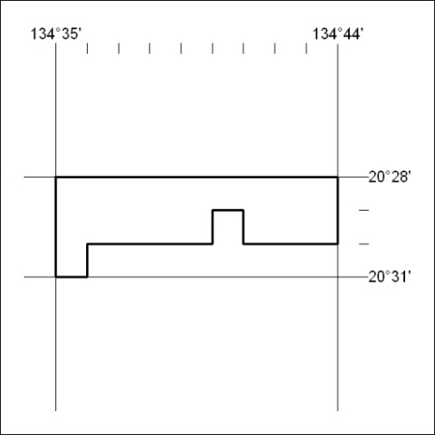

143/18

Mineral Titles Act
NOTICE OF LAND CEASING TO BE A MINERAL TITLE AREA
Title Type and Number: | Exploration Licence 30664
Area Ceased on: | 24 April 2018
Area: | 37 Blocks, 118.98 km²
Locality: | DAVENPORT RANGE
Name of Applicant(s)/Holder(s): | 50% ADDISON Stevan, 50% DUNNELL Kevin
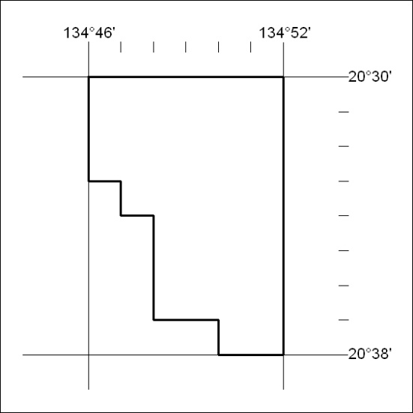

144/18

Mineral Titles Act
NOTICE OF LAND CEASING TO BE A MINERAL TITLE AREA
Title Type and Number: | Exploration Licence 31073
Area Ceased on: | 24 April 2018
Area: | 0 Blocks, 919.01 km²
Locality: | DAVENPORT RANGE
Name of Applicant(s)/Holder(s): | 50% DUNNELL Kevin, 50% SKELDON Alison
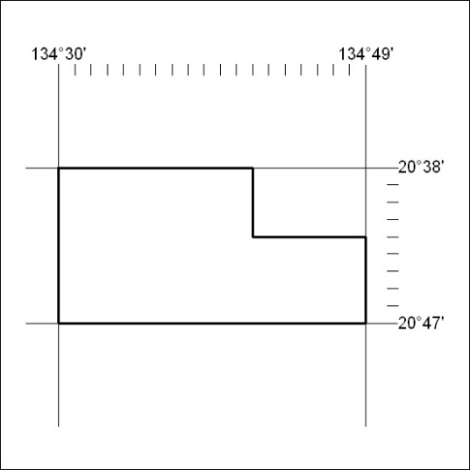

145/18

Corrigendum
Notice Number 142/18 appearing in MN49/18 on
23 April 2018 is hereby cancelled and replaced by the following:

Mineral Titles Act
NOTICE OF GRANT OF A MINERAL TITLE
Title Type and Number: | Exploration Licence 27266
Granted: | 19 April 2018, for a period of 6 Years
Area: | 164 Blocks, 516.09 km²
Locality: | LAKE CAROLINE
Name of Holder/s: | 100% RED METAL LIMITED [ACN. 103 367 684]
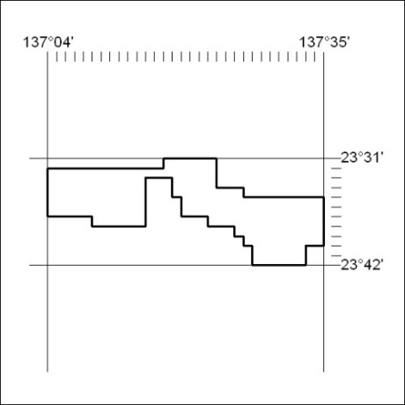
Area granted is indicated above. The titleholder is not permitted to exercise occupational rights on any land that is subject to a development title, or an application for a development title. Any land the subject of a Reserved Land gazettal under the Mineral Titles Act and all land vested in the Commonwealth of Australia is also excluded by description but not excised from the grant area.

146/18

