Mineral Titles Act
NOTICE OF LAND CEASING TO BE A MINERAL TITLE
Title Type and Number: | Extractive Mineral Permit 22676
Area ceased on: | 26 June 2018
Area: | 40.00 Hectare
Locality: | KOOLPINYAH
Name of Applicants(s)Holder(s): | 100% SAVEGUARD PTY LTD [ACN. 065 514 203]
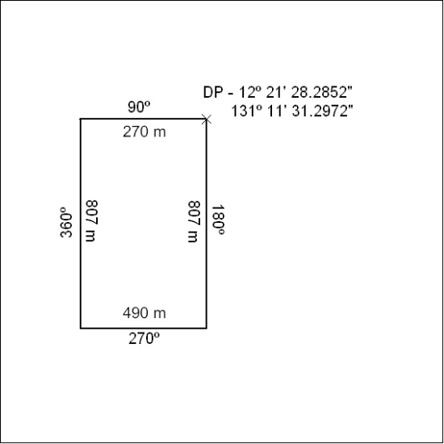

279/18

Mineral Titles Act
NOTICE OF LAND CEASING TO BE A MINERAL TITLE AREA
Title Type and Number: | Extractive Mineral Exploration Licence 31716
Area Ceased on: | 22 June 2018
Area: | 3 Blocks, 10.06 km²
Locality: | KOOLPINYAH
Name of Applicant(s)/Holder(s): | 100% BENGER John William
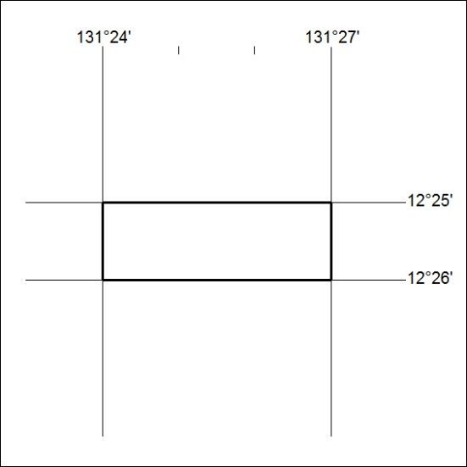

280/18

