Corrigendum
Notice Number 408/18 appearing in MN118/18 on 18 SEPTEMBER 2018 is hereby cancelled and replaced by the following:

Mineral Titles Act
NOTICE OF LAND CEASING TO BE A MINERAL TITLE AREA
Title Type and Number: | Exploration Licence 30669
Area Ceased on: | 18 September 2018
Area: | 10 Blocks, 29.77 km²
Locality: | UNDOOLYA
Name of Applicant(s)/Holder(s): | 100% DBL BLUES PTY LTD [ACN. 140 024 442]
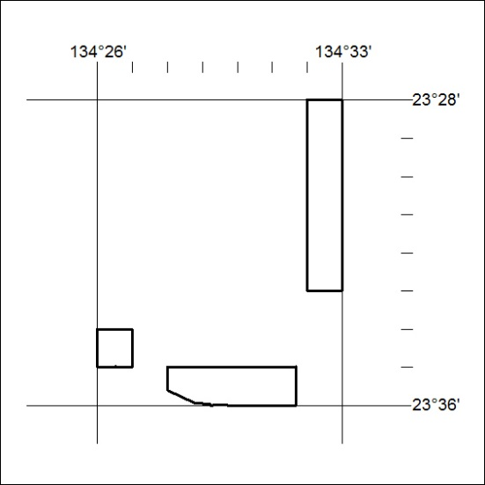

409/18

