Mineral Titles Act
NOTICE OF LAND CEASING TO BE A MINERAL TITLE AREA
Title Type and Number: | Exploration Licence 27014
Area Ceased on: | 07 November 2018
Area: | 250 Blocks, 779.12 km²
Locality: | IMBUMBUNNA
Name of Applicant(s)/Holder(s): | 100% GEMPART (NT) PTY LTD* [ACN. 081 859 896]
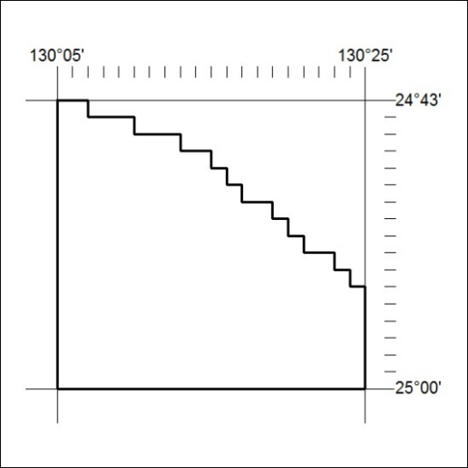

503/18

Mineral Titles Act
NOTICE OF LAND CEASING TO BE A MINERAL TITLE AREA
Title Type and Number: | Exploration Licence 31526
Area Ceased on: | 07 November 2018
Area: | 169 Blocks, 563.24 km²
Locality: | MARY RIVER
Name of Applicant(s)/Holder(s): | 100% THUNDERBIRD METALS PTY LTD [ACN. 608 077 345]
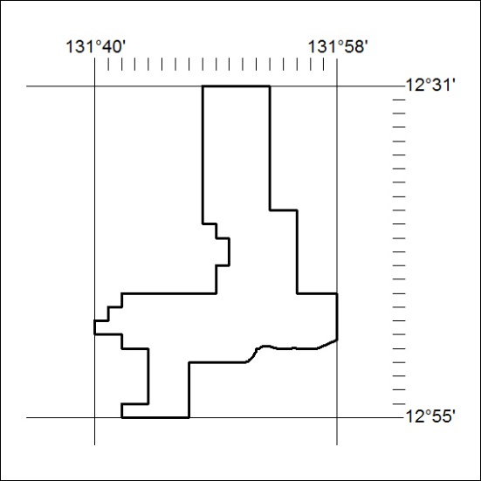

504/18

Mineral Titles Act
NOTICE OF LAND CEASING TO BE A MINERAL TITLE AREA
Title Type and Number: | Exploration Licence 31527
Area Ceased on: | 07 November 2018
Area: | 66 Blocks, 202.64 km²
Locality: | DALY RIVER
Name of Applicant(s)/Holder(s): | 100% THUNDERBIRD METALS PTY LTD [ACN. 608 077 345]
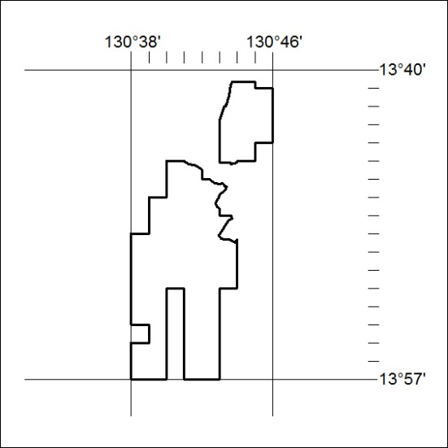

505/18

Mineral Titles Act
NOTICE OF LAND CEASING TO BE A MINERAL TITLE AREA
Title Type and Number: | Exploration Licence 31528
Area Ceased on: | 07 November 2018
Area: | 40 Blocks, 133.49 km²
Locality: | TIPPERARY
Name of Applicant(s)/Holder(s): | 100% THUNDERBIRD METALS PTY LTD [ACN. 608 077 345]
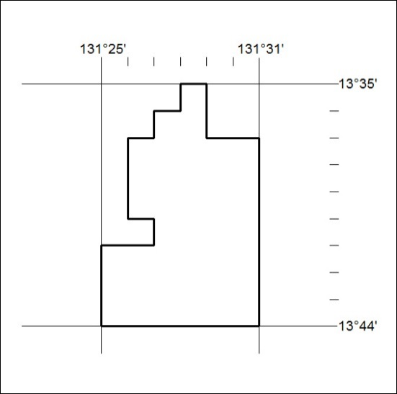

506/18

Mineral Titles Act
NOTICE OF LAND CEASING TO BE A MINERAL TITLE AREA
Title Type and Number: | Exploration Licence 31529
Area Ceased on: | 07 November 2018
Area: | 175 Blocks, 560.09 km²
Locality: | TIPPERARY
Name of Applicant(s)/Holder(s): | 100% THUNDERBIRD METALS PTY LTD [ACN. 608 077 345]
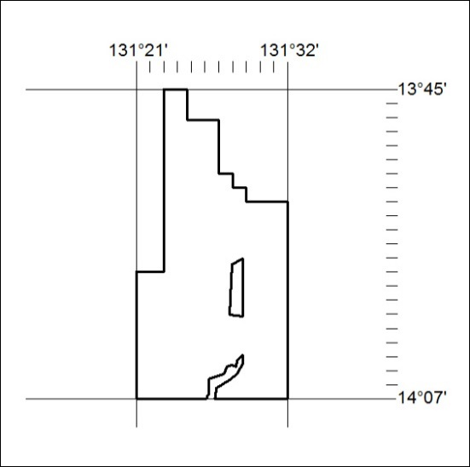

507/18

