Mineral Titles Act
NOTICE OF LAND CEASING TO BE A MINERAL TITLE AREA
Title Type and Number: | Exploration Licence 28765
Area Ceased on: | 15 November 2018
Area: | 4 Blocks, 13.17 km²
Locality: | VICTORIA RIVER DOWNS
Name of Applicant(s)/Holder(s): | 100% AUSTRALIA MINING & GEMSTONE CO. PTY LTD [ACN. 114 395 247]
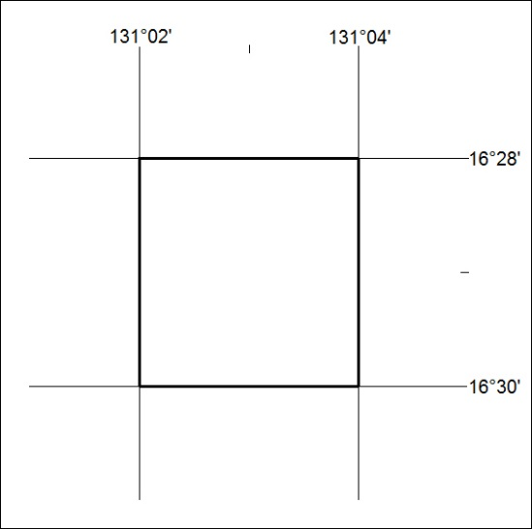

518/18

Mineral Titles Act
NOTICE OF LAND CEASING TO BE A MINERAL TITLE AREA
Title Type and Number: | Exploration Licence 28766
Area Ceased on: | 15 November 2018
Area: | 6 Blocks, 19.79 km²
Locality: | HUMBERT
Name of Applicant(s)/Holder(s): | 100% AUSTRALIA MINING & GEMSTONE CO. PTY LTD [ACN. 114 395 247]
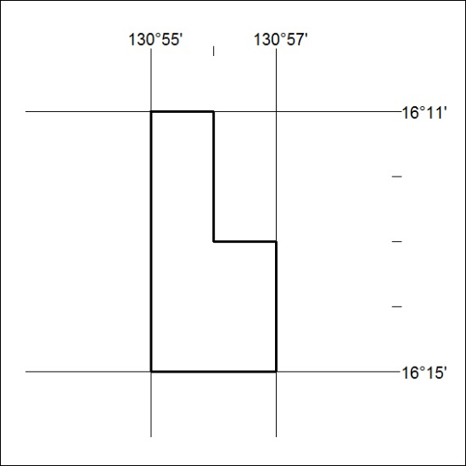

519/18

Mineral Titles Act
NOTICE OF GRANT OF A MINERAL TITLE
Title Type and Number: | Extractive Mineral Permit 31577
Granted: | 13 November 2018, for a period of 5 Years
Area: | 78.45 Hectares
Locality: | NOONAMAH
Name of Holder/s: | 100% ALISANTE HOLDINGS PTY LTD [ACN. 067 361 559]
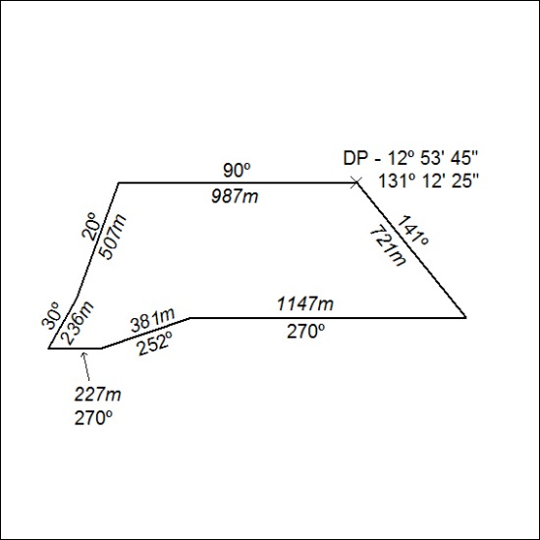

520/18

Mineral Titles Act
NOTICE OF GRANT OF A MINERAL TITLE
Title Type and Number: | Extractive Mineral Permit 31578
Granted: | 13 November 2018, for a period of 5 Years
Area: | 96.97 Hectares
Locality: | NOONAMAH
Name of Holder/s: | 100% ALISANTE HOLDINGS PTY LTD [ACN. 067 361 559]
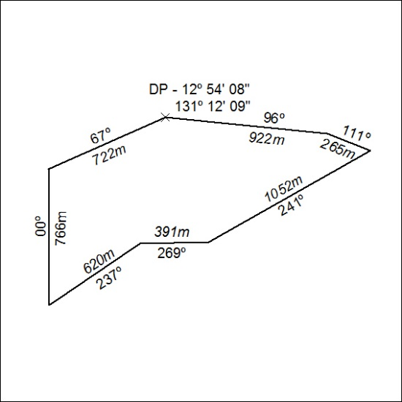

521/18

