Mineral Titles Act
NOTICE OF LAND CEASING TO BE A MINERAL TITLE
Title Type and Number: | Extractive Mineral Permit 24086
Area ceased on: | 29 November 2018
Area: | 13.24 Hectare
Locality: | KOOLPINYAH
Name of Applicants(s)Holder(s): | 100% ALISANTE HOLDINGS PTY LTD [ACN. 067 361 559]
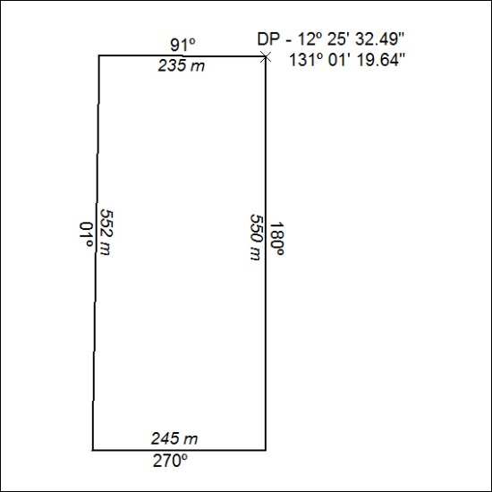

552/18

Mineral Titles Act
NOTICE OF GRANT OF A MINERAL TITLE
Title Type and Number: | Exploration Licence 31875
Granted: | 28 November 2018, for a period of 6 Years
Area: | 5 Blocks, 16.45 km²
Locality: | MALLAPUNYAH
Name of Holder/s: | 100% MMG EXPLORATION PTY LTD* [ACN. 119 136 659]
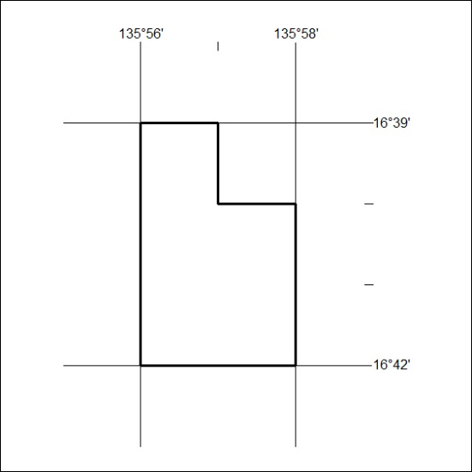
Area granted is indicated above. The titleholder is not permitted to exercise occupational rights on any land that is subject to a development title, or an application for a development title. Any land the subject of a Reserved Land gazettal under the Mineral Titles Act and all land vested in the Commonwealth of Australia is also excluded by description but not excised from the grant area.

553/18

