Mineral Titles Act
NOTICE OF GRANT OF A MINERAL TITLE
Title Type and Number: | Mineral Lease (Northern) 1152
Granted: | 31 January 2019, for a period of 25 Years
Area: | 716.20 Hectares
Locality: | BATCHELOR
Name of Holder/s: | 100% NEWMARKET GOLD NT HOLDINGS PTY LTD* [ACN. 136 505 587]
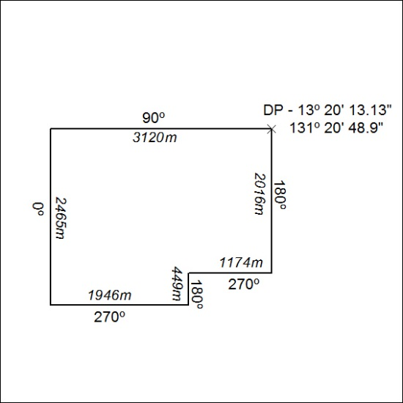

36/19

