Mineral Titles Act 2010
NOTICE OF LAND CEASING TO BE A MINERAL TITLE AREA
Title Type and Number: | Extractive Mineral Permit 27924
Area ceased on: | 08 April 2019
Area: | 0.23 Hectare
Locality: | KOOLPINYAH
Name of Applicants(s)Holder(s): | 100% MOUSELLIS & SONS PTY. LTD. [ACN. 009 654 791]
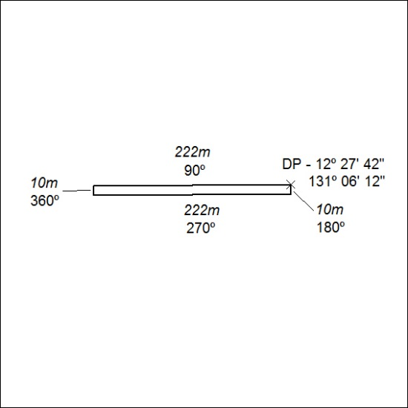

124/19

Mineral Titles Act 2010
NOTICE OF LAND CEASING TO BE A MINERAL TITLE AREA
Title Type and Number: | Mineral Authority 29642
Area ceased on: | 10 April 2019
Area: | 8.00 Hectare
Locality: | KOOLPINYAH
Name of Applicants(s)Holder(s): | 100% ALISANTE HOLDINGS PTY LTD [ACN. 067 361 559]
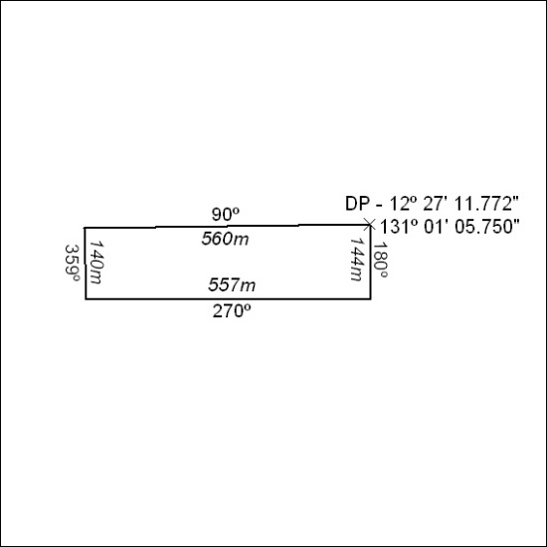

125/19

