Mineral Titles Act 2010
NOTICE OF LAND CEASING TO BE A MINERAL TITLE AREA
Title Type and Number: | Exploration Licence 29362
Area Ceased on: | 02 May 2019
Area: | 4 Blocks, 13.36 km²
Locality: | PINE CREEK
Name of Applicant(s)/Holder(s): | 100% PRIMARY MINERALS PTY LTD* [ACN. 153 582 962]
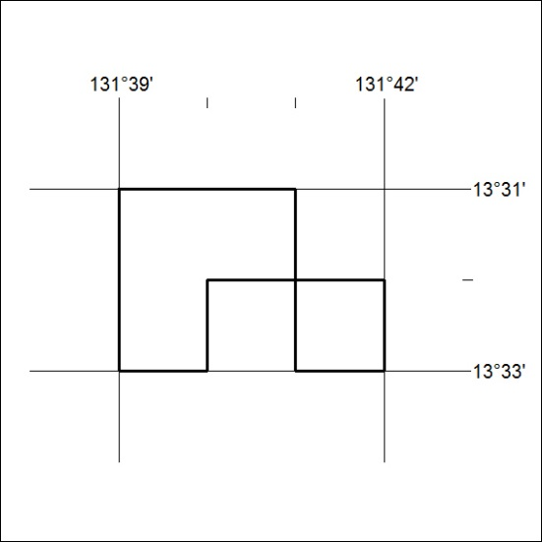

150/19

Mineral Titles Act 2010
NOTICE OF LAND CEASING TO BE A MINERAL TITLE AREA
Title Type and Number: | Exploration Licence 29520
Area Ceased on: | 02 May 2019
Area: | 4 Blocks, 13.34 km²
Locality: | PINE CREEK
Name of Applicant(s)/Holder(s): | 100% PRIMARY MINERALS PTY LTD* [ACN. 153 582 962]
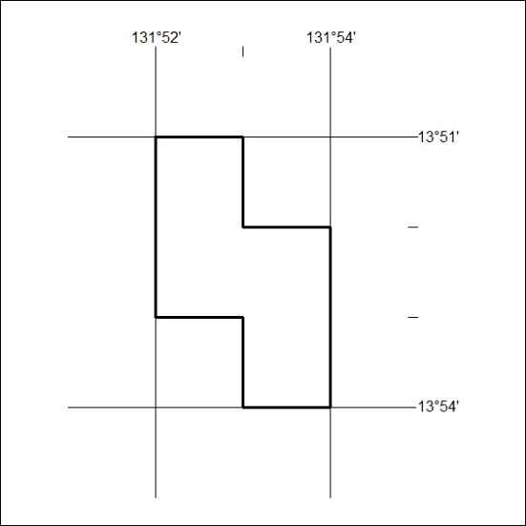

151/19
Mineral Titles Act 2010
NOTICE OF LAND CEASING TO BE A MINERAL TITLE AREA
Title Type and Number: | Exploration Licence 29521
Area Ceased on: | 02 May 2019
Area: | 9 Blocks, 30.05 km²
Locality: | PINE CREEK
Name of Applicant(s)/Holder(s): | 100% PRIMARY MINERALS PTY LTD* [ACN. 153 582 962]
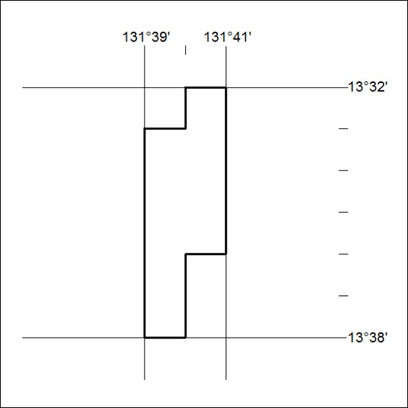

152/19

