Mineral Titles Act 2010
NOTICE OF LAND CEASING TO BE A MINERAL TITLE APPLICATION AREA
Title Type and Number: | Exploration Licence 28613
Area Ceased on: | 04 June 2019
Area: | 123 Blocks, 397.07 km²
Locality: | TANAMI
Name of Applicant(s)/Holder(s): | 60% TANAMI (NT) PTY LTD [ACN. 141 658 933], 40% NORTHERN STAR (TANAMI) PTY LTD [ACN. 603 860 831]
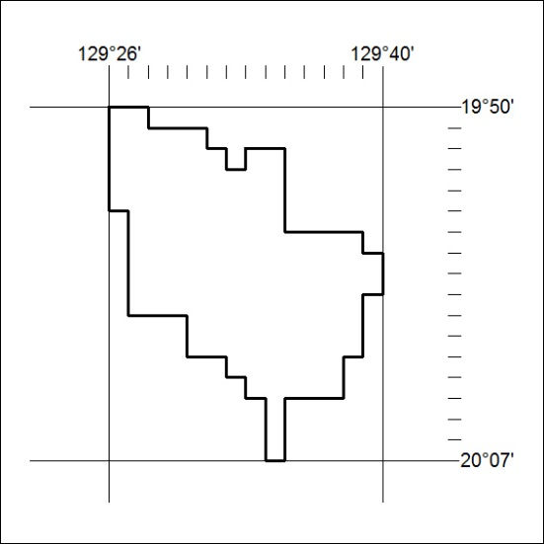

244/19

