Mineral Titles Act 2010
NOTICE OF LAND CEASING TO BE A MINERAL TITLE AREA
Title Type and Number: | Exploration Licence 26833
Area Ceased on: | 09 June 2019
Area: | 7 Blocks, 23.14 km²
Locality: | TAWALLAH RANGE
Name of Applicant(s)/Holder(s): | 60% MMG EXPLORATION PTY LTD* [ACN. 119 136 659], 40% SANDFIRE RESOURCES NL [ACN. 105 154 185]
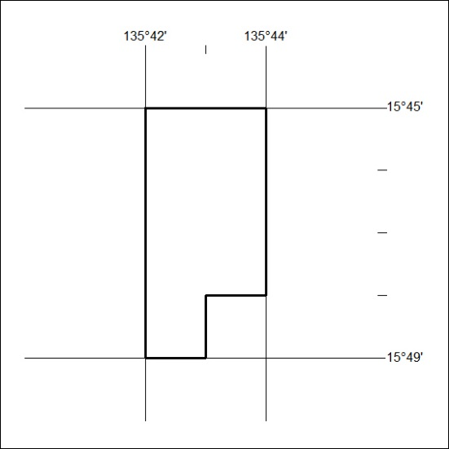

247/19

Mineral Titles Act 2010
NOTICE OF LAND CEASING TO BE A MINERAL TITLE AREA
Title Type and Number: | Exploration Licence 26835
Area Ceased on: | 09 June 2019
Area: | 76 Blocks, 251.34 km²
Locality: | TAWALLAH RANGE
Name of Applicant(s)/Holder(s): | 60% MMG EXPLORATION PTY LTD* [ACN. 119 136 659], 40% SANDFIRE RESOURCES NL [ACN. 105 154 185]
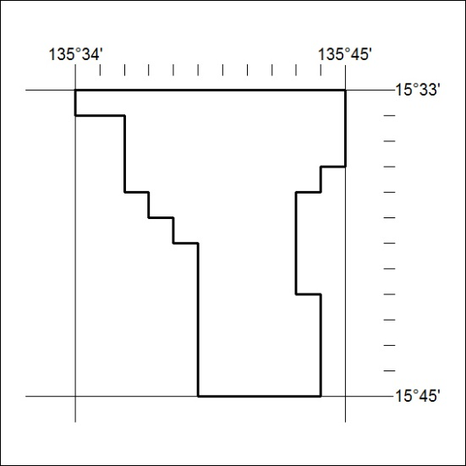

248/19
Mineral Titles Act 2010
NOTICE OF LAND CEASING TO BE A MINERAL TITLE AREA
Title Type and Number: | Exploration Licence 26836
Area Ceased on: | 09 June 2019
Area: | 97 Blocks, 321.09 km²
Locality: | MT YOUNG
Name of Applicant(s)/Holder(s): | 60% MMG EXPLORATION PTY LTD* [ACN. 119 136 659], 40% SANDFIRE RESOURCES NL [ACN. 105 154 185]
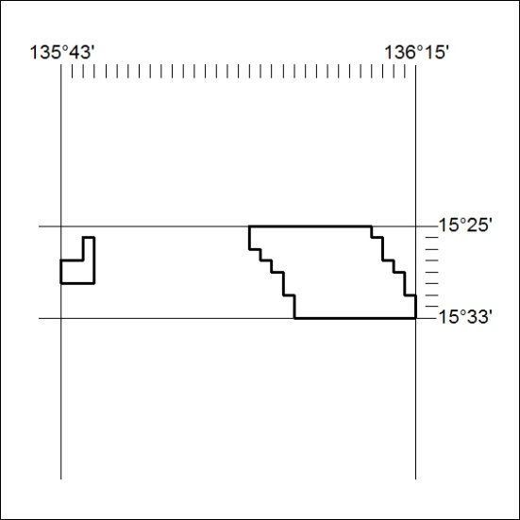

249/19

Mineral Titles Act 2010
NOTICE OF LAND CEASING TO BE A MINERAL TITLE AREA
Title Type and Number: | Exploration Licence 30137
Area Ceased on: | 09 June 2019
Area: | 68 Blocks, 224.49 km²
Locality: | TAWALLAH RANGE
Name of Applicant(s)/Holder(s): | 60% MMG EXPLORATION PTY LTD* [ACN. 119 136 659], 40% SANDFIRE RESOURCES NL [ACN. 105 154 185]
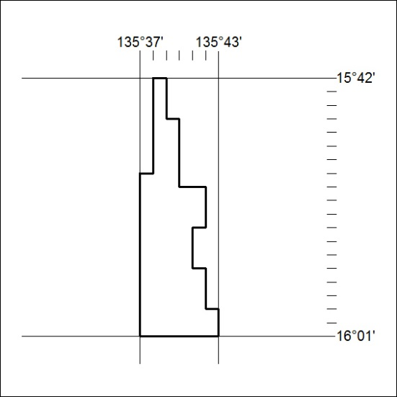

250/19
Mineral Titles Act 2010
NOTICE OF LAND CEASING TO BE A MINERAL TITLE AREA
Title Type and Number: | Exploration Licence 30152
Area Ceased on: | 09 June 2019
Area: | 108 Blocks, 357.53 km²
Locality: | TAWALLAH RANGE
Name of Applicant(s)/Holder(s): | 60% MMG EXPLORATION PTY LTD* [ACN. 119 136 659], 40% SANDFIRE RESOURCES NL [ACN. 105 154 185]
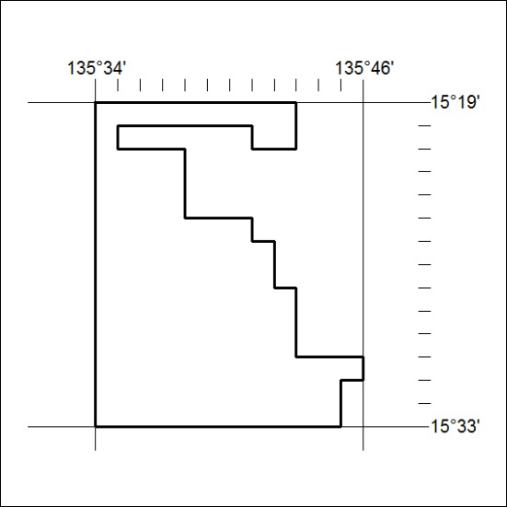

251/19

Mineral Titles Act 2010
NOTICE OF LAND CEASING TO BE A MINERAL TITLE AREA
Title Type and Number: | Exploration Licence 30158
Area Ceased on: | 09 June 2019
Area: | 83 Blocks, 274.82 km²
Locality: | MT YOUNG
Name of Applicant(s)/Holder(s): | 60% MMG EXPLORATION PTY LTD* [ACN. 119 136 659], 40% SANDFIRE RESOURCES NL [ACN. 105 154 185]
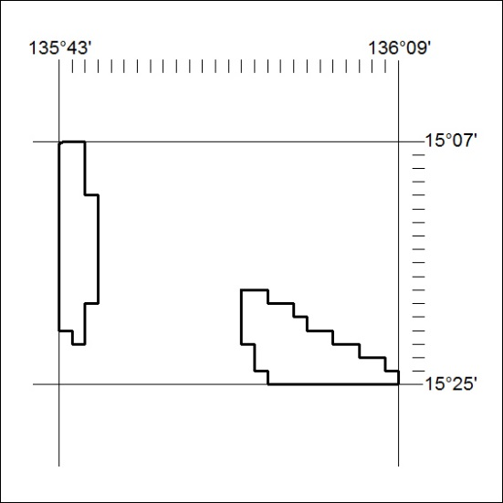

252/19

