Mineral Titles Act 2010
NOTICE OF LAND CEASING TO BE A MINERAL TITLE APPLICATION AREA
Title Type and Number: | Exploration Licence 32028
Area Ceased on: | 23 July 2019
Area: | 250 Blocks, 823.06 km²
Locality: | FLAT TOP HILL
Name of Applicant(s)/Holder(s): | 100% ALBIAN RESOURCES PTY LTD [ACN. 629 786 161]
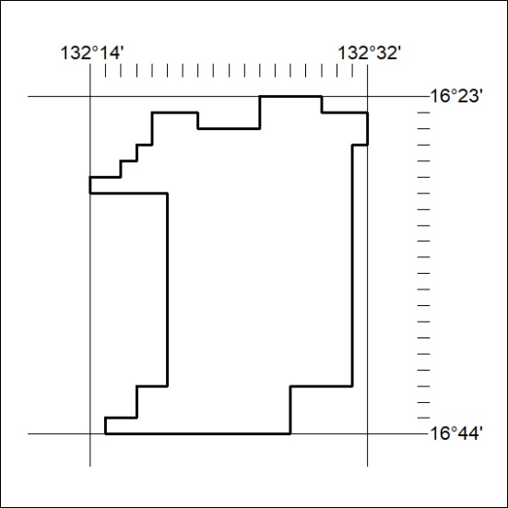

314/19

Mineral Titles Act 2010
NOTICE OF LAND CEASING TO BE A MINERAL TITLE APPLICATION AREA
Title Type and Number: | Exploration Licence 32029
Area Ceased on: | 23 July 2019
Area: | 250 Blocks, 821.70 km²
Locality: | FLAT TOP HILL
Name of Applicant(s)/Holder(s): | 100% ALBIAN RESOURCES PTY LTD [ACN. 629 786 161]
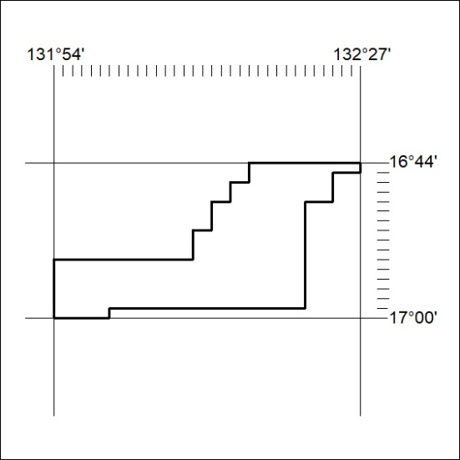

315/19
Mineral Titles Act 2010
NOTICE OF LAND CEASING TO BE A MINERAL TITLE APPLICATION AREA
Title Type and Number: | Extractive Mineral Exploration Licence 32018
Area Ceased on: | 24 July 2019
Area: | 1 Block, 3.35 km²
Locality: | NOONAMAH
Name of Applicant(s)/Holder(s): | 100% OSTOJIC GROUP PTY LTD* [ACN. 009 629 805]
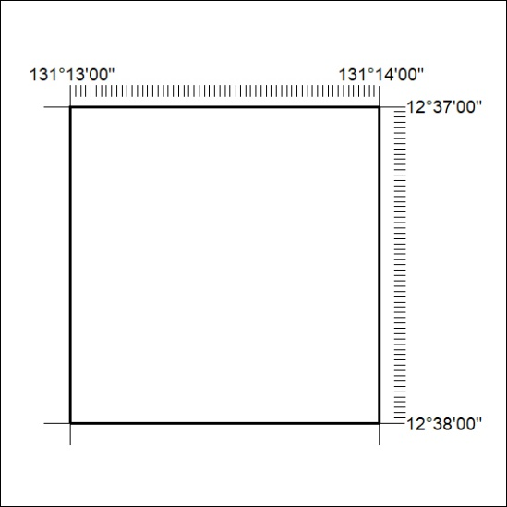

316/19

