Mineral Titles Act 2010
NOTICE OF LAND CEASING TO BE A MINERAL TITLE AREA
Title Type and Number: | Exploration Licence 31079
Area Ceased on: | 08 August 2019
Area: | 149 Blocks, 486.57 km²
Locality: | PARADISE BORE
Name of Applicant(s)/Holder(s): | 100% TOEPRINT RESOURCES PTY LTD [ACN. 626 051 287]
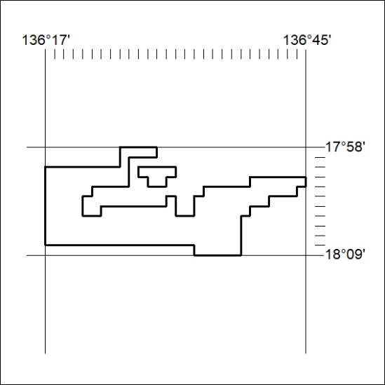

332/19

Mineral Titles Act 2010
NOTICE OF LAND CEASING TO BE A MINERAL TITLE AREA
Title Type and Number: | Exploration Licence 31737
Area Ceased on: | 08 August 2019
Area: | 155 Blocks, 478.74 km²
Locality: | HENBURY
Name of Applicant(s)/Holder(s): | 100% BMEX LIMITED* [ACN. 615 217 680]
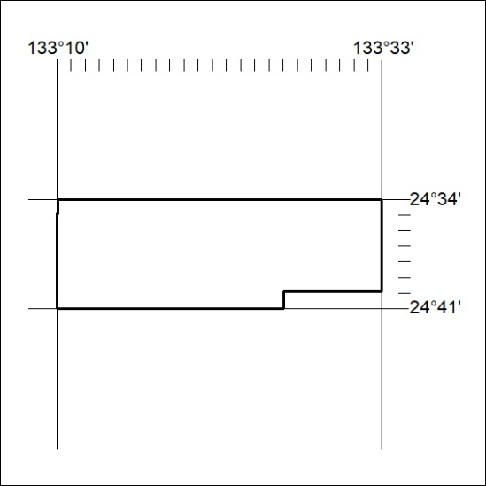

333/19
Mineral Titles Act 2010
NOTICE OF LAND CEASING TO BE A MINERAL TITLE AREA
Title Type and Number: | Exploration Licence 31761
Area Ceased on: | 08 August 2019
Area: | 250 Blocks, 823.79 km²
Locality: | ROBINSON
Name of Applicant(s)/Holder(s): | 100% TSC EXPLORATION PTY LTD* [ACN. 622 780 027]
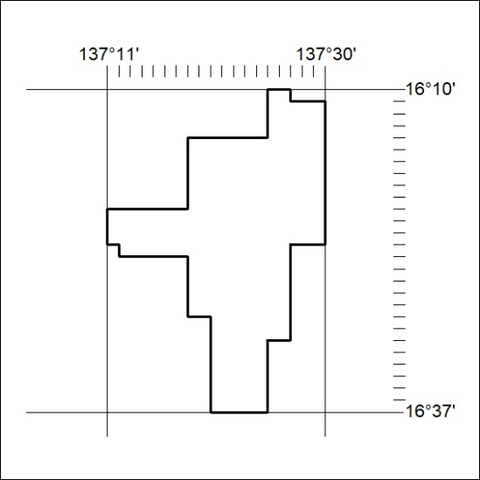

334/19

Mineral Titles Act 2010
NOTICE OF LAND CEASING TO BE A MINERAL TITLE APPLICATION AREA
Title Type and Number: | Extractive Mineral Lease 24720
Area ceased on: | 22 March 2018
Area: | 6.00 Hectare
Locality: | MARY RIVER
Name of Applicants(s)Holder(s): | 100% AUSTMIN DEVELOPMENT PTY LTD [ACN. 108 019 585]
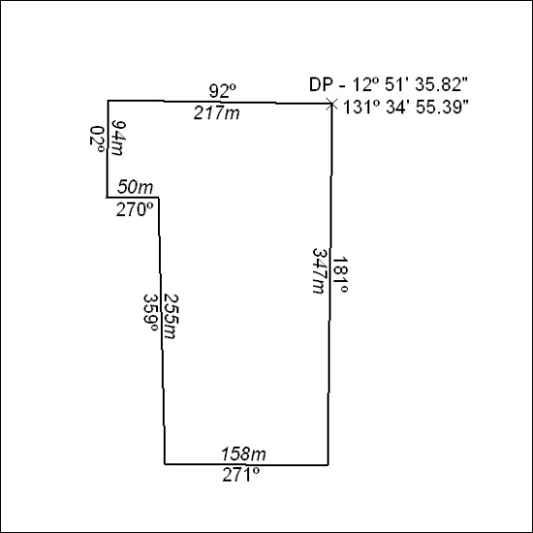

335/19

Mineral Titles Act 2010
NOTICE OF LAND CEASING TO BE A MINERAL TITLE AREA
Title Type and Number: | Extractive Mineral Permit 30263
Area ceased on: | 07 August 2019
Area: | 3.00 Hectare
Locality: | PINE CREEK
Name of Applicants(s)Holder(s): | 100% BIRCH Alan James
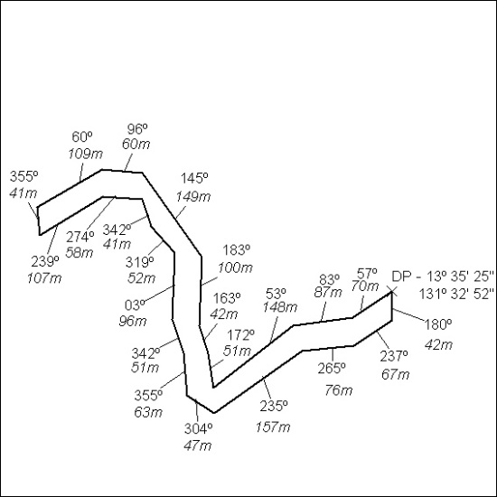

336/19

Mineral Titles Act 2010
NOTICE OF LAND CEASING TO BE A MINERAL TITLE AREA
Title Type and Number: | Extractive Mineral Permit 30264
Area ceased on: | 07 August 2019
Area: | 1.00 Hectare
Locality: | PINE CREEK
Name of Applicants(s)Holder(s): | 100% BIRCH Alan James
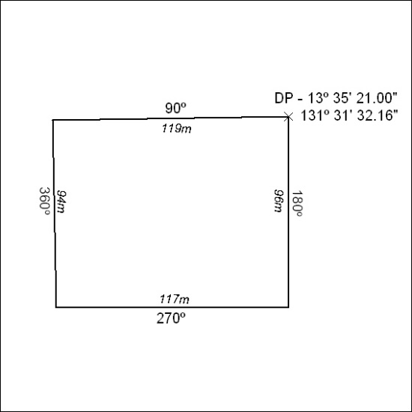

337/19

Mineral Titles Act
NOTICE OF GRANT OF A MINERAL TITLE
Title Type and Number: | Mineral Lease 29985
Granted: | 05 August 2019, for a period of 10 Years
Area: | 40.00 Hectares
Locality: | BYNOE
Name of Holder/s: | 100% OUTBACK METALS PROPRIETARY LIMITED* [ACN. 126 797 573]
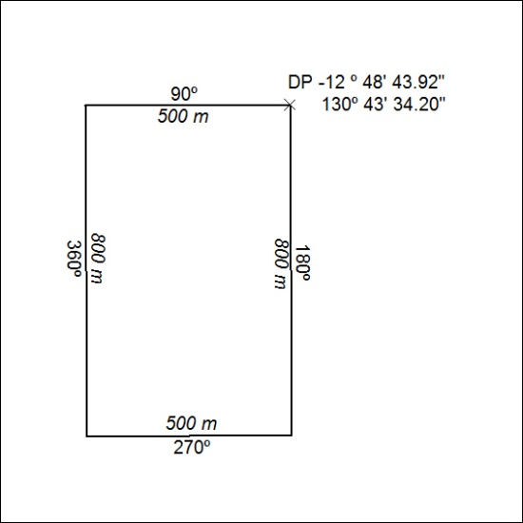

338/19

