Mineral Titles Act 2010
NOTICE OF LAND CEASING TO BE A MINERAL TITLE AREA
Title Type and Number: | Exploration Licence 31617
Area Ceased on: | 26 April 2020
Area: | 33 Blocks, 106.43 km²
Locality: | CHALUBA
Name of Applicant(s)/Holder(s): | 100% TREASURE CREEK PTY LTD [ACN. 619 057 644]
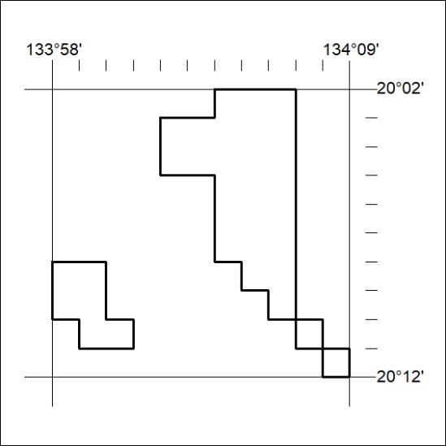
172/20

Mineral Titles Act 2010
NOTICE OF LAND CEASING TO BE A MINERAL TITLE AREA
Title Type and Number: | Exploration Licence 31619
Area Ceased on: | 26 April 2020
Area: | 10 Blocks, 32.35 km²
Locality: | GOSSE RIVER
Name of Applicant(s)/Holder(s): | 100% TREASURE CREEK PTY LTD [ACN. 619 057 644]
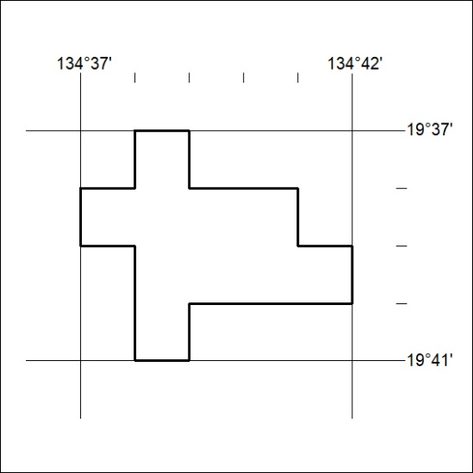
173/20

