Mineral Titles Act 2010
NOTICE OF LAND CEASING TO BE A MINERAL TITLE AREA
Title Type and Number: | Mineral Authority 30826
Area ceased on: | 29 April 2020
Area: | 77.00 Hectare
Locality: | NOONAMAH
Name of Applicants(s)Holder(s): | 100% BERNO BROS. PTY. LIMITED [ACN. 009 592 741]
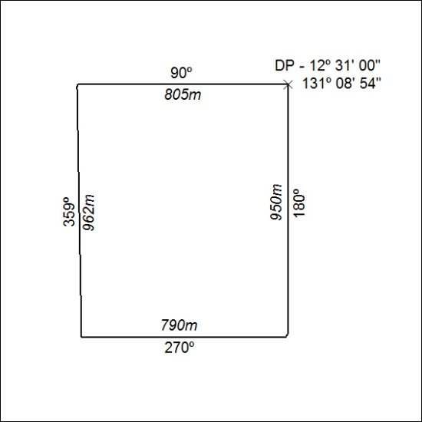
174/20

Mineral Titles Act 2010
NOTICE OF LAND CEASING TO BE A MINERAL TITLE AREA
Title Type and Number: | Mineral Authority 30827
Area ceased on: | 29 April 2020
Area: | 71.00 Hectare
Locality: | NOONAMAH
Name of Applicants(s)Holder(s): | 100% BERNO BROS. PTY. LIMITED [ACN. 009 592 741]
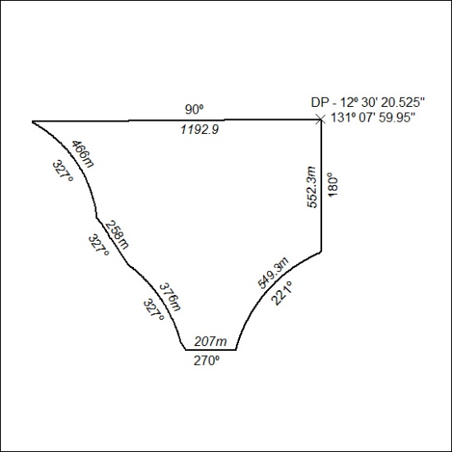
175/20

Mineral Titles Act 2010
NOTICE OF LAND CEASING TO BE A MINERAL TITLE AREA
Title Type and Number: | Mineral Authority 30828
Area ceased on: | 29 April 2020
Area: | 86.00 Hectare
Locality: | NOONAMAH
Name of Applicants(s)Holder(s): | 100% BERNO BROS. PTY. LIMITED [ACN. 009 592 741]
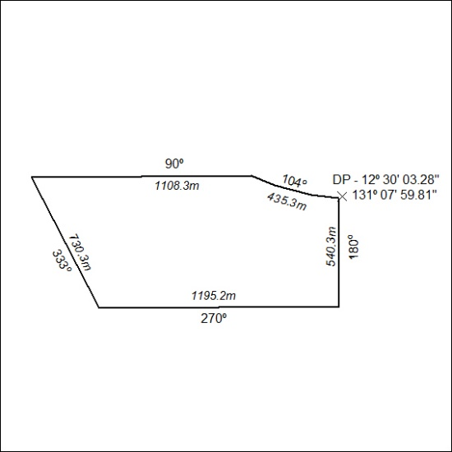
176/20

