Mineral Titles Act 2010
NOTICE OF LAND CEASING TO BE A MINERAL TITLE AREA
Title Type and Number: | Exploration Licence 31624
Area Ceased on: | 02 June 2020
Area: | 8 Blocks, 25.76 km²
Locality: | OORADIDGEE
Name of Applicant(s)/Holder(s): | 100% TREASURE CREEK PTY LTD [ACN. 619 057 644]
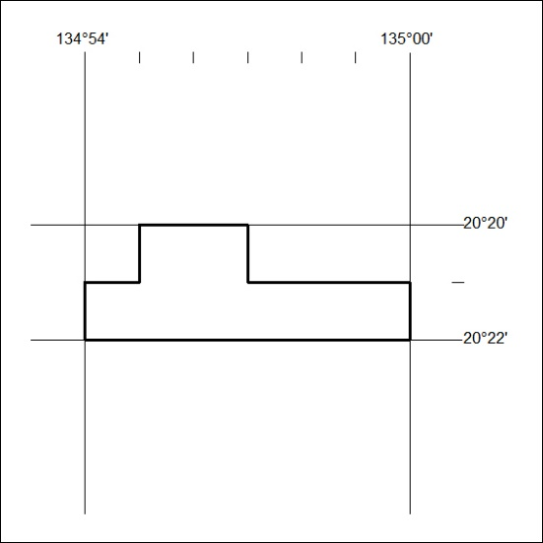
193/20

Mineral Titles Act 2010
NOTICE OF LAND CEASING TO BE A MINERAL TITLE AREA
Title Type and Number: | Exploration Licence 31626
Area Ceased on: | 02 June 2020
Area: | 48 Blocks, 154.46 km²
Locality: | OORADIDGEE
Name of Applicant(s)/Holder(s): | 100% TREASURE CREEK PTY LTD [ACN. 619 057 644]
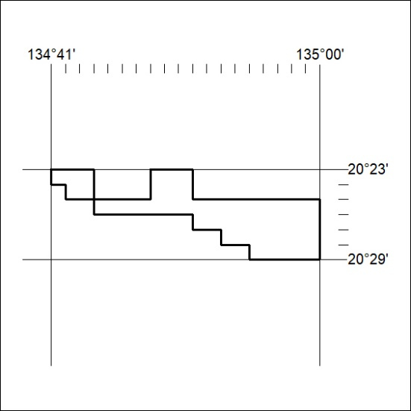
194/20

Mineral Titles Act
NOTICE OF GRANT OF A MINERAL TITLE
Title Type and Number: | Exploration Licence 27584
Granted: | 29 May 2020, for a period of 6 Years
Area: | 30 Blocks, 93.16 km²
Locality: | HOWSHIP
Name of Holder/s: | 100% NORTH MINERALS PTY LTD [ACN. 139 469 195]
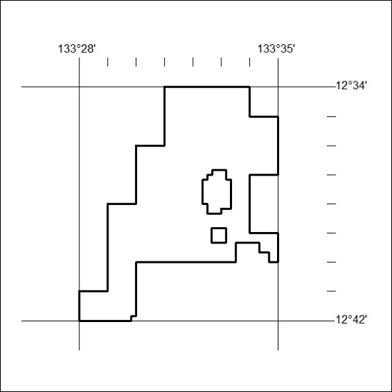
Area granted is indicated above. The titleholder is not permitted to exercise occupational rights on any land that is subject to a development title, or an application for a development title. Any land the subject of a Reserved Land gazettal under the Mineral Titles Act and all land vested in the Commonwealth of Australia is also excluded by description but not excised from the grant area.
195/20

