Mineral Titles Act 2010
NOTICE OF LAND CEASING TO BE A MINERAL TITLE APPLICATION AREA
Title Type and Number: | Exploration Licence 25157
Area Ceased on: | 16 July 2020
Area: | 8 Blocks, 25.78 km²
Locality: | FRANKENIA
Name of Applicant(s)/Holder(s): | 100% NORTHERN STAR (TANAMI) PTY LTD [ACN. 603 860 831]
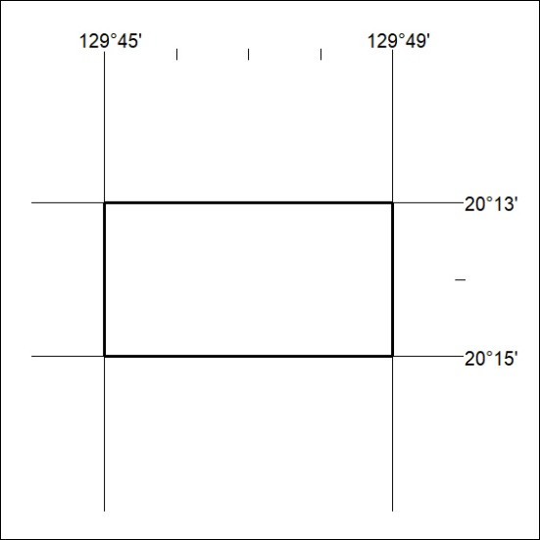

228/20

Mineral Titles Act 2010
NOTICE OF LAND CEASING TO BE A MINERAL TITLE APPLICATION AREA
Title Type and Number: | Exploration Licence 25158
Area Ceased on: | 16 July 2020
Area: | 12 Blocks, 38.69 km²
Locality: | FRANKENIA
Name of Applicant(s)/Holder(s): | 100% NORTHERN STAR (TANAMI) PTY LTD [ACN. 603 860 831]
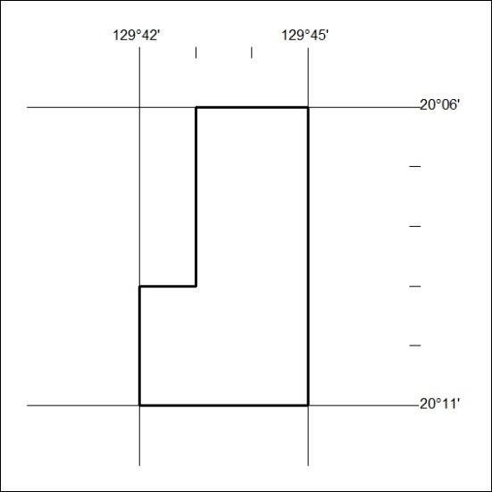

229/20
Mineral Titles Act 2010
NOTICE OF LAND CEASING TO BE A MINERAL TITLE APPLICATION AREA
Title Type and Number: | Exploration Licence 29621
Area Ceased on: | 16 July 2020
Area: | 8 Blocks, 25.87 km²
Locality: | PARGEE
Name of Applicant(s)/Holder(s): | 100% NORTHERN STAR (TANAMI) PTY LTD [ACN. 603 860 831]
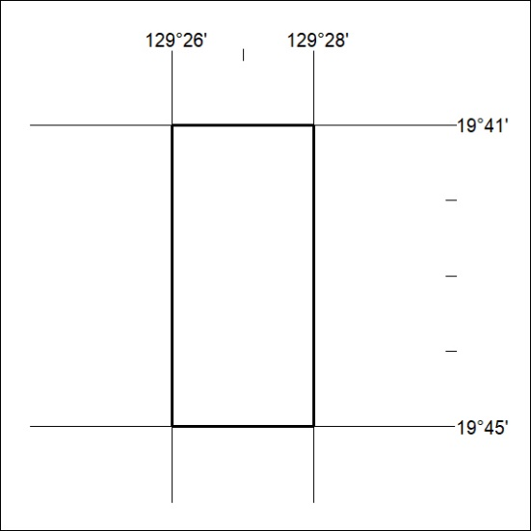

230/20

Mineral Titles Act 2010
NOTICE OF LAND CEASING TO BE A MINERAL TITLE AREA
Title Type and Number: | Exploration Licence 31058
Area Ceased on: | 16 July 2020
Area: | 58 Blocks, 185.48 km²
Locality: | CRAWFORD
Name of Applicant(s)/Holder(s): | 100% LITHIUM DEVELOPMENTS PTY LTD [ACN. 612 245 020]
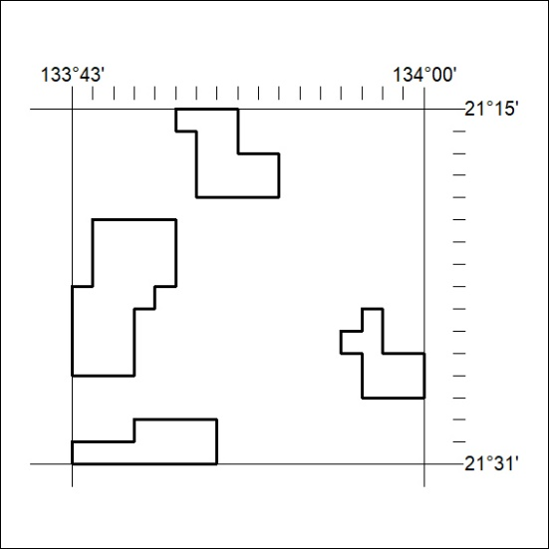

231/20

