Mineral Titles Act 2010
NOTICE OF LAND CEASING TO BE A MINERAL TITLE AREA
Title Type and Number: | Exploration Licence 25566
Area Ceased on: | 02 September 2020
Area: | 62 Blocks, 191.94 km²
Locality: | COCKBURN
Name of Applicant(s)/Holder(s): | 100% GEMPART (NT) PTY LTD* [ACN. 081 859 896]
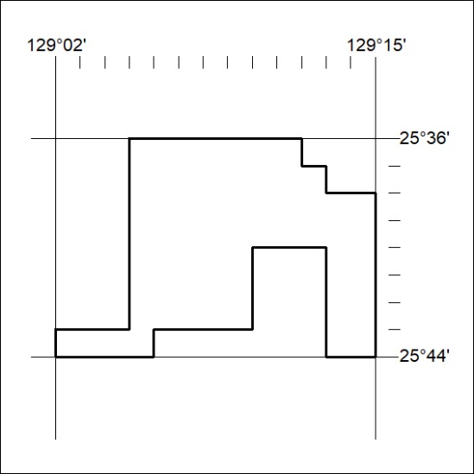

305/20

Mineral Titles Act 2010
NOTICE OF LAND CEASING TO BE A MINERAL TITLE AREA
Title Type and Number: | Exploration Licence 31383
Area Ceased on: | 02 September 2020
Area: | 62 Blocks, 189.78 km²
Locality: | COCKBURN
Name of Applicant(s)/Holder(s): | 100% GEMPART (NT) PTY LTD* [ACN. 081 859 896]
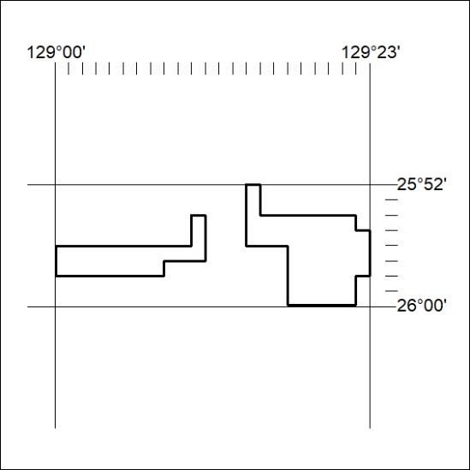

306/20

