Mineral Titles Act 2010
NOTICE OF LAND CEASING TO BE A MINERAL TITLE APPLICATION AREA
Title Type and Number: | Mineral Lease 32257
Area ceased on: | 18 September 2020
Area: | 39.00 Hectare
Locality: | McKINLAY RIVER
Name of Applicants(s)Holder(s): | 100% GMG MINING (NT) PTY LTD [ACN. 634 618 410]
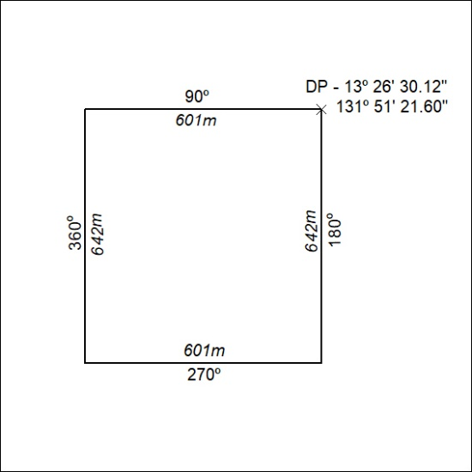

318/20

Mineral Titles Act 2010
NOTICE OF LAND CEASING TO BE A MINERAL TITLE APPLICATION AREA
Title Type and Number: | Mineral Lease 32258
Area ceased on: | 18 September 2020
Area: | 38.00 Hectare
Locality: | McKINLAY RIVER
Name of Applicants(s)Holder(s): | 100% GMG MINING (NT) PTY LTD [ACN. 634 618 410]
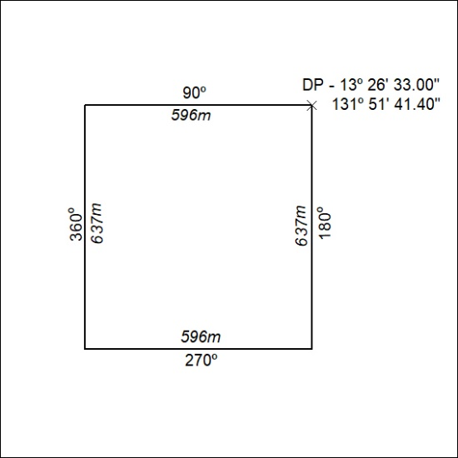

319/20

