OzDelta-1 Exploration Well

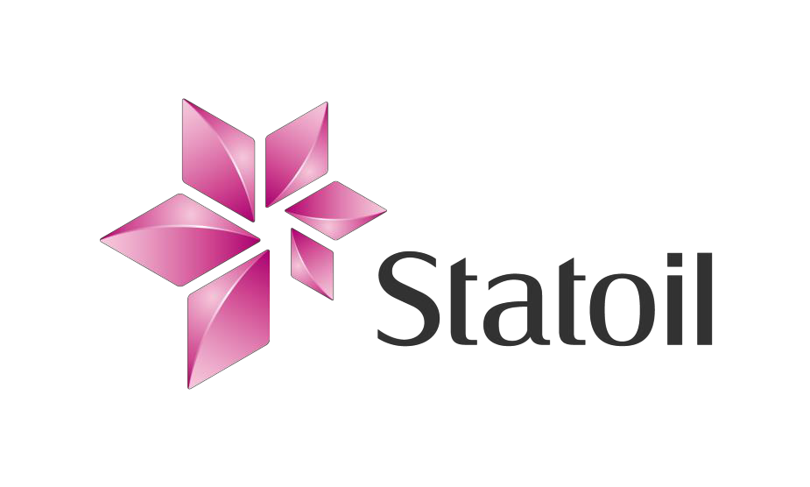

Environmental Management Plan Summary

Addendum for Stimulation and Testing

**1 INTRODUCTION**

Statoil successfully drilled the OzDelta-1 exploration well in June 2014 to 840m MD. The well site is located in EP 128 in the South Georgina Basin in the eastern part of the Northern Territory approximately 375 km north east of Alice Springs. Co-ordinates for the well site are: 673580mE, 7613132mS (UTM, Zone 53). A map of the location is contained in Appendix 2.

In September 2014 Statoil will return to hydraulically fracture and test the OzDelta-1 well. The Thorntonia and Basal Arthur Creek formations will be targeted to determine the potential for hydrocarbon production. The planned single stage stimulation operation in the vertical well will result in a predictable and relatively small fracture requiring a relatively low amount of fracturing fluids.

The operation will involve the following stages:

1. Well preparation including Diagnostic Fracture Injection Test (DFIT)

2. Perforation and pumping

3. Testing

4. Down hole abandonment

The addendum to the EMP for drilling includes the hydraulic fracturing and testing operation. It details the water monitoring program involving the sampling and testing of local water bores. The addendum to the EMP lists chemicals to be used during the fracture stimulation and the relevant Safety Data Sheets (**SDS**) are included in an appendix. Well integrity schematics (well barrier diagrams) for the hydraulic fracturing operation are included in the Stimulation, Testing, and Abandonment Program.

Statoil plans to permanently plug and abandon the OzDelta-1 well and carry out remediation works in consultation with the pastoral lessee and according to the rehabilitation actions in the EMP.

**2 MANAGEMENT APPROACH**

Statoil employs highly skilled and experienced engineers and consultants to ensure that the environmental risks from its operations are as low as reasonably practicable. Statoil acknowledges the importance of the sustainable development to secure its future and to ensure the ongoing relationship with all stakeholders.

Operations at the OzDelta-1 have been planned based on the following principles:

- Minimise interference with the use of the land by other persons;

- Prevent unnecessary disturbance of flora, fauna and other natural resources;

- Avoid pollution of soil, water or the atmosphere;

- Minimise the incidence and effects of soil erosion.

**3 PROJECT DESCRIPTION**

The core activities involve well preparation, perforation, pumping, testing and permanent abandonment.

After diagnostic testing, the well will undergo a casing pressure test and a cement evaluation log will be recorded. Provided the tests validate the well’s integrity, the well will be hydraulically fractured. Once stimulated, the well will be production tested for approximately 10 days.

After the production test, cement plugs will be placed in the well to isolate all hydrocarbon bearing zones in accordance with an approved technical program.

The site is scheduled for rehabilitation in the final quarter of 2014.

**4 ENVIRONMENT DESCRIPTION**

OzDelta-1 lies on sandy undulating plains with minor relief from sand ridges. It consists of an upper storey of *Corymbia opaca*, *Hakea macrocarpa* and *Atalya hemiglauca*. The mid to upper shrub layer consisted of juvenile *Acacia coriacea*, with *Eucalyptus odontocarpa a*nd *Streptoglossa odora*; over a ground layer of a mixture of grasses, *Triodia pungens, Arista holathera, Aristida contorta* and *Astrebla pectinata*.

The OzDelta-1 site crosses the boundary between the Toko Plains and Georgina Limestone Interim Biogeographic Regionalisation of Australia (IBRA) subregions of the Channel Country and Mitchell Grass Downs IBRA regions respectively.

The Channel Country IBRA region lies over the Georgina Basin on sedimentary rocks overlain by massive earths and shallow sandy soils. The land system at OzDelta-1 is described as level sandplain, red earth, low open sugar brother woodlands over hard spinifex hummock grasslands.

The NT portion of the Mitchell Grass Downs IBRA bioregion is characterised by flat, gently undulating treeless plains consisting of deep grey clay soils, with seasonal shallow lake basins.

The region is mainly pastoral leasehold, with the dominant land use being cattle grazing. There are a number of protected areas within the Channel Country IBRA region, however, none of these are within the Toko Plains IBRA subregion.

A search of the NT Parks and Wildlife Fauna Atlas for the area within a 50km radius of the OzDelta-1 site identified 114 species. One of these species is listed as extinct, one as endangered, four as near threatened and one as vulnerable under the *Territory Parks and Wildlife Conservation Act* (TPWC Act). The implementation of environmental management techniques will ensure minimal impacts to these species.

Rainfall data from Argadargada Station (11km south-southwest) shows mean annual rainfall is 322.5mm. Mean monthly rainfall ranges from 1.9 mm in August to 79.7 mm in January.

The OzDelta-1 site is located in the Georgina River Basin. The major rivers in the catchment are the Georgina and Hamilton Rivers and Eyre Creek and major drainages include the Sandover and Field Rivers. The catchment flows south into Lake Eyre.

No established drainage lines were observed during the survey of OzDelta-1. There is very minor relief from sand ridges to the north and south of the site.

**5 ENVIRONMENTAL IMPACT**

The impact on the environment will be temporary and minimised wherever practicable. The main impacts will be to fauna and flora from the clearing of the well site and camp site, however given the small size of the affected area, the impact will be relatively insignificant.

OzDelta-1 is not within any site of bioregional significance, protected areas or wetlands of national or international importance. The vegetation community surrounding OzDelta-1 is relatively common and widespread within the surrounding areas. Care will be taken in clearing of the well site, camp site and associated access tracks to avoid removal of established trees such as *Corymbia opaca* (Desert Bloodwoods) *Hakea spp,* and *Acacia coriacea* where possible, as these trees may provide significant habitat for native fauna. Best practice techniques will be employed to minimise vegetation loss and the operations will have little impact on the larger flora species (>2 m tall) or those with a diameter at breast height (DBH) of greater than 15cm.

There will be localised loss of flora and habitat for fauna where the removal of small shrubs is required to allow for access of vehicles and site works. Site works can also result in the removal of topsoil and the formation of windrows. Windrows which channel water will be constructed to avoid erosion. Top soil will be stockpiled where vegetation is removed to protect loss resulting from the wind and water process.

Exploration will indirectly impact on the local fauna through increased noise, vibration, dust, lights, roads and human activity, however this is unlikely to have any long term negative impact.

**6 MANAGEMENT OF ENVIRONMENTAL RISKS**

The clearing of the OzDelta-1 site will avoid removal of established trees such as Desert Bloodwoods where possible, as these trees provide significant habitat for native fauna.

Watering and compacting the cleared soil surface at the well and camp site and the use of other environmentally accepted dust suppression techniques will mitigate dust generation and erosion. The work at OzDelta-1 will be commenced during the dry season and therefore destruction of soil under wet conditions is not anticipated.

Any topsoil or sub-soil removed during land clearing will be stockpiled separately to maximise rehabilitation success by maintaining soil seed banks. Soil and vegetation stockpiles will be placed in low windrows around the boundary of the well and camp sites to form bunding to mitigate surface water run-on in the event of rain. Early measures to maximise rehabilitation success will aid in erosion mitigation at the site. The stockpiled soil will be re-spread over the cleared area to promote the growth of plants, which will help

hold the soil in place. Changes to the topography of the area will be minimised to prevent erosion and changes to drainage patterns.

All personnel will undergo an environmental and cultural induction prior to commencing work at the OzDelta-1 site to enable them to identify flora and fauna of conservation significance. All land clearing and operations will be contained within the well and camp site dimensions and all personnel will be made aware of the boundaries.

Vehicle speed limits will be imposed and night driving will only occur in an emergency to reduce the risk to fauna collision and fauna fatality.

Clearing of vegetation can promote the spread of weeds into an area. Weed hygiene measures, such as vehicle wash-downs prior to mobilisation to the site will be enforced. Where possible, access roads will divert around any areas of weed infestation to minimise the risk of spread. All designated weeds of the Northern Territory have been identified. The growth and spread of these weeds will be controlled within the OzDelta-1 site and associated access tracks.

All domestic and putrescible wastes generated on site are to be disposed of in covered receptacles or covered landfill (in the case of organic wastes). Standing water will be fenced appropriately to reduce the presence of native and introduced fauna, including cattle.

Appendix 1 sets out each major risk to the environment and the associated measure taken to reduce the risk to an acceptable level.

**7 CONSULTATION**

Approval for the OzDelta-1 well has been received from the Central Land Council after a sacred site clearance survey of the area. Statoil has also provided detailed information regarding the operations to the pastoral lease holder.

Delta.

For any further information contact Vegard Lyngmo, Statoil leader in safety and sustainability at [vly@statoil.com](mailto:vly@statoil.com)

**Appendix 1 - Environmental Hazards and Risk Treatment Table**

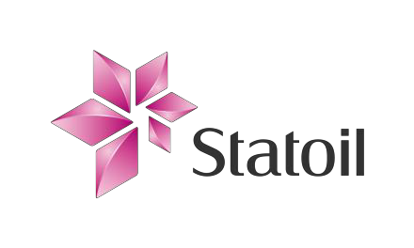

|  |  |  |  |
| --- | --- | --- | --- |
| **Hazard / Risk** | **Cause** | **Consequence** | **Risk Treatment** |
| Removal of native vegetation and potential fauna habitat | ▪ Onsite flora and fauna not previously determined during ecological assessments   Off-road driving | ▪ Loss of native vegetation   Loss of declared rare flora or priority species   Destruction of fauna habitat | Desktop review of botanic surveys undertaken to ensure well site, camp site and access tracks avoid listed flora species. |
| Existing access tracks used where possible to minimise the area cleared of native vegetation. |
| Larger and mature vegetation will be avoided where possible. |
| Vehicles and personnel restricted to existing access tracks, camp site and well site. |
| Access tracks sighted to avoid native fauna burrows and habitat. |
| Create designated turn around points to minimise disturbance to native vegetation. |
| Soil disturbance | ▪ Poor drainage control over cleared areas and topsoil/spoil stockpiles   Light compaction required for rig stability   Unstable subsoils   Poor stormwater / surface flow management | ▪ Erosion and sedimentation   Compaction   Subsidence   Dust emissions | Drainage controls implemented during operations (e.g. erosion berms and silt barriers). |
| Topsoil and spoil stockpiled separately. |
| Stockpiles constructed with low profile and away from drainage lines to reduce erosion potential. |
| Implement dust-control measures (e.g. water spraying, dust suppressant). |
| Sites rehabilitated as soon as practicable after the completion of operations to minimise potential for erosion. |
| Following the first wet season after rig release, the project area will be inspected to determine whether any soil disturbance issues persist and remediation actions initiated where required. |
| Disturbance of indigenous heritage site(s) | ▪ Onsite indigenous heritage sites not previously determined during ethnographic study   Personnel straying from access track, camp site and well site | ▪ Damage to indigenous heritage sites | Sites located to avoid indigenous cultural areas. |
| Sacred Site Clearance Certificate issued by the Central Land Council |
| Site induction to cover local cultural sensitivities |

OzDelta-1 EMP Summary – Addendum for Stimulation and Testing Page 5 of 9

|  |  |  |  |
| --- | --- | --- | --- |
| **Hazard / Risk** | **Cause** | **Consequence** | **Risk Treatment** |
| Water quality | ▪ Fractures contacting water source | ▪ Contamination | Well integrity established through pressure test and cement bond log |
| Fracture modelling shows 500 metres between maximum fracture height and relevant water source |
| Water well monitoring program to provide early identification of any contamination |
| Well control event | ▪ Release of liquid hydrocarbons to the environment   Release of gaseous hydrocarbons to the atmosphere | ▪ Contaminated soil, surface water and/or ground water   Uncontrolled fire   Air pollution | Blow out preventer used during operations from when the surface casing is set through to when the well is plugged and abandoned or when the wellhead is installed. |
| Oil Spill Contingency Plan in place. |
| Emergency Response Plan in place |
| Emergency response drills conducted regularly. |
| Noise | ▪ Noise generated during operations | ▪ Disturbance to local residents, wildlife or adjacent activities | Area has very low population density |
| Disturbance or damage to infrastructure and services | ▪ Unknown infrastructure located in the planned drilling   Human error | ▪ Disruption of services to local residents e.g.  power, telecommunication   Damage to fence lines and farm gates | Area has very low population density and no infrastructure that will be used during the operations |
| Repair all fences and affected infrastructure to pre-operation condition as agreed with the relevant pastoralists. |
| Gas venting | ▪ Venting during operations | ▪ Explosions   Fire  Loss of vegetation or fauna   Destruction of fauna habitat | Gaseous wastes are flared |
| Combustible materials cleared from the area surrounding the flare pit |
| Adequate fire equipment located on-site and personnel suitably trained. |
| Bushfires NT advised of flaring |
| Blowout during well drilling or testing | ▪ Unexpected over-pressured or under-pressured formation | ▪ Loss of vegetation or fauna   Destruction of fauna habitat   Soil contamination | Blow out preventers in use |
| Blow out preventers tested |
| Drills to ensure preparedness for blow out event |



|  |  |  |  |
| --- | --- | --- | --- |
| **Hazard / Risk** | **Cause** | **Consequence** | **Risk Treatment** |
| Hydrocarbon contamination of flare pit | ▪ Loss of combustion in flare pit   Failure to burn all fluids in flare pit | ▪ Physical or chemical impacts on flora, fauna, soil, surface water or groundwater from released fluids | Measures to ensure flare pit does not lose combustion (e.g. pilot light, automatic sparker). |
| Testing of soils in flare pit following operations followed by soil remediation (if required) |
| Flare pit lined and filled with water to prevent soil contamination |
| Release of waste, chemicals or rubbish into the environment | ▪ Improper disposal of wastes | ▪ Soil, surface water and groundwater contamination   Mortality of flora and fauna arising from soil, surface and groundwater contamination   Visual pollution from rubbish   Increased vermin or scavenger numbers locally | Use of licensed waste management contractor if required. |
| Program in place to minimise the volume of wastes generated and recycling of materials wherever practical (e.g. recycling plastic bottles). |
| Water-based drilling cuttings, muds and wastewater disposed to sump, evaporated, and the sump buried on site after all liquids have been evaporated. |
| Solid wastes and litter segregated and stored in covered rubbish skips for offsite recycling or disposal by waste management contractor. |
| Waste oils and chemicals labelled and stored appropriately for offsite disposal by licensed contractors at approved facilities. |
| Food wastes disposed of in animal proof bins, covered skips or closed trailers. |
| Site inspected at conclusion of operations. |
| For camps of more than 10 people, sewage treated by aerobic/anaerobic treatment plant and by-products disposed of in an excavated hole away from watercourses and subsequently backfilled |
| Introduction of noxious weeds and vermin, exotic species, flora and animal diseases | ▪ Weeds and contaminated soil on vehicles | ▪ Infection of soil with diseases and pathogens   Infestation of weeds in cleared areas   Loss of native flora and fauna | Equipment and vehicles cleaned and inspected for soil, plant material and pest animal contamination prior to mobilisation to site. |
| Uncontrolled fires | ▪ Ignition sources (e.g. vehicle exhaust, smokers)   Grass fires and bush fires in | ▪ Loss of vegetation and native fauna | Adequate fire equipment located on-site and personnel suitably trained. |
| Only diesel vehicles used in operations. |

|  |  |  |  |
| --- | --- | --- | --- |
| **Hazard / Risk** | **Cause** | **Consequence** | **Risk Treatment** |
|  | uncleared areas from sources of ignition |  | Smoking restricted to designated areas. |
| No open fires. |
| Fuel, oil or chemical spills | ▪ Lack of appropriate bunding around storage and refuelling areas   Inappropriate storage of fuel, oil or chemical containers   Inappropriate handling of fuel, oil or chemicals during use | ▪ Contamination of soil, surface water or groundwater | Fuel, oil and chemical storage areas appropriately segregated, labelled and bunded, as required. |
| Containers inspected for leaks or potential leaks. |
| Personnel trained in the correct procedures for use of materials, including refuelling and clean-up and spill management procedures. |
| Well site not located within a sensitive environment. |
| Drip trays used while refuelling |
| Portable fuel cans to be stored in bunded containers or trailers capable of holding at least 2.5 times the volume of stored fuel |
| Emergency Response Plan and Oil Spill Contingency Plan in place and personnel trained in their implementation. |
| Spill kits available in all relevant areas. |
| Dust suppressant non-toxic and environmentally friendly |
| Vehicle collision with fauna | ▪ Unpredictable movement of animals   Vehicles travelling at high speeds   Vehicles travelling at dawn or dusk or in times of poor visibility | ▪ Fauna death or injury | Limit vehicle activities to daylight hours when fauna are more visible and avoid driving at night. |
| Limit vehicle speeds to road conditions on access tracks |
| Vehicle inspected to ensure they have working lights and/or spotlights. |
| Vehicles to remain on designated access tracks. |

*a*

OzDelta-1 location and exploration permits map

:>

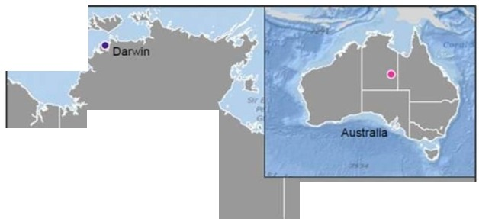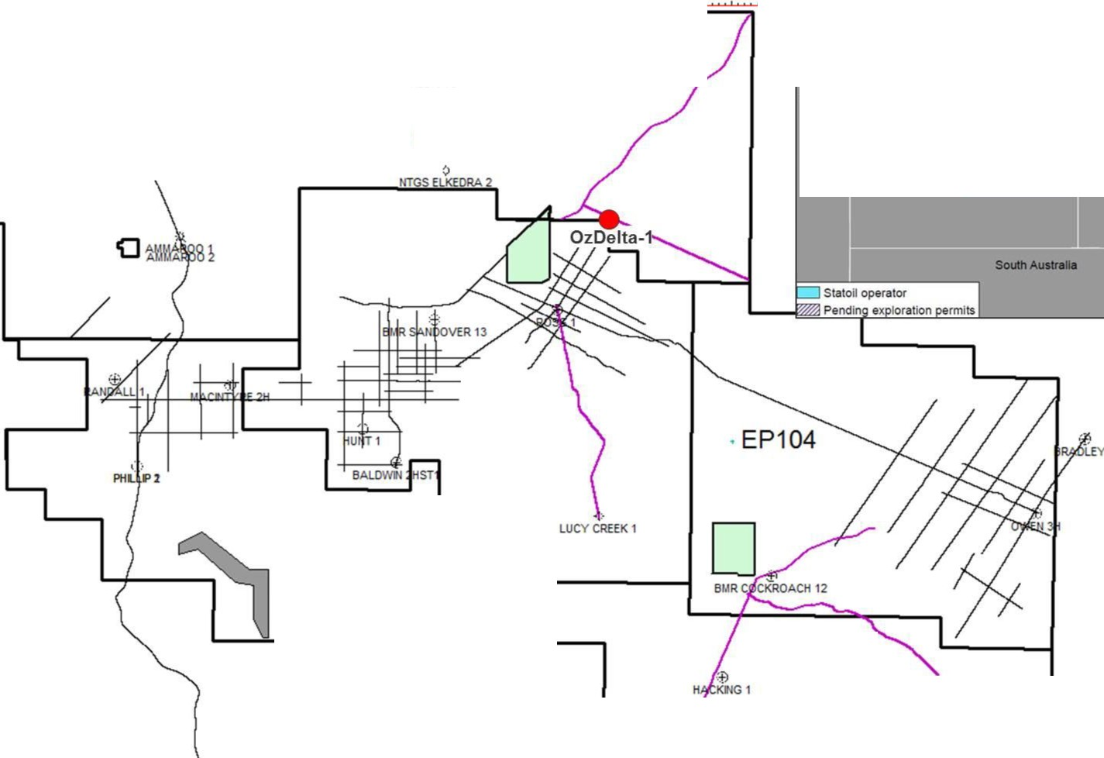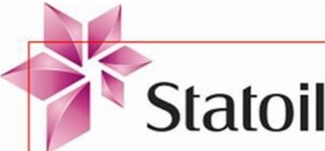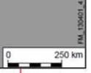

"C

;::;:

m:s:

-u

(/)

c

3

3

.:::

I

)> c. c.

(II

c.

c

3

*Q*

*g}*

*r*

£

g·

c.

-I

(II

lC

520000 540000 560000 580000 600000 620000 640000 660000 660000 700000 720000

Bt.IR E DRA 3 / I Iw.wt'

Aushllll

.... 1 I I I ·EP128

·EP103

·EP127

Norlhem Tenlloly

a.-.llnd

:::s

c.

)('

IV

0Aboriginal Land Trust

D National Park

- Seismic lines

41

tiTGS99-1

'&

TODD

-Amy Seismic 2013 *J* '--, J

1 ,

*"Jl* 0' Pe,trolum 'Wels ' , ' ' , '' ' ' ' ' ' ' ' ' ' ' ' ' ' ' ' , ' ' ' ' ' ' , '



lC

(II

(D

0 10Xl0 :0000 X1C1C10 t0000 !OIXICI ICICO) 7'0:100 IOXlO to000 1 1Xl1XJ01!1

(D ,12J1U$