Mineral Titles Act
NOTICE OF LAND CEASING TO BE A MINERAL TITLE
Title Type and Number: | Extractive Mineral Permit 28208
Area ceased on: | 23 February 2018
Area: | 85.00 Hectare
Locality: | NOONAMAH
Name of Applicants(s)Holder(s): | 100% DNR ENTERPRISES (NT) PTY LTD [ACN. 099 942 373]
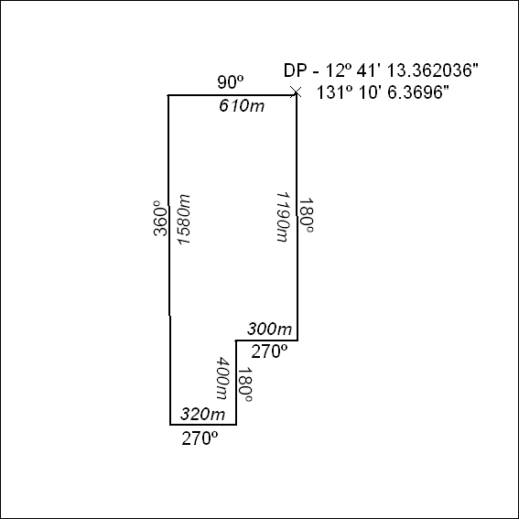

80/18

Mineral Titles Act
NOTICE OF LAND CEASING TO BE A MINERAL TITLE AREA
Title Type and Number: | Exploration Licence 31130
Area Ceased on: | 25 February 2018
Area: | 9 Blocks, 28.53 km²
Locality: | JERVOIS RANGE
Name of Applicant(s)/Holder(s): | 100% MOLYHIL MINING PTY LTD [ACN. 112 922 497]
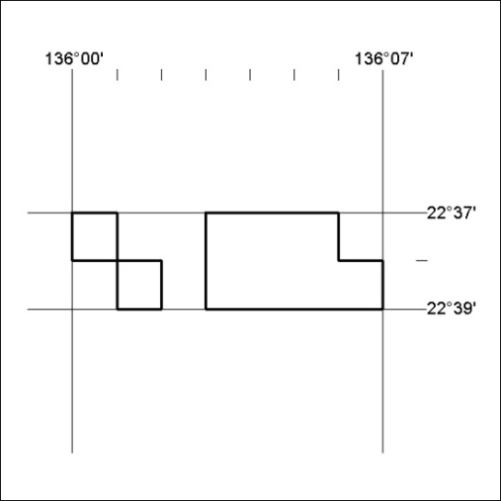

81/18
Corrigendum
Notice Number 77/18 appearing in MN27/18 on 15 February 2018 is hereby cancelled and replaced by the following:

Mineral Titles Act
NOTICE OF LAND CEASING TO BE A MINERAL TITLE AREA
Title Type and Number: | Exploration Licence 30818
Area Ceased on: | 15 February 2018
Area: | 125 Blocks, 411.42 km²
Locality: | VICTORIA RIVER DOWNS
Name of Applicant(s)/Holder(s): | 100% RIPPLE RESOURCES PTY LTD [ACN. 127 220 768]
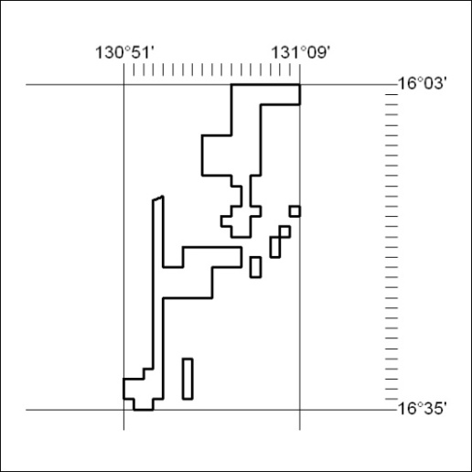

82/18

