Mineral Titles Act
NOTICE OF LAND CEASING TO BE A MINERAL TITLE
Title Type and Number: | Extractive Mineral Permit 23663
Area ceased on: | 02 March 2018
Area: | 42.00 Hectare
Locality: | NOONAMAH
Name of Applicants(s)Holder(s): | 100% A AND SF MADDALOZZO PTY. LIMITED [ACN. 009 624 015]
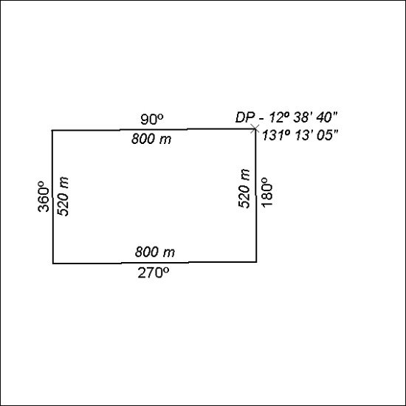

86/18

Mineral Titles Act
NOTICE OF LAND CEASING TO BE A MINERAL TITLE
Title Type and Number: | Extractive Mineral Permit 27033
Area ceased on: | 02 March 2018
Area: | 9.00 Hectare
Locality: | NOONAMAH
Name of Applicants(s)Holder(s): | 100% A AND SF MADDALOZZO PTY. LIMITED [ACN. 009 624 015]
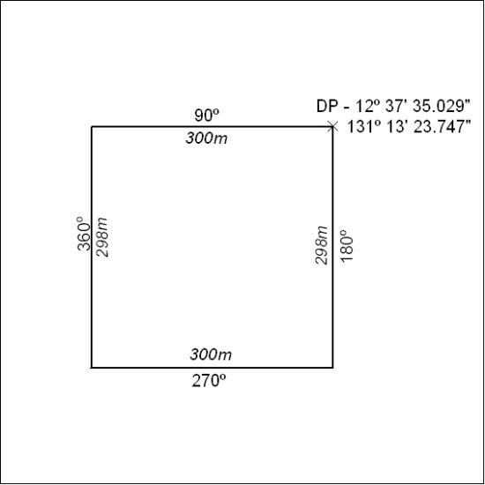

87/18

Mineral Titles Act
NOTICE OF LAND CEASING TO BE A MINERAL TITLE
Title Type and Number: | Mineral Authority 28194
Area ceased on: | 01 March 2018
Area: | 22.00 Hectare
Locality: | PINE CREEK
Name of Applicants(s)Holder(s): | 100% SILVER COIN MINING & PROSPECTING PTY. LTD. [ACN. 009 618 517]
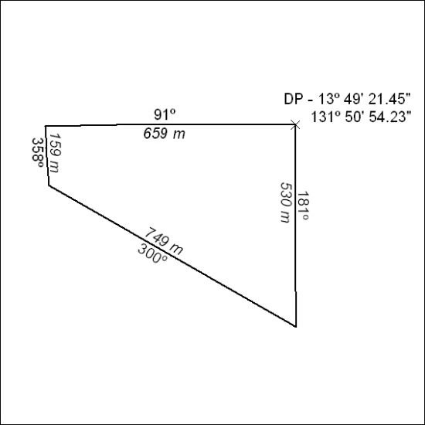

88/18

Mineral Titles Act
NOTICE OF LAND CEASING TO BE A MINERAL TITLE AREA
Title Type and Number: | Exploration Licence 30810
Area Ceased on: | 02 March 2018
Area: | 5 Blocks, 16.45 km²
Locality: | MALLAPUNYAH
Name of Applicant(s)/Holder(s): | 100% RIPPLE RESOURCES PTY LTD [ACN. 127 220 768]
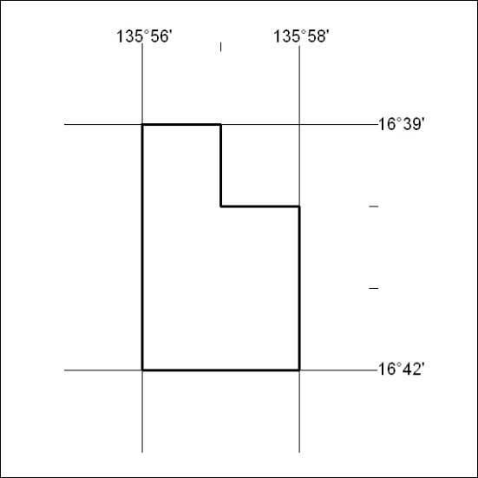

89/18

