Mineral Titles Act
NOTICE OF GRANT OF A MINERAL TITLE
Title Type and Number: | Extractive Mineral Exploration Licence 31604
Granted: | 05 March 2018, for a period of 2 Years
Area: | 3 Blocks, 7.69 km²
Locality: | KOOLPINYAH
Name of Holder/s: | 100% SAGE CONSTRUCTIONS PTY. LTD. [ACN. 009 654 648]
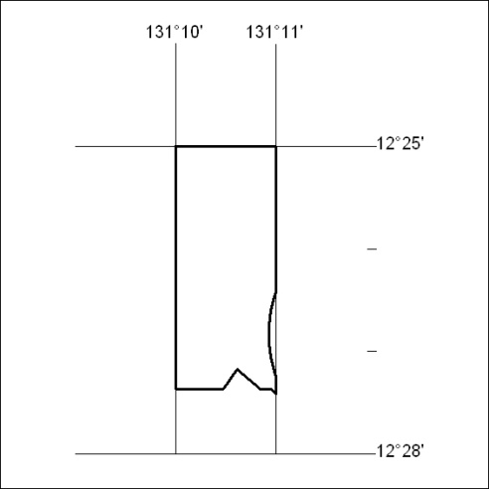
Area granted is indicated above. The titleholder is not permitted to exercise occupational rights on any land that is subject to a development title, or an application for a development title. Any land the subject of a Reserved Land gazettal under the Mineral Titles Act and all land vested in the Commonwealth of Australia is also excluded by description but not excised from the grant area.

100/18

Mineral Titles Act
NOTICE OF GRANT OF A MINERAL TITLE
Title Type and Number: | Extractive Mineral Exploration Licence 31605
Granted: | 05 March 2018, for a period of 2 Years
Area: | 2 Blocks, 1.66 km²
Locality: | KOOLPINYAH
Name of Holder/s: | 100% SAGE CONSTRUCTIONS PTY. LTD. [ACN. 009 654 648]
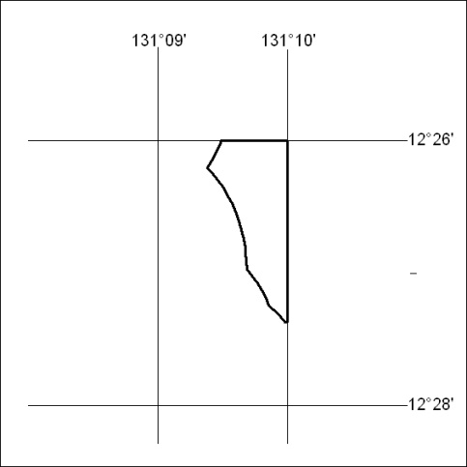
Area granted is indicated above. The titleholder is not permitted to exercise occupational rights on any land that is subject to a development title, or an application for a development title. Any land the subject of a Reserved Land gazettal under the Mineral Titles Act and all land vested in the Commonwealth of Australia is also excluded by description but not excised from the grant area.

101/18

Mineral Titles Act
NOTICE OF GRANT OF A MINERAL TITLE
Title Type and Number: | Extractive Mineral Exploration Licence 31656
Granted: | 05 March 2018, for a period of 2 Years
Area: | 3 Blocks, 7.82 km²
Locality: | KOOLPINYAH
Name of Holder/s: | 100% SAGE CONSTRUCTIONS PTY. LTD. [ACN. 009 654 648]
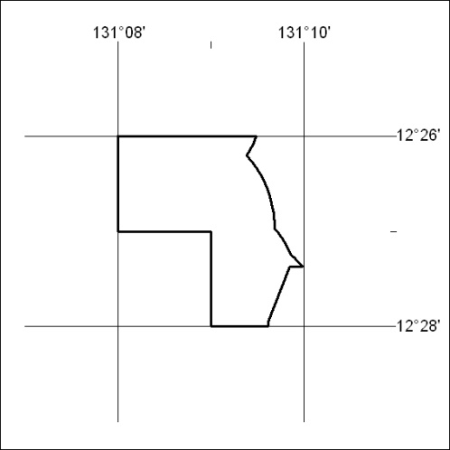
Area granted is indicated above. The titleholder is not permitted to exercise occupational rights on any land that is subject to a development title, or an application for a development title. Any land the subject of a Reserved Land gazettal under the Mineral Titles Act and all land vested in the Commonwealth of Australia is also excluded by description but not excised from the grant area.

102/18

Mineral Titles Act
NOTICE OF GRANT OF A MINERAL TITLE
Title Type and Number: | Exploration Licence 31591
Granted: | 07 March 2018, for a period of 6 Years
Area: | 221 Blocks, 692.44 km²
Locality: | PINE CREEK
Name of Holder/s: | 100% WOODLEIGH NOMINEES PTY LIMITED [ACN. 050 120 057]
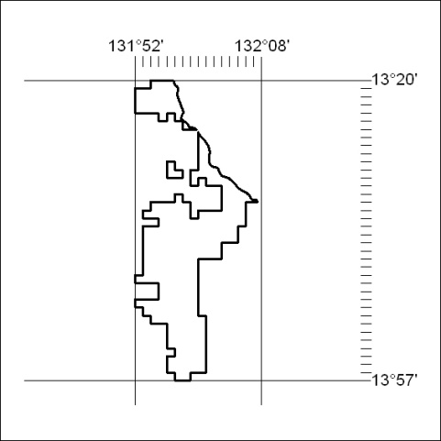
Area granted is indicated above. The titleholder is not permitted to exercise occupational rights on any land that is subject to a development title, or an application for a development title. Any land the subject of a Reserved Land gazettal under the Mineral Titles Act and all land vested in the Commonwealth of Australia is also excluded by description but not excised from the grant area.

103/18

Mineral Titles Act
NOTICE OF GRANT OF A MINERAL TITLE
Title Type and Number: | Exploration Licence 31631
Granted: | 06 March 2018, for a period of 6 Years
Area: | 1 Block, 3.34 km²
Locality: | PINE CREEK
Name of Holder/s: | 100% BACCHUS RESOURCES PTY LTD [ACN. 606 340 872]
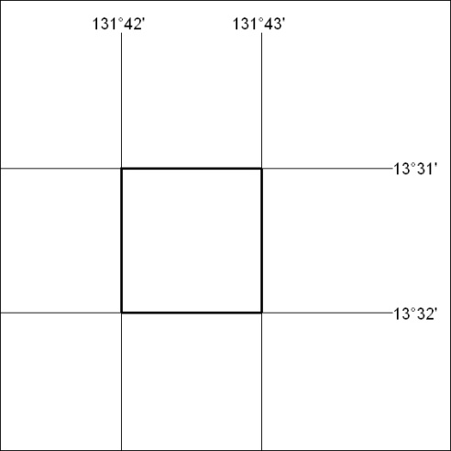
Area granted is indicated above. The titleholder is not permitted to exercise occupational rights on any land that is subject to a development title, or an application for a development title. Any land the subject of a Reserved Land gazettal under the Mineral Titles Act and all land vested in the Commonwealth of Australia is also excluded by description but not excised from the grant area.

104/18

Mineral Titles Act
NOTICE OF GRANT OF A MINERAL TITLE
Title Type and Number: | Exploration Licence 31631
Granted: | 06 March 2018, for a period of 6 Years
Area: | 1 Block, 3.34 km²
Locality: | PINE CREEK
Name of Holder/s: | 100% BACCHUS RESOURCES PTY LTD [ACN. 606 340 872]
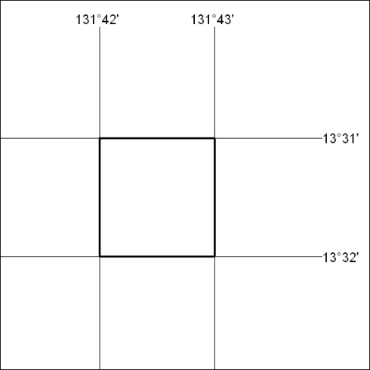
Area granted is indicated above. The titleholder is not permitted to exercise occupational rights on any land that is subject to a development title, or an application for a development title. Any land the subject of a Reserved Land gazettal under the Mineral Titles Act and all land vested in the Commonwealth of Australia is also excluded by description but not excised from the grant area.

105/18

