Mineral Titles Act
NOTICE OF LAND CEASING TO BE A MINERAL TITLE
Title Type and Number: | Mineral Lease 30258
Area ceased on: | 11 April 2018
Area: | 3.00 Hectare
Locality: | PINE CREEK
Name of Applicants(s)Holder(s): | 50% WILSON Peter John, 50% WILSON Henry Robert
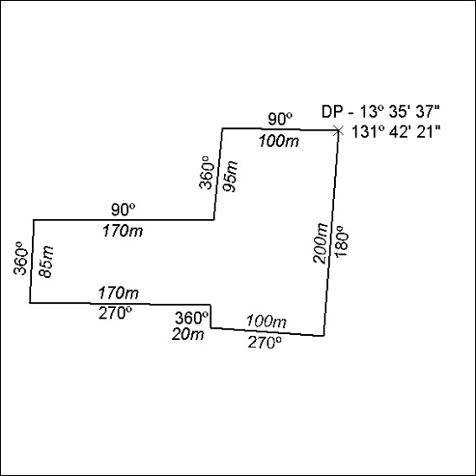

125/18

Mineral Titles Act
NOTICE OF LAND CEASING TO BE A MINERAL TITLE AREA
Title Type and Number: | Exploration Licence 28902
Area Ceased on: | 11 April 2018
Area: | 34 Blocks, 112.46 km²
Locality: | MARANBOY
Name of Applicant(s)/Holder(s): | 51% PNX METALS LIMITED* [ACN. 127 446 271], 49% NEWMARKET GOLD NT HOLDINGS PTY LTD* [ACN. 136 505 587]
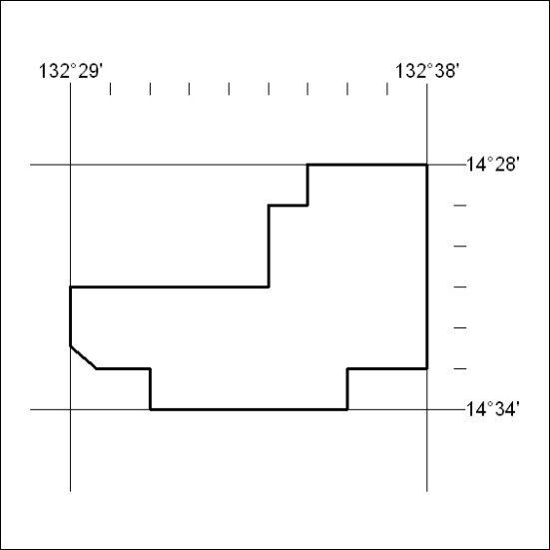

126/18

