Mineral Titles Act
NOTICE OF LAND CEASING TO BE A MINERAL TITLE
Title Type and Number: | Mineral Authority 30930
Area ceased on: | 29 May 2018
Area: | 443.00 Hectares
Locality: | NOONAMAH
Name of Applicants(s)Holder(s): | 100% BANDIAS Leo John
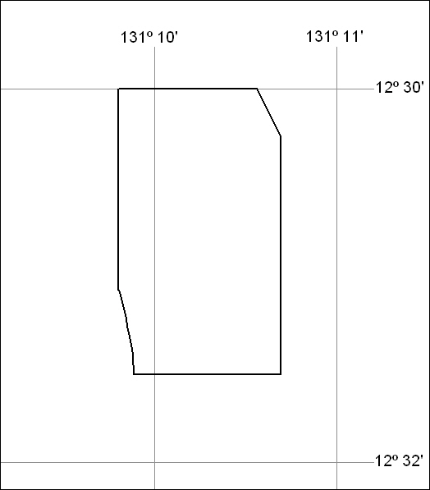

219/18

