Mineral Titles Act
NOTICE OF LAND CEASING TO BE A MINERAL TITLE AREA
Title Type and Number: | Exploration Licence 28602
Area Ceased on: | 18 July 2018
Area: | 130 Blocks, 368.68 km²
Locality: | KELLY
Name of Applicant(s)/Holder(s): | 100% GIANTS REEF EXPLORATION PTY LTD* [ACN. 009 200 346]
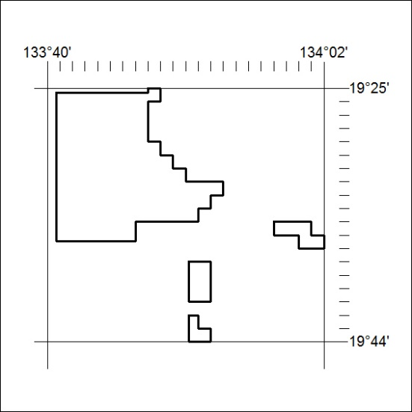

313/18

Mineral Titles Act
NOTICE OF LAND CEASING TO BE A MINERAL TITLE AREA
Title Type and Number: | Exploration Licence 28603
Area Ceased on: | 18 July 2018
Area: | 3 Blocks, 9.72 km²
Locality: | SHORT RANGE
Name of Applicant(s)/Holder(s): | 100% GIANTS REEF EXPLORATION PTY LTD* [ACN. 009 200 346]
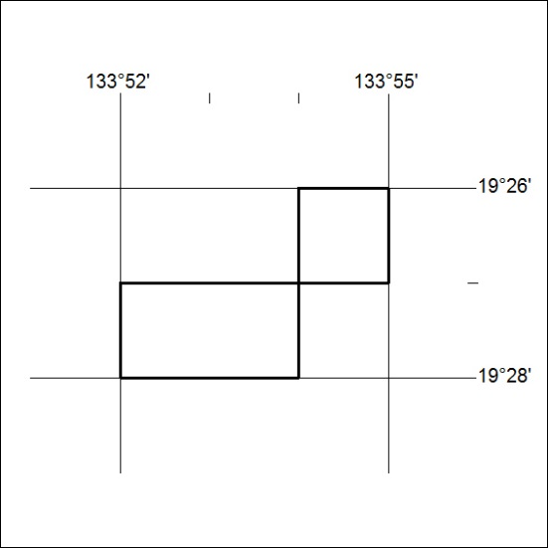

314/18

