Mineral Titles Act
NOTICE OF GRANT OF A MINERAL TITLE
Title Type and Number: | Exploration Licence 31760
Granted: | 31 August 2018, for a period of 6 Years
Area: | 111 Blocks, 363.66 km²
Locality: | SURPRISE CREEK
Name of Holder/s: | 100% EL CARO RESOURCES PTY LTD [ACN. 619 093 819]
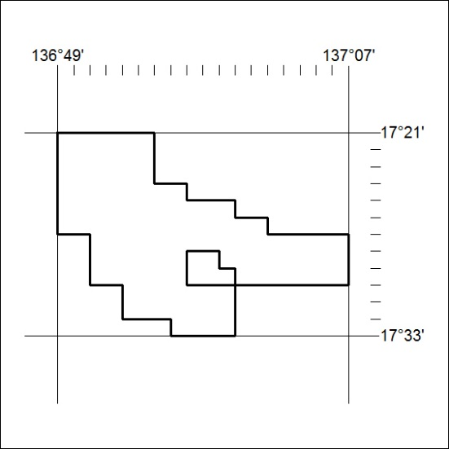
Area granted is indicated above. The titleholder is not permitted to exercise occupational rights on any land that is subject to a development title, or an application for a development title. Any land the subject of a Reserved Land gazettal under the Mineral Titles Act and all land vested in the Commonwealth of Australia is also excluded by description but not excised from the grant area.

389/18

