Mineral Titles Act
NOTICE OF LAND CEASING TO BE A MINERAL TITLE AREA
Title Type and Number: | Exploration Licence 27912
Area Ceased on: | 13 September 2018
Area: | 42 Blocks, 129.90 km²
Locality: | COCKBURN
Name of Applicant(s)/Holder(s): | 100% GEMPART (NT) PTY LTD* [ACN. 081 859 896]
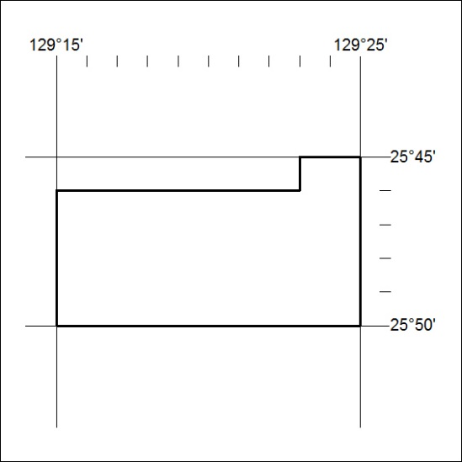

401/18

Mineral Titles Act
NOTICE OF LAND CEASING TO BE A MINERAL TITLE AREA
Title Type and Number: | Exploration Licence 27913
Area Ceased on: | 13 September 2018
Area: | 64 Blocks, 198.28 km²
Locality: | DUFFIELD
Name of Applicant(s)/Holder(s): | 100% GEMPART (NT) PTY LTD* [ACN. 081 859 896]
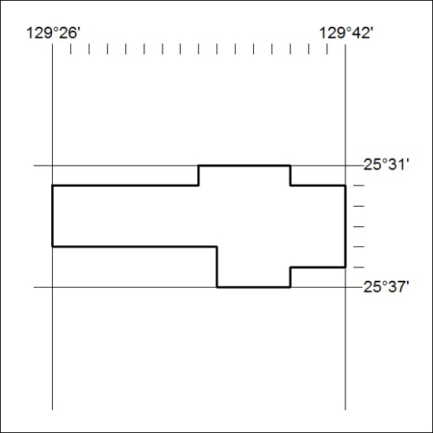

402/18

Mineral Titles Act
NOTICE OF LAND CEASING TO BE A MINERAL TITLE AREA
Title Type and Number: | Exploration Licence 31096
Area Ceased on: | 13 September 2018
Area: | 49 Blocks, 129.66 km²
Locality: | BUSHY PARK
Name of Applicant(s)/Holder(s): | 100% ARAFURA RESOURCES LIMITED [ACN. 080 933 455]
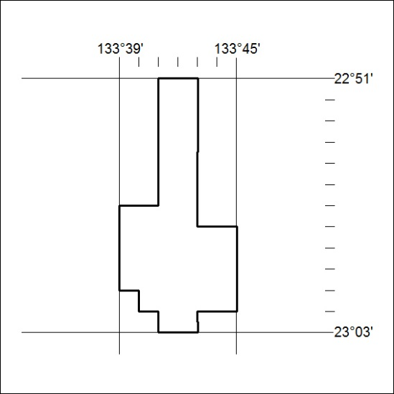

403/18

Mineral Titles Act
NOTICE OF LAND CEASING TO BE A MINERAL TITLE AREA
Title Type and Number: | Exploration Licence 31097
Area Ceased on: | 13 September 2018
Area: | 111 Blocks, 351.08 km²
Locality: | AILERON
Name of Applicant(s)/Holder(s): | 100% ARAFURA RESOURCES LIMITED [ACN. 080 933 455]
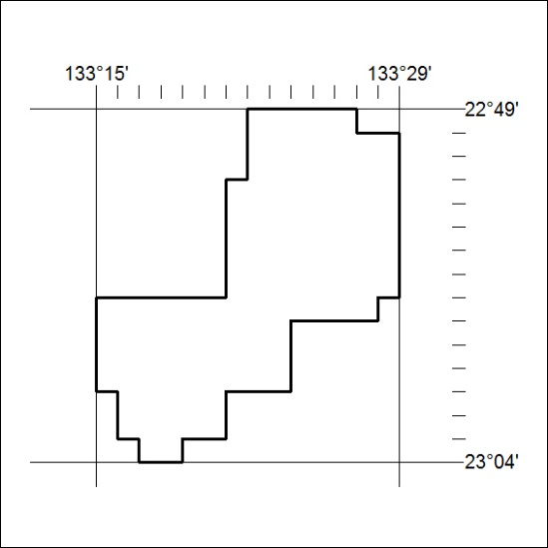

404/18

