Mineral Titles Act
NOTICE OF LAND CEASING TO BE A MINERAL TITLE AREA
Title Type and Number: | Exploration Licence 29470
Area Ceased on: | 12 November 2018
Area: | 9 Blocks, 28.47 km²
Locality: | JINKA
Name of Applicant(s)/Holder(s): | 100% XAVIER RESOURCES PTY LTD [ACN. 623 262 304]
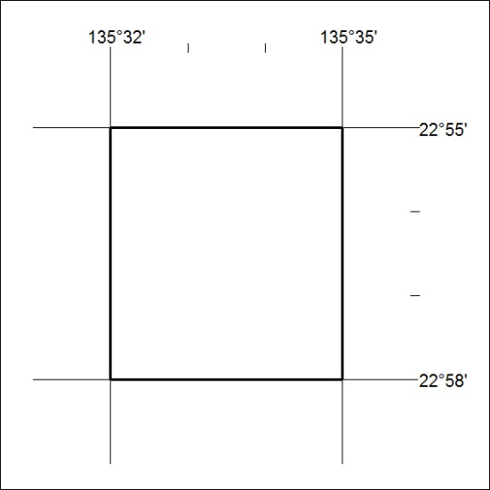

512/18

