Mineral Titles Act
NOTICE OF LAND CEASING TO BE A MINERAL TITLE
Title Type and Number: | Extractive Mineral Permit 24175
Area ceased on: | 04 January 2019
Area: | 26.00 Hectare
Locality: | MARY RIVER
Name of Applicants(s)Holder(s): | 100% A AND SF MADDALOZZO PTY. LIMITED [ACN. 009 624 015]
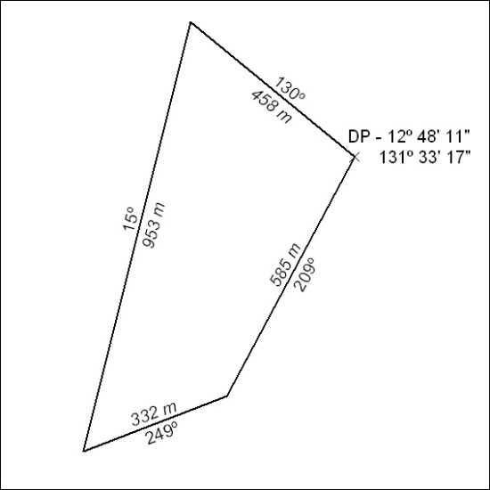

05/19

Mineral Titles Act
NOTICE OF LAND CEASING TO BE A MINERAL TITLE AREA
Title Type and Number: | Exploration Licence 31558
Area Ceased on: | 04 January 2019
Area: | 244 Blocks, 798.11 km²
Locality: | COANJULA
Name of Applicant(s)/Holder(s): | 100% CEDAR RESOURCES PTY LTD [ACN. 612 086 932]
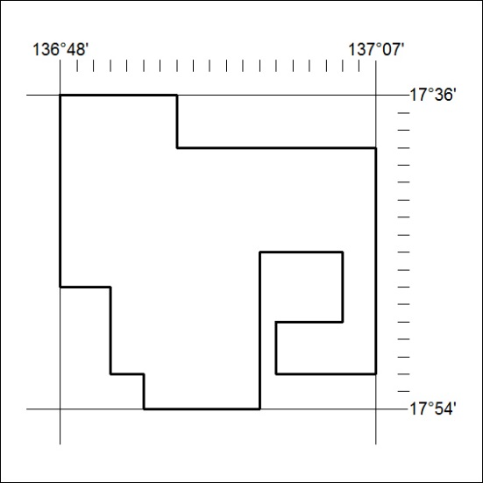

06/19

